Change Request
for the update of ISO 20022 financial repository items

- Origin of the request:
A.1 Submitter:
European Payments Council (EPC)
Cours Saint-Michel 30A, B-1040 Brussels
Belgium
A.2 Contact person:
Mr Valentin Vlad (valentin.vlad@epc-cep.eu)
A.3 Sponsors:
EPC Multi-stakeholder Group on E-invoice Presentment and Payments (EIPP MSG) upon invitation by the ERPB
Organisations represented in the EIPP MSG:
- EPC (European Payments Council)
- EESPA (European E-invoicing Service Providers Association)
- EACT (European Association of Corporate Treasurers)
- EuroCommerce (association representing the retail, wholesale and international trade sector in Europe)
- EcommerceEurope (association representing companies selling goods and/or services online to consumers in Europe)

- Related messages:
pain.013.001.06 and pain.014.001.06

- Description of the change request:
Addition of an optional and repetitive element to pain.013.001.06 and pain.014.001.06, derived from the existing element Enclosed File This element will be used to transport the E-invoice along with the Request-to-pay within the ISO messages.
Enclosed File already exists in the ISO trade messages (tsrv) but the request is to add a new element that is inspired from the Enclosed File but with some differences (see below). The purpose is not to change the existing Enclosed File (Document9) in the tsrv messages.

The optional and repetitive element will contain following sub-elements:

Element Name | Element Definition | Multiplicity | DataType
Type* | Type of document or template. | [1..1] | Choice between Code (‘20-DocumentType’ External Code Set list) or Proprietary
Identifier* | Identification of the document or template. | [1..1] | Max35Text
Issue Date Time¹ | Issue date of the document. | [1..1] | DateAndDateTimeChoice
Name¹ | Name of the document or transaction, for example, tax invoice. | [0..1] | Max140Text
Language Code¹ | Unique identifier for a language used the document. | [0..1] | ISO 639 to be used in 2 or 3 letter variant (example: English = EN or ENG)
Format* | Format of the document or template, such as PDF, XML, XSLT. | [1..1] | Choice between Code (‘37-DocumentFormat’ External Code Set list) or Proprietary
File Name² | Technical name of the File. | [0..1] | Max140Text
Digital signature* | Digital signature | [0..1] | Includes Party Identification and signature
Enclosure* | Binary file representing the enclosed document or template, such as a PDF file, image file, XML file, MT message. | [1..1] | Max10MBBinary (see additional request infra)
*Element has been functionality inherited from the existing Enclosed File element (Document9).
^{1’}Name’, ‘IssueDateTime’ and ‘Language Code’ help users in a Business-To-Customer interface to display some info prior to open/download.
^{2’}FileName’ ensures a common end-to-end name from upload to download.

The below schema is only used as a visual representation of the additional element. No proper xml tags used at this stage for the elements added to the existing EnclosedFile. (IssueDateTime, Name, LanguageCode, FileName added).

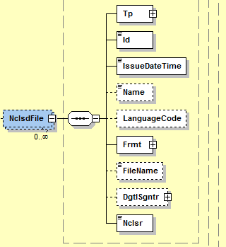

Note:

As part of this CR, it is being requested to:

a. For ‘Type’: Add an additional code to the ExternalDocumentType1Code list in the ISO external code set list. The additional code to be added it ‘OTHR’ (other). As part of the EIPP project, it is not currently possible to specify all types of documents that could be inserted..

b. For ‘Enclosure’: In the current element Document9, “Enclosure” has a capacity/data type of 2 MB Binary. In the EIPP context the Files (Invoices, credit notes, etc,…) could easily exceed the data type Max2MBBinary. Therefore, a datatype with higher capacity is being requested.
Request: Definitively register the data type Max10MBBinary (that is currently provisionally registered) and use it for Enclosure.

Requested Location of the “optional” Enclosed File in the pain.013 and pain.014 :

In the pain.013 -> Level 1 (after remittance information)
In the pain.014
- Level 3 (after Original Transaction Reference) -> This can include a document issued by the Payer to be delivered to the Payee, different from the original document received in the pain.013
- Level 4 (after remittance information in Original Transaction Reference) -> This optionally includes the same Enclosed File as was present in the pain.013.

For pain.013:
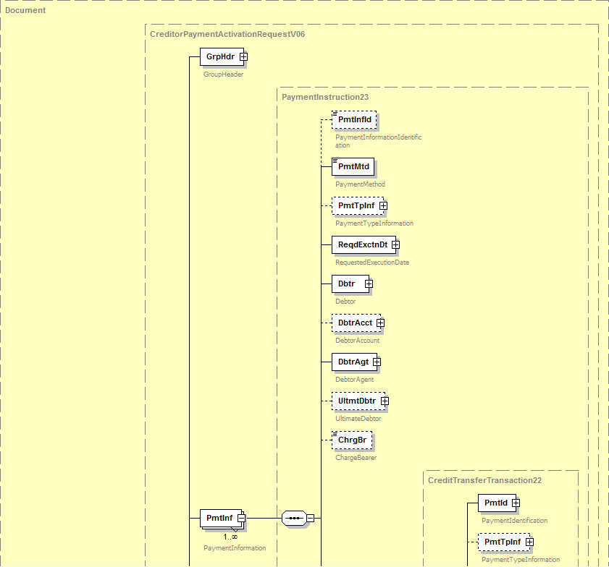
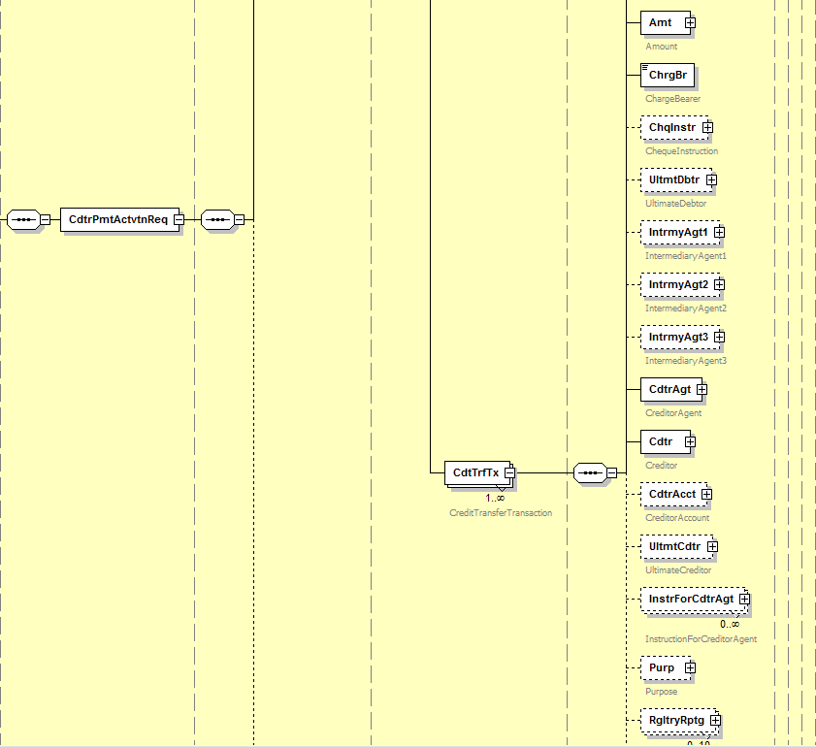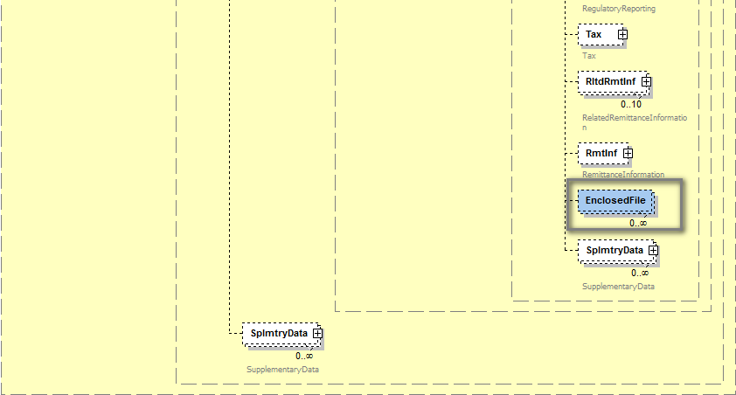

For pain.014:

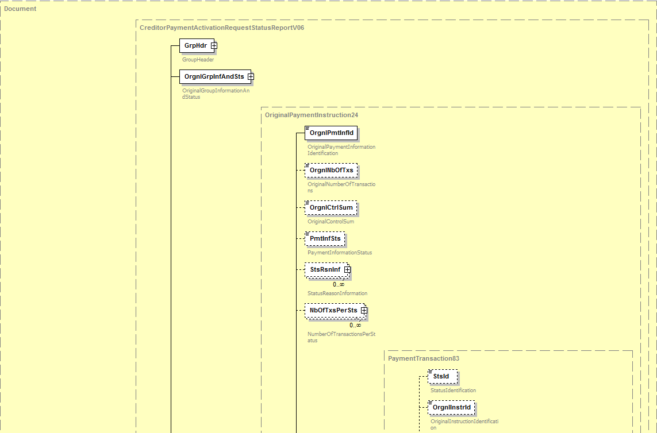
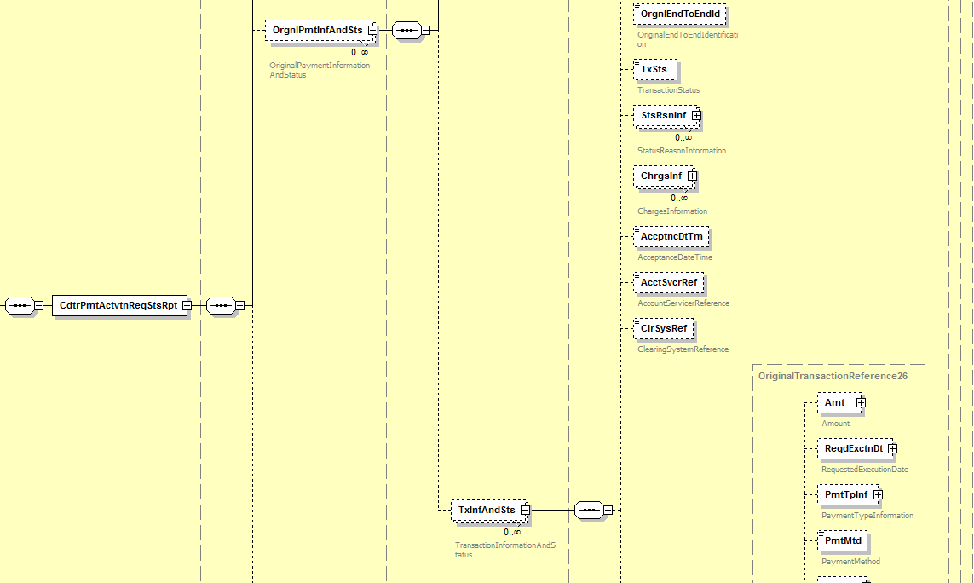
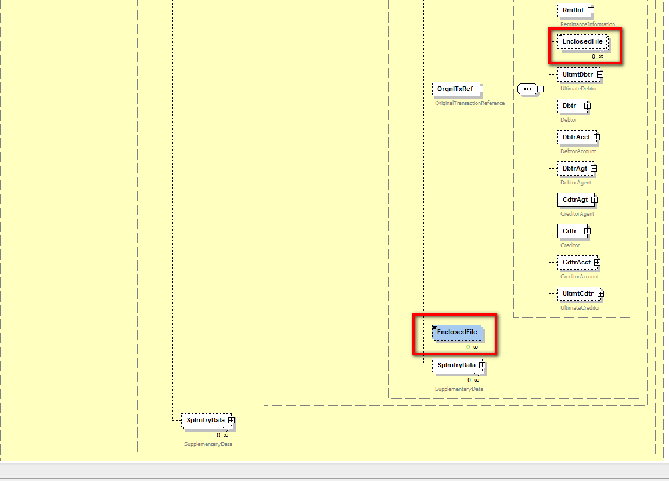

- Purpose of the change:
At the end of the year 2016 the ERPB mandated a working group to define the minimum requirements for EIPP at the levels of business rules and technical standards and report on the outcome of its work in one year. The working group’s report was approved and published in November 2017. The ERPB took note of the report and endorsed the set of minimum requirements for the development of pan-European interoperability of EIPP services. Following a step-by-step approach, the work would first focus on the adoption of a technical ISO 20022-based message for Request-to-pay for EIPP and the harmonisation of other EIPP “servicing messages”. The ERPB invited the EPC to coordinate the required work among the payment services providers with the involvement of other stakeholders including e-invoicing solution providers.
Responding to the invitation of the ERPB to coordinate the follow-up work, the EPC created the EPC Multi-stakeholder Group on EIPP (EIPP MSG) which started its activity in February 2018. As indicated by the ERPB, the EIPP MSG is focusing in 2018 on the adoption of a standardised technical ISO 20022-based message for Request-to-pay and the harmonisation of other identified servicing messages related to EIPP.
After analysing the existing pain.013 and pain.014 messages (Creditor Payment Activation Request and Report), the EIPP MSG considers that they are to a large extent suitable for the requirements related to Request-to-pay identified in the ERPB report. Nevertheless, the delivery of the underlying E-invoice and other related E-documents was highlighted as an important requirement. Although the current version of the pain.013 message could partially respond to this need by making use of the field Related Remittance Information or Supplementary Data, in which references (e.g. URLs) to the E-invoices could be added, it was considered necessary to support the inclusion of E-invoices and other E-documents as attachments within the pain.013 message. Several arguments in favour of this option were found such as the need for a Request-to-pay to be a container for all information that it may refer to, the use of a single and secured channel for both request-to-pay and E-invoices, or the interoperability between various existing solutions that could be better achieved using attachments.
The fulfilment of the requirements, the analyses of the current practices and of the capabilities of a similar ISO 20022 element – EnclosedFile – present for example in tsrv.001, justified the request from the EIPP MSG for a new element with the structure described above. It is important to highlight that the “raw” document contained in the sub-element Enclosure can be in any format, binary (e.g. PDF) or XML (to transport any format of the E-invoices) by using the universal Base64 conversion. The other sub-elements help structuring the document with metadata.
By making use of this new element, the pain.013 message would support the needs of:
- Invoice issuers (Sellers/ Payees) by offering them a “vehicle” to transport the E-invoices and other documents along with the Request-to-pay
- Individual B2C Business-to-Consumer) customers (Payers) who will benefit from the function proposed by their PSP to view and pay the E-invoices directly within their PSP electronic channels
- Individual B2B (Business-to Business) customers (Payers) who can receive through a single interface XML request-to-pay and associated E-invoices, making possible the generation of payment orders and simultaneously the accountability related tasks
- Public administrations (e.g. tax services, public health services) as Payees for sending the payment requests along with administrative documents to individuals or businesses, or as Payers for receiving payment requests and associated E-invoices for procurement needs from services and goods suppliers.
- Payment Service Providers (PSPs) which will be able to propose to their customers a “one-stop” function combining the payment and the visualisation and download of E-invoices.
- E-invoicing Solution Providers which will have the possibility to enhance their products by encapsulating the E-invoices in a standardised envelop (request-to-pay) facilitating the payment.
Consequently, the pain.014 should be adapted for the same reasons.
- Urgency of the request: next release
- Business examples:
- In B2C (individual customers) or B2b (small enterprises), the Payee generates the Request-to-pay including the corresponding E-invoice and sends it to the Payer through the network (PSPs, EISPs, Clearing Houses, etc). The Payer can view and download the attached E-invoice. After having given its consent, he/she instructs its PSP to execute the payment and if needed to send a pain.014 using the existing ISO messages.

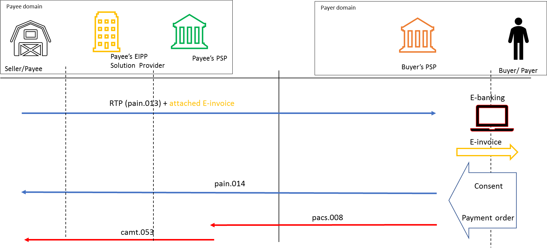

- In B2B (corporates), the Seller generates the Request-to-pay including the corresponding E-invoice and sends it to the Payer through the network (PSPs, EISPs, Clearing Houses, etc). The message reaches the Payer’s domain. The Payer gives its consent, its PSP generates the pain.014 message, generates the corresponding “Customer-To-Bank” payment message and extracts the attached E-invoice for processing.

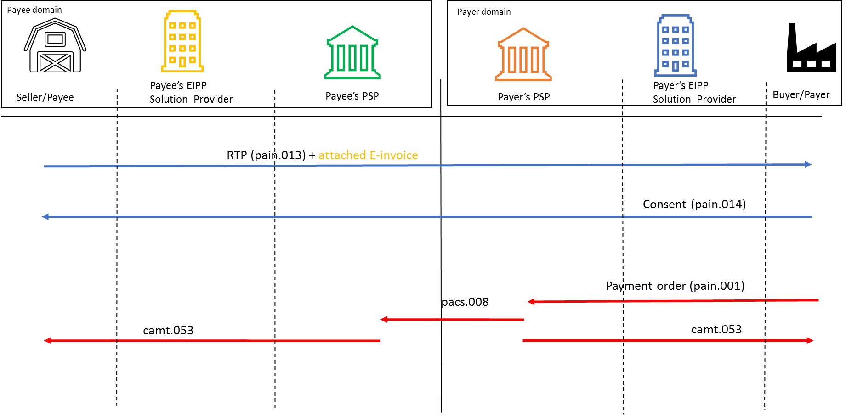

SEG/TSG recommendation:

Consider |  | X | Timing
 |  |  | - Next yearly cycle: 2018/2019  (the change will be considered for implementation in the yearly maintenance cycle which starts in 2018 and completes with the publication of new message versions in the spring of 2019) |  | X
- At the occasion of the next maintenance of the messages
(the change will be considered for implementation, but does not justify maintenance of the messages in its own right – will be pending until more critical change requests are received for the messages)
- Urgent unscheduled
(the change justifies an urgent implementation outside of the normal yearly cycle)
 |  |  | - Other timing:
Comments: Decision made at the Payments SEG meeting on July 2nd, 2018.

Reject
Reason for rejection:

ECB’s Euro Retail Payments Board, see the ERPB statement published in November 2017: (link ERPB Statement, page 3)
Report of the ERPB Working Group on EIPP - November 2017

