Change Request
for the update of ISO 20022 financial repository items
- Origin of the request:
A.1 Submitter:
- Deutsche Bundesbank, on behalf of the Eurosystem
- TARGET2-Securities

A.2 Contact person:
- Alexander Topel / Julia Lohle
- +49 69 – 9566 8184 / +49 69 – 9566 8843
- T2S-FAM@bundesbank.de

A.3 Sponsors:
- TARGET2-Securities Community
- Deutsche Bundesbank on Behalf of the German National User Group (NUG)

- Related messages:
- Sese.030.001.07 - SecuritiesSettlementConditionsModificationRequestV07
- Sese.031.001.07 - SecuritiesSettlementConditionModificationStatusAdviceV07

- Description of the change request:
This request proposes to add Restriction References in the sese.030 and consequently in the sese.031. It is suggested to add the new block ‘Restriction References’ in the ‘Request Details’ section of both messages, sese.030 and sese.031 (see figure). According to other blocks (i.e. Linkages) within the Request Details it is proposed to add the Restriction References in the same way, i.e. one code indicating the action (ADDS, REMS, ADDC, REMC) and one field for the reference.
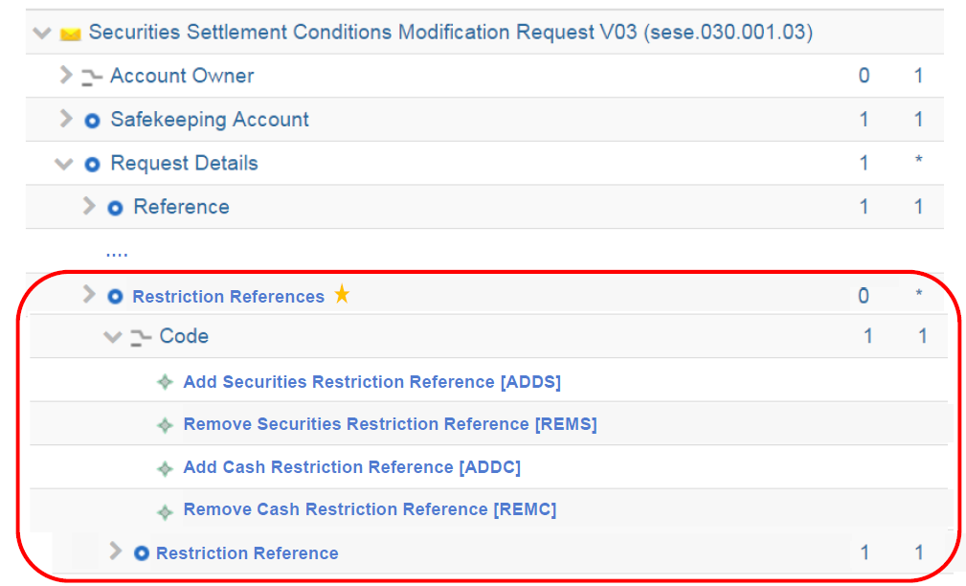

- Purpose of the change:
This change request would enable a more efficient cash management of sensitive settlements.

T2S provides its actors with a functionality to reserve dedicated liquidity to be used for the settlement of the cash leg of a specific DVP settlement transaction.
In order to reserve liquidity, the owner of the cash account can move liquidity into a dedicated sub-balance, resulting in a blocking of the requested cash amount. This process is known as “cash blocking”. The blocked amount is identified by a unique restriction reference assigned by T2S and can only be used for settlement purposes if the same restriction reference is specified in a DVP settlement instruction.
Accordingly, in order to know the restriction reference to be entered in the settlement instruction expected to make use of the blocked amount, the cash blocking needs to take place first.
In reality, most DVP settlement instructions are submitted without knowing that a need for dedicated liquidity would arise later on in the settlement process. Only at a later point in time when there is an actual lack of cash and there are several DVP instructions competing for additional incoming liquidity, the need to allocate liquidity to a specific instruction may arise. Similar situations in which the restriction reference is not known upfront may arise if the DVP instruction is instructed by a third party.

The current design of the sese.030 limits the availability to block cash for a specific purpose after the DVP instruction has already been submitted; indeed, it is not possible to add/remove any restriction references after the settlement instruction was created.

Therefore it is requested to add the Restriction Reference in the sese.030 to allow adding and removing of the restriction references even after the settlement instruction was created. The sese.031 needs to be changed accordingly to inform about the changed process indicator.

In addition to cash restrictions, for consistency reason and potentially future usage, it is proposed to add Restriction References in sese.030 and sese.031 not only for the cash side but also for the securities side.

- Urgency of the request:
The Securities SEG is requested to consider this change request for the next maintenance cycle.

- Business examples:
- SEG/TSG recommendation:
This section is not to be taken care of by the submitter of the change request. It will be completed in due time by the SEG(s) in charge of the related ISO 20022 messages or the TSG for changes related to the BAH.

Consider |  | X | Timing
 |  |  | - Next yearly cycle: 2018/2019  (the change will be considered for implementation in the yearly maintenance cycle which starts in 2018 and completes with the publication of new message versions in the spring of 2019) |  | X
- At the occasion of the next maintenance of the messages
(the change will be considered for implementation, but does not justify maintenance of the messages in its own right – will be pending until more critical change requests are received for the messages)
- Urgent unscheduled
(the change justifies an urgent implementation outside of the normal yearly cycle)
 |  |  | - Other timing:
Comments:

Reject
Reason for rejection:

