Change Request
for the update of ISO 20022 financial repository items
- Origin of the request:
A.1 Submitter: nexo A.I.S.B.L
A.2 Contact person: Philippe CECE (Philippe.cece@ingenico.com), Frederic Laloux (Amex) Frederic.b.laloux@aexp.com, Pierre MOURA (pierre.moura@frenchsys.com)
A.3 Sponsors: nexo A.I.S.B.L.

- Related messages:

- AcceptorBatchTransferV08 caaa.011.001.08
- AcceptorBatchTransferResponseV07 caaa.012.001.07

- Description of the change request:

In order to manage batch of completion:

  - Add a new value in codeset ResponseCode: “Suspended”
  - Add value "Suspended" in code set Response1Code
  - Update the message component CardPaymentDataSet20 to support the new ResponseCode.
  - Update the message component CardPaymentDataSet21 by adding:
    - the message element SuspendedTransaction with the definition "Transaction in the batch, whose capture needs further processing" with multiplicity [0,1] and type to the previous update of the CardPaymentDataSet20
    - the message elements ResumedApproval with the definition "Approval of Transactions with a completion previously suspended" with multiplicity [0,*] and type to the previous update of the CardPaymentDataSet20
    - the message elements ResumedRejection with the definition "Rejection of Transactions with a completion previously suspended" with multiplicity [0,*] and type to the previous update of the CardPaymentDataSet20

To manage batch of authorisation:

- Add value "Suspended" in code set Response5Code
- Update the message component CardPaymentDataSetTransaction26 by updating:
- the message element TransactionResponse by updating:
      - the message element AuthorisationResult by updating:
        - the message element ResponseToAuthorisation by updating:
          - Response to the updated Response5Code.

- Purpose of the change:

In a context where batches of completion are exchanged with online messages, it might be difficult to provide a BatchTransferResponse with the processing result of all transactions. Consequently it is interesting to delay the response of the completion of the transaction to a later exchange.

Regarding, batch of authorizations, mainly aiming server to server communication, the result of the processing is recorded in a BatchTransfer sent back by the receiver to the sender. Consequently, the authorization response is updated in order to provide an additional codeset value to inform of delayed authorization.

These updates allows the acquirer to meet strict performance issues for some specific transactions and relax constraints for others.

- Urgency of the request: Urgent

- Business examples:

The following sequence diagrams highlight the process with 2 examples. The first one stresses how batches of completion are managed and the second one focus on batches of authorisation.

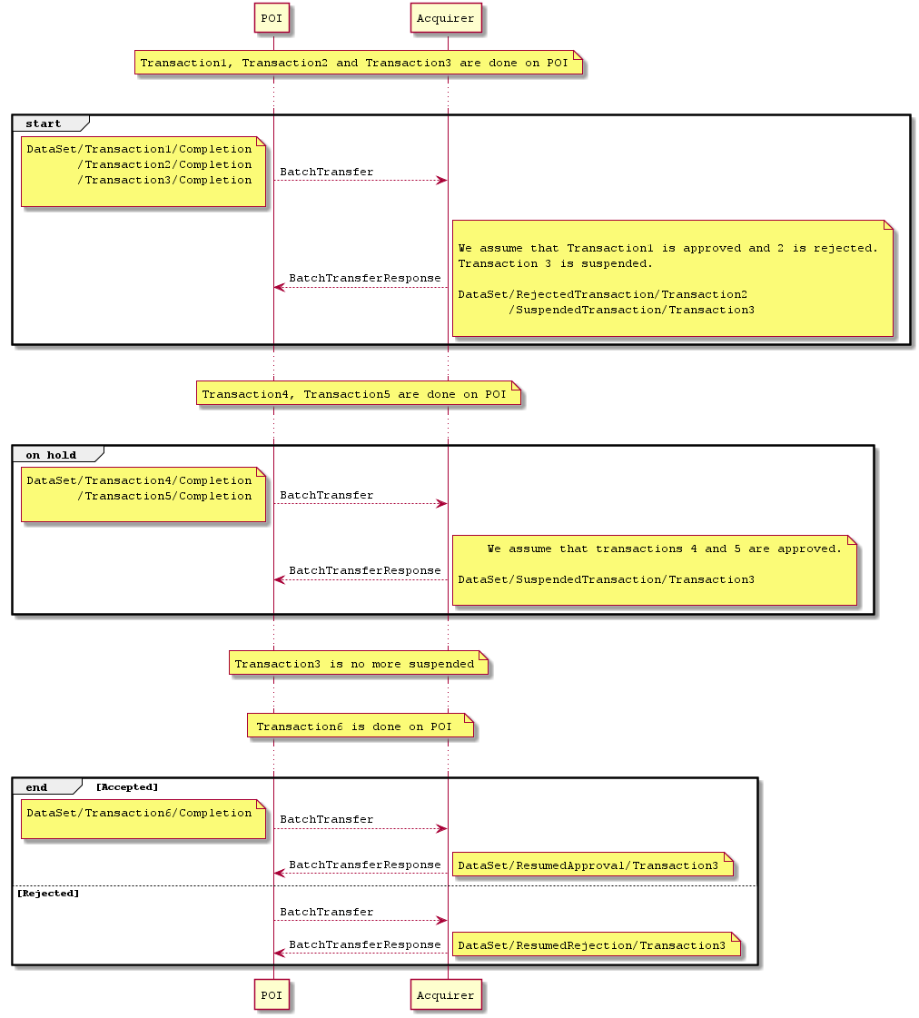

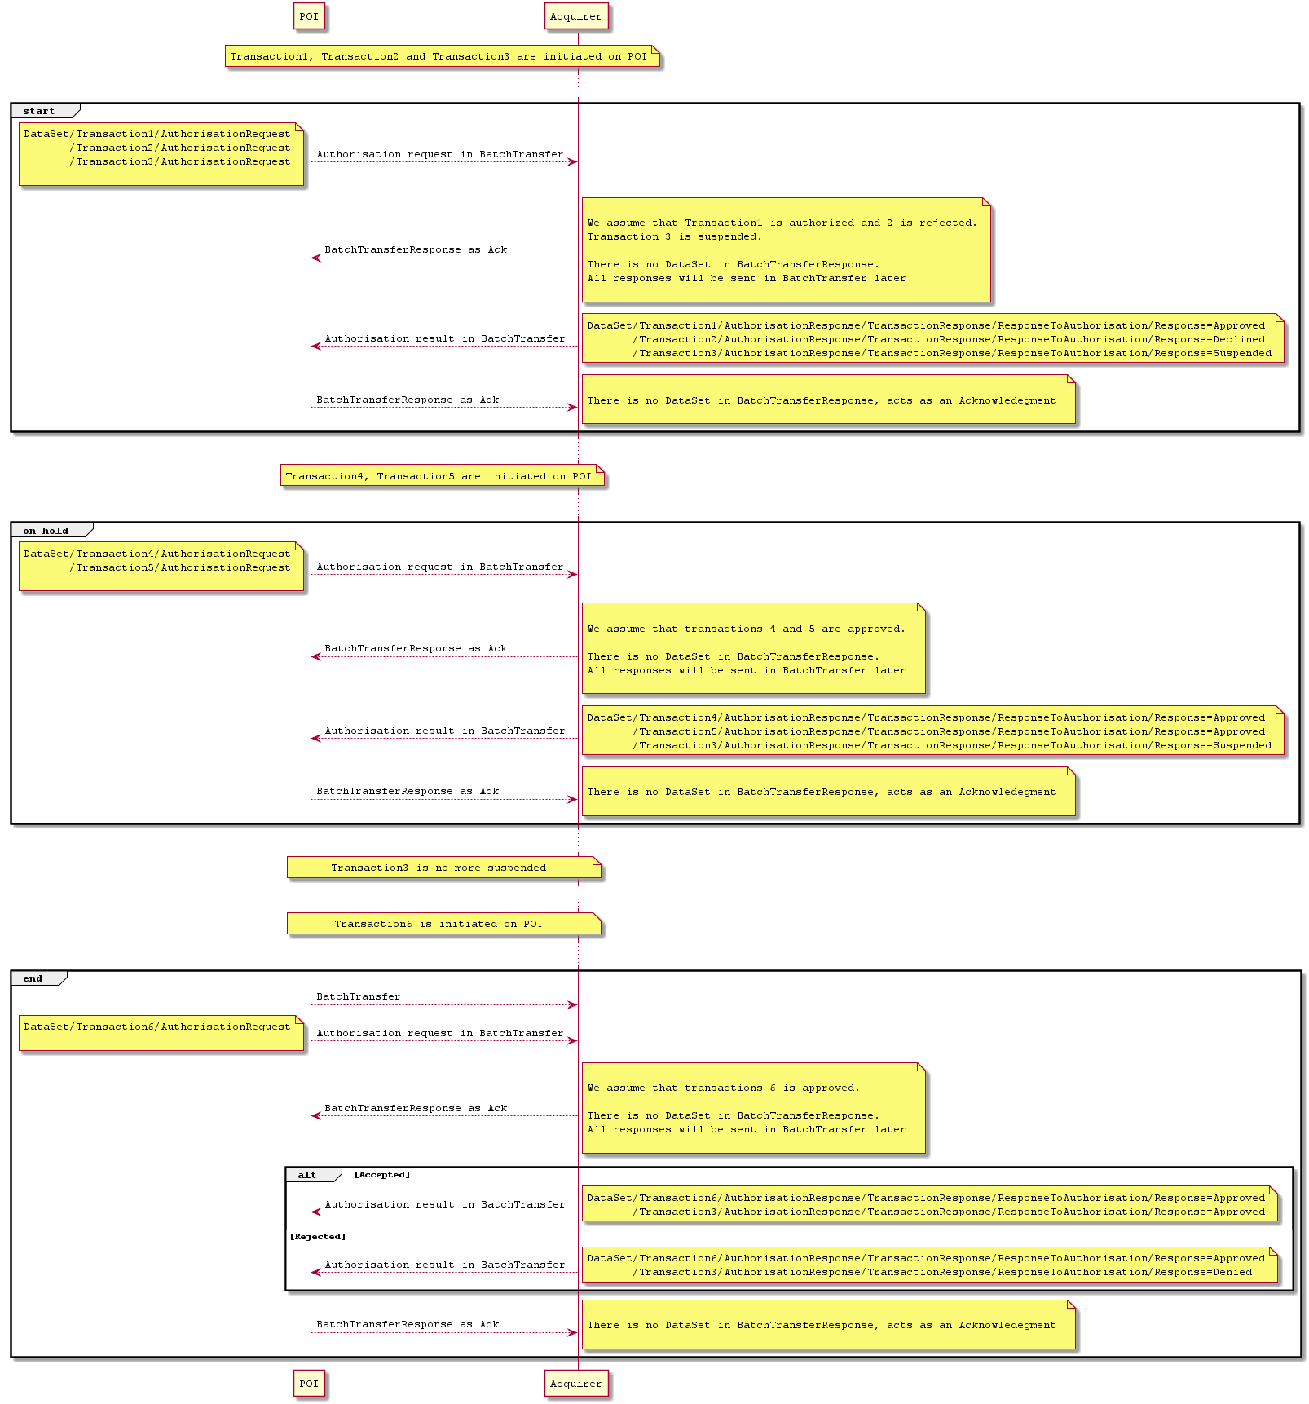

- SEG recommendation:
This section is not to be taken care of by the submitter of the change request. It will be completed in due time by the SEG(s) in charge of the related ISO 20022 messages.

Consider |  | X | Timing
 |  |  | - Next yearly cycle: 2019/2020  (the change will be considered for implementation in the yearly maintenance cycle which starts in 2019 and completes with the publication of new message versions in the spring of 2020) |  | X
- At the occasion of the next maintenance of the messages
(the change will be considered for implementation, but does not justify maintenance of the messages in its own right – will be pending until more critical change requests are received for the messages)
- Urgent unscheduled
(the change justifies an urgent implementation outside of the normal yearly cycle)
 |  |  | - Other timing:

Comments:

Reject
Reason for rejection:

