Change Request
for the update of ISO 20022 financial repository items
- Origin of the request:
A.1 Submitter: Payments Market Practice Group (PMPG)
A.2 Contact person: Neil Buchan, neil.buchan@swift.com +442077622135
A.3 Sponsors: the Change Request is supported by the Eurosystem

- Related messages:
pain.001.001.08 Customer Credit Transfer Initiation
pain.002.001.09 Customer Payment Status Report
pain.013.001.06 Creditor Payment Activation Request
pain.014.001.06 Creditor Payment Request Status Report
pacs.002.001.09 FI to FI Payments Status Report
pacs.003.001.07 FI to FI Customer Direct Debit
pacs.004.001.08 Payment Return
pacs.007.001.08 FI to FI Payment Reversal
pacs.008.001.07 FI to FI Customer Credit Transfer
pacs.009.001.07 Financial Institution Credit Transfer
pacs.010.001.02 Financial Institution Direct Debit
pacs.028.001.02 FI to FI Payment Status Request
camt.052.001.07 Bank to Customer Account Report

It is acknowledged other messages maybe impacted by this Change Request; the above represent the messages where this Change Request is required.

- Description of the change request:
Additional new optional Lei element typed by the existing LEI identifier data type:
OrganisationIdentification <OrgID> (‘OrganisationIdentification8’ message component)
and
FinancialInstitutionIdentification <FinInstnId> (‘FinancialInstitutionIdentification8 in BranchAndFinancialInstitutionIdentification5’ message component)
Available in both the Business Application Header and Transaction Information

- Purpose of the change:
The Basel Committee on Payments and Market Infrastructure (CPMI) recommended in their report on Correspondent banking in July 2016 that the financial service industry should consider the use of the LEI as additional information in payment messages (https://www.bis.org/cpmi/publ/d147.pdf) . The report cited the inclusion of the LEI in payment messages as one of the measures “that could help improve the efficiency of procedures, reduce compliance costs and help address perceived uncertainty, without altering the applicable rules and the basic channels for correspondent banking services between correspondent and respondent banks.”
CPMI invited relevant industry groups such as the Wolfsberg Group and the Payments Market Practice Group (PMPG) “to review their principles governing the use-cases for payment messages, what information should be included and which data fields should be used.” In response the PMPG conducted a market survey of the global payments community in 2017 followed by a discussion paper (https://www.swift.com/about-us/community/swift-advisory-groups/payments-market-practice-group/document-centre/document-centre) in November 2017 listing the following benefits for including the LEI in payment messages:
- Increase data validation at payments capture and during processing.
- Potentially higher STP rates
- Mitigate data truncation in name and address data when it exceeds the field size of message party fields when it will be possible to substitute the LEI to the name and address data.
- Simplify screening and control processes resulting in reduced lead time for Compliance related investigations and eliminating potential delays during payment processing from false hits in compliance and sanctions screening.
- Optimized and more accurate AML controls and detection of suspicious activities by leveraging LEI to standard industry code mappings
- A connection between LEI data and external data services bases providing by specific data vendors including line of business and industry codes can permit a more systematic and robust review of payments for inconsistent or suspicious patterns.
- Improve credit and counterparty risk management capabilities.
The PMPG, in response to a mandate from the Committee on Payment and Market Infrastructure (CPMI) to include LEI in payment messages proposes to introduce the option ability to populate the Legal Entity Identifier (ISO 17442) in ISO 20022 payment messages as an unambiguous identifier for legal entities.

- Urgency of the request:
Request can be supported in a new message version
- Business examples:
<DbtrAgt>
<FinInstnId>
<LEI> 254900Y8NKGV541U8Q32</LEI>
</FinInstnId>
</DbtrAgt>

<Assgne>
<Agt>
<FinInstnId>
<LEI> 254900Y8NKGV541U8Q32</LEI>
</FinInstnId>
</Agt>
</Assgne>

<Dbtr>
<OrgId>
<LEI> HB7FFAZI0OMZ8PP8OE26</LEI>
</OrgId>
</Dbtr>

<Invcee>
<OrgId>
<LEI> HB7FFAZI0OMZ8PP8OE26</LEI>
</OrgId>
</Invcee>

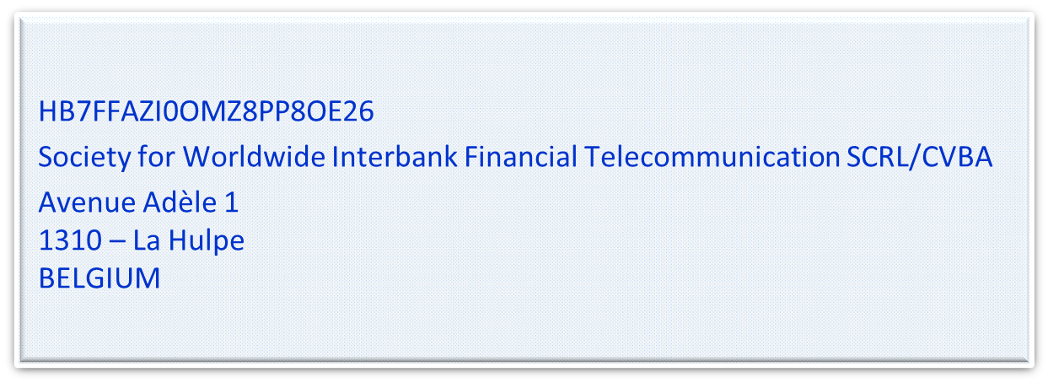

- SEG/TSG recommendation:

Consider | X | Timing
 |  | - Next yearly cycle: 2018/2019  (the change will be considered for implementation in the yearly maintenance cycle which starts in 2018 and completes with the publication of new message versions in the spring of 2019) |  | X
- At the occasion of the next maintenance of the messages
(the change will be considered for implementation, but does not justify maintenance of the messages in its own right – will be pending until more critical change requests are received for the messages)
- Urgent unscheduled
(the change justifies an urgent implementation outside of the normal yearly cycle)
 |  | - Other timing:
Comments: Decision made at the Payments SEG meeting on July 9th, 2018.

Reject
Reason for rejection:

