Change Request
for the incorporation Settlement Time Indication

- Origin of the request:
A.1 Submitter: Deutsche Bundesbank, on behalf of the EurosystemA.2 Contact person: Steffen Fährmann / Mustafa Sahin
E-mail: evolution.emip@bundesbank.de
Phone: +49 9566 4046 / 49 9566 4538
A.3 Sponsors: The banking community of future EMIP-RTGS (Eurosystems’ Market Infrastructures Platform)
The CR is also supported by
- EBA – contact person: Jette Simson
E-mail: j.simson@ebaclearing.eu
- Bank of England – contact person: Gwyn Jones
E-mail: Gwyn.Jones@bankofengland.gsi.gov.uk

- Related messages:
pacs.004.001.08 Payment Return
pacs.010.001.02 Financial Institution Direct Debit
It is acknowledged other messages maybe impacted by this Change Request; the above represent the messages where this Change Request is required.

- Description of the change request:
Request to add the following new elements:
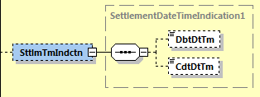
Needed to provide information on the occurred settlement time(s) of the payment transaction.

- Purpose of the change:
The change would be an alignment to pacs.008/009 where these elements are already available in <CreditTransferTransactionInformation> block of the payload.

Type of the element would also be ISODateTime (based on dateTime).
In the case of EMIP-RTGS, the date and time at which the payment has been debited (pacs.010) or credited (pacs.004), expressed in Central European Time (CET).

- Urgency of the request:
Request can be supported in a new message version

- Business examples:
The following payment flow illustrates the payment return messaging on basis of a pacs.004 between two direct participants, previously a pacs.008 or pacs.009 was settled between the participants

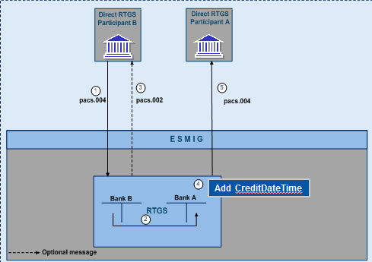
- The direct participant B sends a pacs.004 to the RTGS service for execution of a return settlement in the RTGS.
- Simultaneously booking on the RTGS DCAs of Bank A and Bank B if business validation positive.
- Booking confirmation to Bank B generated by the RTGS service (optional)
- CreditDateTime to be added in the message
- Forwarding of pacs.004 by the RTGS service to direct participant A

The processing of pacs.010 would be similiar, only difference would be that a DebitDateTime would be added to the message.

SEG recommendation:

Consider | X | Timing
 |  | - Next yearly cycle: 2018/2019  (the change will be considered for implementation in the yearly maintenance cycle which starts in 2018 and completes with the publication of new message versions in the spring of 2019) |  | X
- At the occasion of the next maintenance of the messages
(the change will be considered for implementation, but does not justify maintenance of the messages in its own right – will be pending until more critical change requests are received for the messages)
- Urgent unscheduled
(the change justifies an urgent implementation outside of the normal yearly cycle)
 |  | - Other timing:

Comments: Decision made at the Payments SEG meeting on July 9th, 2018.

Reject
Reason for rejection:

