Change Request
for the update of ISO 20022 financial repository items
- Origin of the request:
A.1 Submitter: Bank of England Real Time Gross Settlement (RTGS) Renewal Programme
A.2 Contact person(s): Helen Bygrave helen.bygrave@bankofengland.co.uk +44 (0)20 3217 8398
Neil Pearston, Analyst, neil.pearston@bankofengland.co.uk + 44 (0) 20 3461 4893
A.3 Sponsors: The New Payment System Operator (NPSO) United Kingdom
James Whittle, Director, International Standards and Services James.Whittle@newpso.uk

- Related messages:
pacs.002.001.09 - FIToFIPaymentStatusReportV09
pacs.003.001.07 - FIToFICustomerDirectDebitV07
pacs.004.001.08 - PaymentReturnV08
pacs.007.001.08 - FIToFIPaymentReversalV08
pacs.008.001.07 - FIToFICustomerCreditTransferV07
pacs.009.001.07 - FinancialInstitutionCreditTransferV07
pacs.010.001.02 - FinancialInstitutionDirectDebitV02
pacs.028.001.02 - FIToFIPaymentStatusRequestV02

pain.001.001.08 - CustomerCreditTransferInitiationV08
pain.002.001.09 - CustomerPaymentStatusReportV09
pain.007.001.08 - CustomerPaymentReversalV08
pain.008.001.07 - CustomerDirectDebitInitiationV07
pain.013.001.06 - CreditorPaymentActivationRequestV06
pain.014.001.06- CreditorPaymentActivationRequestStatusReportV06

camt.052.001.07 - BankToCustomerAccountReportV07
camt.053.001.07 - BankToCustomerStatementV07
camt.054.001.07 - BankToCustomerDebitCreditNotificationV07
camt.056.001.07 - FIToFIPaymentCancellationRequestV07
camt.060.001.04 - AccountReportingRequestV04
- Description of the change request:
Replace message component PostalAddress6 with ISO 20022 registered message component PostalAddress11.
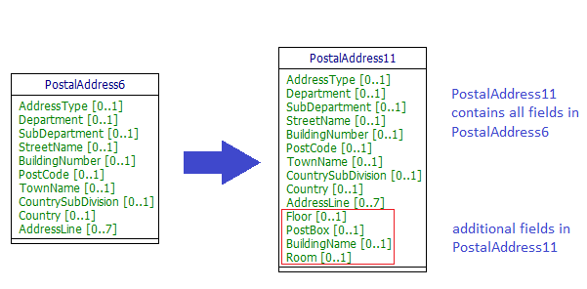

PostalAddress11 includes the additional optional elements as follows:
- Floor - Floor or storey within a building.
- PostBox - Numbered box in a post office, assigned to a person or organisation, where letters are kept until called for.
- BuildingName - Name of the building or house.
- Room - Building room number.

- Purpose of the change:
The RTGS Renewal programme wishes to follow the internationally accepted HVPS+ Guidelines which recommend the use of structured address.
The United Kingdom (UK) has many addresses where there is no street number but only a building name. At present there is no way to carry this essential part of an address in a structured way.
To facilitate the use of structured address we seek to add building name to the address component. This will allow the UK to use structured address and will not only benefit the UK but also the international community who will as a result receive more structured address information from the UK.
We have not sought to include building name in an existing address field, such as street name or building number, as these fields were not intended for this purpose and such a change may lead to confusion as well as diluting the benefits of the structured address component.
We have requested a change from PostalAddress6 to the already registered component PostalAddress11 to eliminate the need to create a new component in the ISO 20022 Data Dictionary just for the UK. The additional elements provided by PostalAddress11 are all optional and should not therefore affect existing processes.

- Urgency of the request:
It is proposed to include this change request in the next regular maintenance cycle.

- Business examples:
Examples of the proposed use of structured address fields where the address does not have a building number.

Example 1: Customer address with no building number
<Ultimate Debtor>
<Name>Mr John Smith</Name>
<Postal Address>
Street Name="Tupwood Lane"
Post Code="WI1 1IW"
Town Name="Winchester"
Country="GB"
Building Name="The Willows"
</Postal Address>
...
</Ultimate Debtor>

Example 2: Financial institution address with no street number

<Intermediary Agent 1>
…
<Name>The Governor and Company</Name>
<Postal Address>
StreetName="Threadneedle Street"
PostCode="EC2R 8AH"
TownName="London"
Country="GB"
BuildingName="Bank of England"/>
</Postal Address>
…
</Intermediary Agent 1>

Example 3: Customer address with no street name or building number

<Ultimate Creditor>
<Name>Mr John Smith</Name>
<Postal Address>
Post Code="XX1 1XX "
Town Name="Lingfield"
Country="GB"
Building Name="The Old Rectory"
</Postal Address>
...
</Ultimate Creditor>

G. SEG/TSG recommendation:

Consider |  | X | Timing
 |  |  | - Next yearly cycle: 2018/2019  (the change will be considered for implementation in the yearly maintenance cycle which starts in 2018 and completes with the publication of new message versions in the spring of 2019) |  | X
- At the occasion of the next maintenance of the messages
(the change will be considered for implementation, but does not justify maintenance of the messages in its own right – will be pending until more critical change requests are received for the messages)
- Urgent unscheduled
(the change justifies an urgent implementation outside of the normal yearly cycle)
 |  |  | - Other timing:
Comments: Decision made at the Payments SEG meeting on June 25th, 2018.
Addition of pain.013 and pain.014 to the list of impacted messages (August 22nd, 2018).

Reject
Reason for rejection:

