Change Request
for the update of ISO 20022 financial repository items
- Origin of the request:
A.1 Submitter: Bank of England Real Time Gross Settlement (RTGS) Renewal Programme
A.2 Contact person(s): Helen Bygrave helen.bygrave@bankofengland.co.uk +44 (0)20 3217 8398
Neil Pearston, Analyst, neil.pearston@bankofengland.co.uk + 44 (0) 20 3461 4893
A.3 Sponsors: The New Payment System Operator (NPSO) United Kingdom
James Whittle, Director, International Standards and Services James.Whittle@newpso.uk

- Related messages:
pacs.009.001.07 - FinancialInstitutionCreditTransferV07

- Description of the change request:
This change request seeks to add optional message element Purpose of existing registered data type Purpose2Choice to the FinancialInstitutionCreditTransfer message.
This requires the creation of a new version of message component CreditTransferTransaction31 containing element Purpose as shown below.
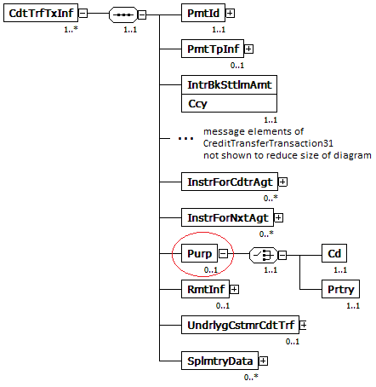

- Purpose of the change:
Being able to clearly identify the underlying reason for a payment transaction is crucial in understanding the underlying economic activity a payment represents. There are a number of uses for this information including the identification of time sensitive, critical or systemic payments as well as mitigating the risk of fraud.
Through industry engagement, it was identified that there is a demand for more granularity in the purpose of payments between financial institutions. The ExternalCategoryPurpose1Code list that currently exists in the FinancialInstitutionCreditTransfer (pacs.009) message was not deemed suitable for this, being at too high a level, limiting its usefulness for deeper analysis.
The more detailed ExternalPurpose1Code list however, currently not available in the pacs.009, includes many codes which only correspond to payments between financial institutions and we believe therefore should be included in the pacs.009 message. Examples of such codes are CCPC - Cleared Initial Margin, CCPM - CCP Cleared Variation Margin, RPSB - Bi-lateral repo broker owned segregated cash collateral, RVPO - Reverse Repurchase Agreement and SBSC - Securities Buy Sell Sell Buy Back,
Including the ExternalPurpose1Code list in the pacs.009 message would allow financial institutions to identify critical payments and facilitate enhanced end-to-end risk management thereby improving financial stability. Further to this, we recognise the value of wider public use of this data. The Office for National Statistics (the body responsible for UK national statistics) recognised that their analysis could benefit from greater granularity on the purpose of these large and important payments and this may be the same for other countries.

- Urgency of the request:
It is proposed to include this change request in the next regular maintenance cycle.

- Business examples:
In the event of an operational outage where there is a delay to payment processing it would be beneficial to identify time critical payments such as margin calls. These payments could then be prioritised with the goal of reducing the effect of the outage. This prioritisation could be facilitated with the use if the ExternalPurpose1Code list which records the underlying reason for the payment.
- SEG/TSG recommendation:

Consider |  | X | Timing
 |  |  | - Next yearly cycle: 2018/2019  (the change will be considered for implementation in the yearly maintenance cycle which starts in 2018 and completes with the publication of new message versions in the spring of 2019) |  | X
- At the occasion of the next maintenance of the messages
(the change will be considered for implementation, but does not justify maintenance of the messages in its own right – will be pending until more critical change requests are received for the messages)
- Urgent unscheduled
(the change justifies an urgent implementation outside of the normal yearly cycle)
 |  |  | - Other timing:
Comments: Decision made at the Payments SEG meeting on July 9th, 2018.

Reject
Reason for rejection:

