Change Request
for the update of ISO 20022 financial repository items
- Origin of the request:
A.1 Submitter: Janice Chapman, on behalf of Funds UK NMPG - UK Electronic Transfer and Re-Registrations Group (UKETRG)
A.2 Contact person: Janice.chapman@swift.com
A.3 Sponsors:
- Related messages:
# | Name | Message Identifier
1 | Transfer Out Instruction | sese.001.001.08
2 | Transfer Out Confirmation | sese.003.001.08
3 | Transfer In Instruction | sese.005.001.08
4 | Transfer In Confirmation | sese.007.001.08
- Description of the change request:
UK Electronic Transfer and Re-Registrations Group (UKETRG) reference change request ID 0710 annex: 5.08 and 5.20.
Currently, the UK funds market is using an earlier version, dating from 2011/2012, of the ISO 20022 investment funds transfers (sese) messages in the SWIFTNet Funds solution. The UK markets have been live with an automated solution for both portfolio transfers and the subsequent financial instrument asset transfers for several years.
However, in order for the UK to make this work, there are a number of ‘work-arounds’ (using the text field of the extension sequence) and a number of element misuses.
The UK publishes its market practice and message usage guidelines on the MyStandards platform.
The work-arounds and element misuses are documented in the message usage guidelines
The work-arounds and element misuses have been assessed and discussed with the UK Electronic Transfer and Re-Registrations Group (UKETRG). In some cases, the work-around would not be necessary because the functionality was added in a later release of the standard. But in some cases, the work-around is required because of a gap in the functionality of the message standards.
In Settlement Details, add an optional element 'Requested Trade Date'.
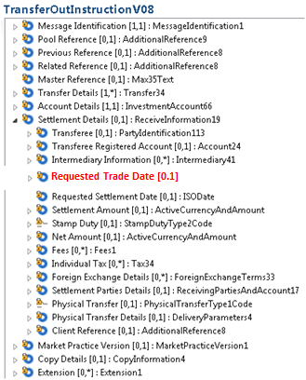
Message Element Definition
Element | Definition | Data Type
Requested Trade Date | Date and time to be used as the trade date when securities are settled through an International Central Securities Depository (ICSD) or Central Securities Depository (CSD). | ISO Date
- Purpose of the Change:
To enable the transfers message set to meet the requirements of the UK transfers market.
- Urgency of the request:
For the next maintenance.
- Business examples:

- SEG/TSG recommendation:
This section is not to be taken care of by the submitter of the change request. It will be completed in due time by the SEG(s) in charge of the related ISO 20022 messages or the TSG for changes related to the BAH.
Consider |  |  | Timing
- Next yearly cycle: 2018/2019
(the change will be considered for implementation in the yearly maintenance cycle which starts in 2018 and completes with the publication of new message versions in the spring of 2019)
- At the occasion of the next maintenance of the messages
(the change will be considered for implementation, but does not justify maintenance of the messages in its own right – will be pending until more critical change requests are received for the messages)
- Urgent unscheduled
(the change justifies an urgent implementation outside of the normal yearly cycle)
 |  |  | - Other timing:
Comments:
WITHDRAWN

Reject
Reason for rejection:

