Change Request
for the update of ISO 20022 financial repository items
- Origin of the request:
A.1 Submitter: Janice Chapman, on behalf of Funds UK NMPG - UK Electronic Transfer and Re-Registrations Group (UKETRG) and SMPG IF.
A.2 Contact person: Janice.chapman@swift.com
A.3 Sponsors:
- Related messages:
# | Name | Message Identifier
1 | Account Holding Information Request | sese.019.001.04
2 | Account Holding Information | sese.018.001.05
3 | Portfolio Transfer Instruction | sese.012.001.08
4 | Portfolio Transfer Confirmation | sese.013.001.08
- Description of the change request:
This change request is complimentary to change request ID 0731, submitted by Clearstream.
Change request ID 0731 proposes the alignment of the Settlement and Custody Details sequences with those in the Securities Settlement Transaction Instruction (sese.023) message in which a depository is available on both the delivery and receive sides of the settlement chain parties and concepts such as ‘receiving agent’, receiver’s custodian, etc, have element names such as ‘party 1’, ‘party 2’ and so on. This change request proposes a similar change for the funds ‘discovery’ and portfolio transfer messages, sese.018, 019 012, 013. (A similar change request will be submitted for the funds transfer messages, see.001, 003, 005, 007).
Illustration of change
The changes are also described in the annex to change request ID 0710 as the need for additional settlement parties has also been discussed in the Funds UK NMPG, UK Electronic Transfer and Re-Registrations Group (UKETRG).

Using the Portfolio Transfer Instruction sese.012 as an example:
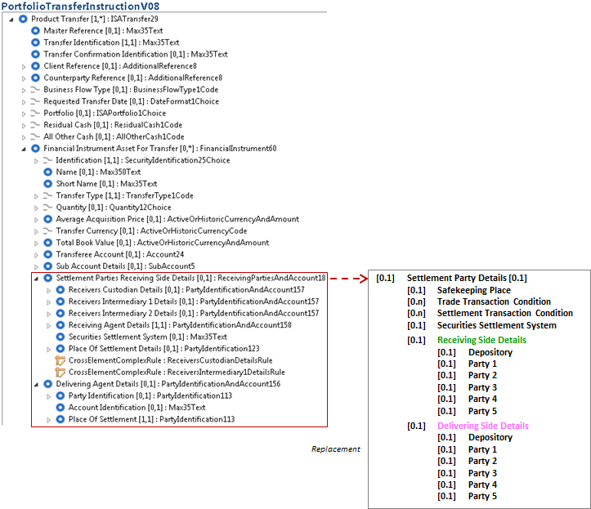
- Purpose of the Change:
This change requested is submitted so that the settlement chain parties in the funds transfer (sese) messages are aligned with the settlement chain parties in the funds order (setr) messages (change request 0731). In turn, change request 0731 was submitted by Clearstream so that the funds order (setr) messages are consistent with the settlement details defined in the ISO 20022 sese.023, sese.028 messages, particularly when two places of settlement are involved as, for example, in the case of T2S cross-CSD settlement.
- Urgency of the request:
For the next maintenance.
- Business examples:
- SEG/TSG recommendation:
This section is not to be taken care of by the submitter of the change request. It will be completed in due time by the SEG(s) in charge of the related ISO 20022 messages or the TSG for changes related to the BAH.
Consider |  | X | Timing
 |  |  | - Next yearly cycle: 2018/2019  (the change will be considered for implementation in the yearly maintenance cycle which starts in 2018 and completes with the publication of new message versions in the spring of 2019) |  | X
- At the occasion of the next maintenance of the messages
(the change will be considered for implementation, but does not justify maintenance of the messages in its own right – will be pending until more critical change requests are received for the messages)
- Urgent unscheduled
(the change justifies an urgent implementation outside of the normal yearly cycle)
 |  |  | - Other timing:
Comments:

Reject
Reason for rejection:

