Change Request
for the update of an External Code List used in ISO 20022

- Origin of the request:
A.1 Submitter: European Payments Council
A.2 Contact person: Christophe Godefroi
E-mail: Christophe.Godefroi@epc-cep.eu
Phone: +32 2 739 16 93
A.3 Sponsors: the banking community of SEPA (Single Euro Payments Area)
- Related External Code List:
ExternalInvestigationExecutionConfirmation1Code
- Description of the change request:
- Request to add the following new codes:

Code | Name | Definition
ACNR | AcceptedClaimNonReceipt | The claim for non-receipt of a payment instruction is accepted.
RJNR | RejectedClaimNonReceipt | The claim for non-receipt of a payment instruction is rejected.
ACVA | AcceptedValueDateAdjustment | The claim for value date correction is accepted.
RJVA | RejectedValueDateAdjustment | The claim for value date correction is rejected.
CVAA | CorrectValueDateAlreadyApplied | The original value date was correct.
- Purpose of the change:
The EPC 2017 SEPA Credit Transfer (SCT) Rulebook v1.1 has introduced the following reasons for an SCT inquiry:
- Claim for non-receipt: The Creditor claims not to have received the initial Credit Transfer. The Debtor Bank is asked to investigate if and when the initial Credit Transfer had been executed. The cause for this claim can be at the Debtor Bank, the Creditor Bank and/or in the clearing and settlement layer.
- Claim for Value Date Correction: The Creditor claims that the initial Credit Transfer has been credited with a value date later than the date the amount would have been value dated had the transaction been correctly executed. The Debtor Bank is asked to investigate at what precise date the initial Credit Transfer had been executed. The cause for this claim can be at the Debtor Bank, the Creditor Bank and/or in the clearing and settlement layer
The above change is required to be able to indicate in a camt.029 message (under Status/Confirmation) whether a claim non-receipt or claim for value date correction was accepted or rejected by the Creditor Bank.
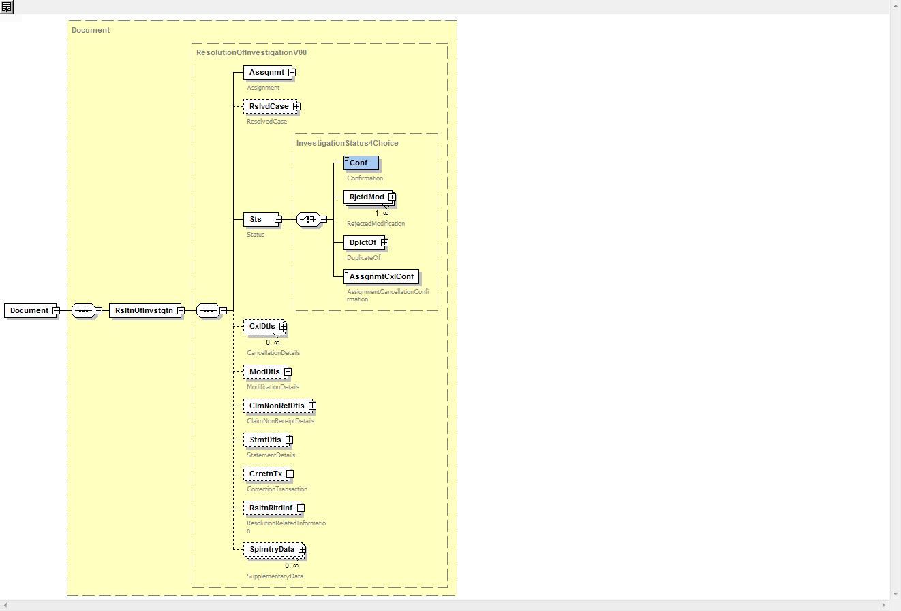

- Urgency of the request:
Publication in the next quarterly External Code Set is desired given that these new codes will be introduced in the finalised SCT 2017 v2.0 implementation guidelines which will be published in Q2 2018.
- Business examples:
A claim for non-receipt is received by the Creditor/Beneficiary Bank and accepted after processing, hence a camt.029 is sent to the Debtor/Originator Bank with status code ‘ACNR’:
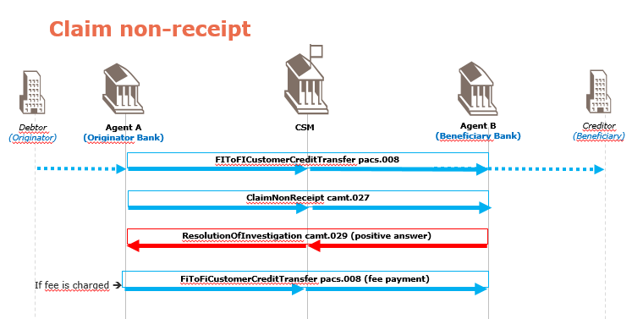
A claim for value date correction is received by the Creditor/Beneficiary Bank and accepted after processing, hence a camt.029 is sent to the Debtor/Originator Bank with status code ‘ACVA’:
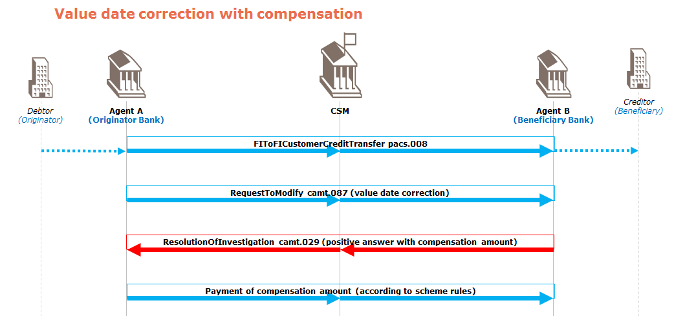
- SEG recommendation:

Accept |  | X | Timing
 |  |  | - Next possible quarterly release |  | X
 |  |  | - Other timing:
Comments: Decision made by the Payments SEG on January 8th, 2018.

Reject
Reason for rejection:

