Change Request
for the update of ISO 20022 financial repository items
- Origin of the request:
A.1 Submitter: Swedish Funds NMPG
A.2 Contact person: Henrik Staffas (henrik.staffas@skandia.se)
A.3 Sponsors:
- Related messages:
The change request is specific to the following messages:
 | Message | Identifier |  |  | Message | Identifier
 | Transfer In Instruction | Sese.005.001.07 |  |  | Transfer Instruction Status Report | Sese.011.001.05
 | Transfer In Cancellation Instruction | Sese.006.001.07
However, in order to keep the funds transfer (sese) message set aligned, these changes may impact other messages in the funds transfer (sese) message set and so the full list of funds transfer (sese) is given:
 | Transfer Out Instruction | Sese.001.001.07 |  |  | Transfer In Confirmation | Sese.007.001.07
 | Transfer Out Cancellation Instruction | Sese.002.001.07 |  |  | Reversal Of Transfer Out Confirmation | Sese.004.001.07
 | Transfer Out Confirmation | Sese.003.001.07 |  |  | Reversal Of Transfer In Confirmation | Sese.008.001.07
 | Portfolio Transfer Instruction | Sese.012.001.07 |  |  | Portfolio Transfer Confirmation | Sese.013.001.07
 | Portfolio Transfer Cancellation Request | Sese.014.001.07 |  |  | Account Holding Information Request | Sese.019.001.04
 | Account Holding Information | Sese.018.001.05 |  |  | Requestor Transfer Status Report | Sese.009.001.05
 | Transfer Cancellation Status Report | Sese.010

- Description of the change request:
Add optional elements to support the single leg transfer process.
[1a] In the transfer in instruction, add element for ‘transfer of holdings as a percentage”
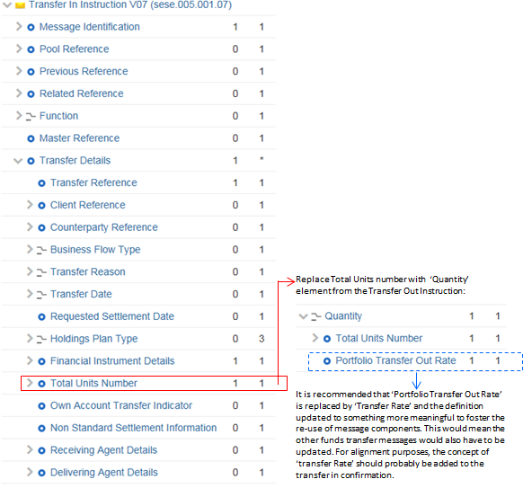
The element Total Units Number is to be replaced by Quantity, which is a choice, typed by Total Units Number and ‘Transfer Rate’.
To keep the funds transfer (sese) message set aligned, this change will also have to be done to the transfer in cancellation instruction (sese.006). And for alignment reasons, the name of the element should be discussed in the context of the transfer-out and transfer-in confirmations messages.
[1b] In the transfer in instruction, add element for ‘transfer currency’
This will also be done to the transfer in cancellation instruction in order to keep the funds transfer (sese) message set aligned.
This element is already present in the transfer in confirmation and reversal messages.
[3a] In the transfer instruction status report (sese.011), in the StatusReport sequence, add a sequence called ‘Units Details’ :
UnitsDetails |  | [0.n] | Information about the units to be transferred.
 | UnitsNumber | [0.1] | Quantity of units.
 | AcquisitionPrice | [0.1] | Average acquisition price of the units in the account before the transfer was executed.
 | AcquisitionDate | [01.] | Date upon which the investor purchased the financial instrument.
[3b] In the transfer instruction status report (sese.011), in the StatusReport sequence, add an element called ‘Transfer Currency’
It should be noted that there are some generic change requests for which the implementation has already been done in the funds order (setr) and funds account management (acmt) messages. These are CR534 (ISIN data type correction), CR 577 (Bloomberg identifier correction) and CR 548 (add LEI). When the funds transfer (sese) message are updated for this change request, at the same time, these generic change requests should also be actioned.
- Purpose of the change:
The senders of the transfer in instruction (sese.005) message have to populate the mandatory TransferDetails / TotalUnitsNumber element. It’s very difficult on a transfer-in to know the exact number of units, particularly the exact number of decimals. If the exact number of units is not specified, the receiver rejects the message. A better approach is to be able to specify ‘transfer-in 100% of the ISIN”. A work-around for the completion of this mandatory field is not a satisfactory solution and will cause difficulties in getting the market to actually implement. This gap has been discussed with the SMPG IF co-chairs and facilitator and it seems very likely that this will also cause problems with the definition of a global market practice for SLT, which the SMPG is currently working on.
The transfer-out instruction message (sese.001) already allows the possibility to specify ‘100%’.
The Swedish market is getting prepared to implement an automated single-leg process for funds transfers and is defining market practice on MyStandards. During this market practice work, gaps were found in the message standard and this change request is to fill these gaps.
- Urgency of the request:
In order to ensure smooth uptake of an automated transfer single-leg process, it is vital that these gaps in the message standard are eliminated as soon as possible and so this change request is for action in the 2017-2018 maintenance cycle.
- Business examples:
None.

- SEG recommendation:

Consider |  | V | Timing
 |  |  | - Next yearly cycle: 2017/2018  (the change will be considered for implementation in the yearly maintenance cycle which starts in 2017 and completes with the publication of new message versions in the spring of 2018) |  | V
- At the occasion of the next maintenance of the messages
(the change will be considered for implementation, but does not justify maintenance of the messages in its own right – will be pending until more critical change requests are received for the messages)
- Urgent unscheduled
(the change justifies an urgent implementation outside of the normal yearly cycle)
 |  |  | - Other timing:
Comments:
The ET agrees to have this in the next cycle. All the pending CRs that are more techinical should be included as well (CR 088, CR475 (only for SESE messages), CR577 (only for SESE messages), CR534 (only for SESE messages), and any other technical CR that could impact the SESE messages that we might have missed.

Reject
Reason for rejection:

