Change Request
for the update of ISO 20022 financial repository items

- Origin of the request:
A.1 Submitter:
Federal Reserve Bank of New York (on behalf of the US Federal Reserve Banks)
33 Liberty Street
New York, NY 10045
U.S.A.
A.2 Contact person:
Federal Reserve Bank of New York Wholesale Product Office
Ms. Gina Russo (gina.russo@ny.frb.org)
Ms. Leslie Lee (leslie.lee@ny.frb.org)
A.3 Sponsors:
US Format Advisory Group

- Related messages:
camt.052.001.06 – BankToCustomerAccountReport
camt.053.001.06 – BankToCustomerAccountStatement
camt.054.001.06 – BankToCustomerDebitCreditNotification

- Description of the change request:
The request is to add a new optional element LocalInstrument to the TransactionDetails component (Entry/EntryDetails/TransactionDetails) as shown in the graphic below.
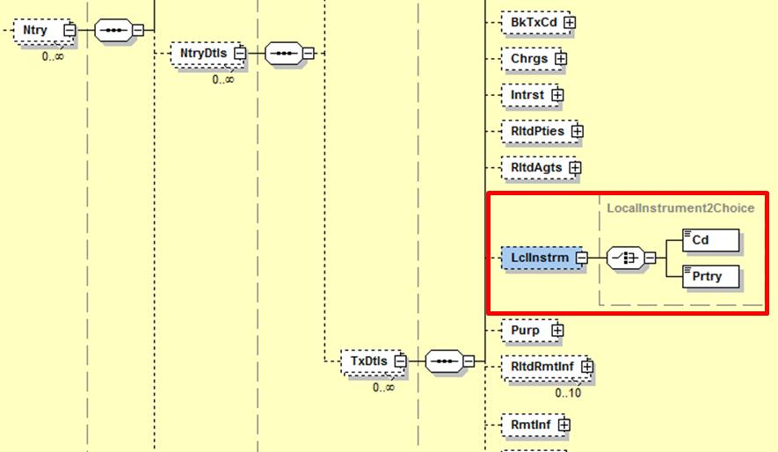

- Purpose of the change:
Many communities that are implementing ISO 20022 use the LocalInstrument element in the payment messages to differentiate between the different types of transactions, for example, domestic vs foreign credit transfers. The change will allow reporting those local payment types with the transaction details.

- Urgency of the request:
Request to include the change in the next maintenance cycle.

- Business examples:
A list with 12 specific Fedwire Funds Service codes will be submitted for inclusion in the ISO 20022 externalized LocalInstrument code list. The above change will allow reporting, for example, that a transaction settled across the Fedwire Funds Service was a normal Customer Credit Transfer (code CTR0), a Customer Drawdown Transfer (code DRW0), or a Bank Transfer (code BTR6).

- SEG/TSG recommendation:

Consider |  | X | Timing
 |  |  | - Next yearly cycle: 2017/2018  (the change will be considered for implementation in the yearly maintenance cycle which starts in 2017 and completes with the publication of new message versions in the spring of 2018) |  | X
- At the occasion of the next maintenance of the messages
(the change will be considered for implementation, but does not justify maintenance of the messages in its own right – will be pending until more critical change requests are received for the messages)
- Urgent unscheduled
(the change justifies an urgent implementation outside of the normal yearly cycle)
 |  |  | - Other timing:
Comments:
Payments SEG meeting on 26 June 2017.

Reject
Reason for rejection:

The Format Advisory Group is jointly chaired by the Federal Reserve Bank of New York and The Clearing House and includes 14 global and regional banks. All institutions are Fedwire Funds Service participants and 10 are also CHIPS participants. The members are Bank of America, Bank of New York Mellon, Citibank, Deutsche Bank, HSBC, JPMC, Key Bank, MUFG Union Bank, PNC Bank, State Street, SunTrust, Wells Fargo, UBS, US Bank.

