Change Request
for the update of ISO 20022 financial repository items

- Origin of the request:
A.1 Submitter:
Federal Reserve Bank of New York (on behalf of the US Federal Reserve Banks)
33 Liberty Street
New York, NY 10045
U.S.A.
A.2 Contact person:
Federal Reserve Bank of New York Wholesale Product Office
Ms. Gina Russo (gina.russo@ny.frb.org)
Ms. Leslie Lee (leslie.lee@ny.frb.org)
A.3 Sponsors:
US Format Advisory Group

- Related messages:
camt.052.001.06 – BankToCustomerAccountReport
camt.053.001.06 – BankToCustomerAccountStatement

- Description of the change request:
The request is to increase the multiplicity of the CreditLine component (in the Balance component) and add a new optional Type element to the component as shown below.

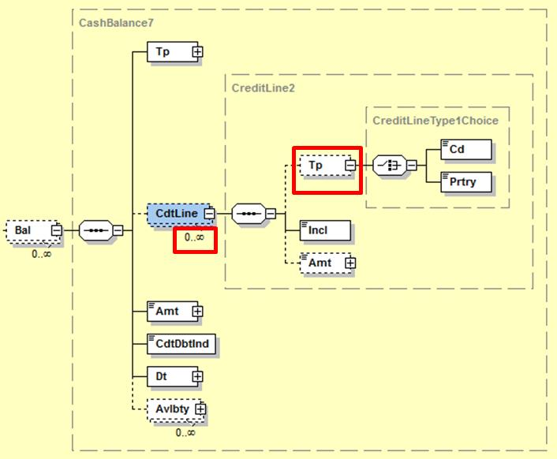

- Purpose of the change:
The change will enable the inclusion of multiple credit lines and allow specifying the type of credit line in line with current business practices as described with a real business example under section E.
The change will not impact current users of the messages as usage of the CreditLine component can be restricted to a single occurrence and the new Type element is optional.

- Urgency of the request:
Request to include the change in the next maintenance cycle.

- Business examples:
The Fedwire Funds Service participants receive an account balance report that typically contains 4 balances: opening balance, daylight overdraft balance, account balance, and available funds balance.
The available funds balance can include up to 2 credit lines, i.e. a net debit cap, and a collateralized capacity.
- SEG/TSG recommendation:

Consider |  | X | Timing
 |  |  | - Next yearly cycle: 2017/2018  (the change will be considered for implementation in the yearly maintenance cycle which starts in 2017 and completes with the publication of new message versions in the spring of 2018) |  | X
- At the occasion of the next maintenance of the messages
(the change will be considered for implementation, but does not justify maintenance of the messages in its own right – will be pending until more critical change requests are received for the messages)
- Urgent unscheduled
(the change justifies an urgent implementation outside of the normal yearly cycle)
 |  |  | - Other timing:
Comments:
Payments SEG meeting on 26 June 2017.

Reject
Reason for rejection:

The Format Advisory Group is jointly chaired by the Federal Reserve Bank of New York and The Clearing House and includes 14 global and regional banks. All institutions are Fedwire Funds Service participants and 10 are also CHIPS participants. The members are Bank of America, Bank of New York Mellon, Citibank, Deutsche Bank, HSBC, JPMC, Key Bank, MUFG Union Bank, PNC Bank, State Street, SunTrust, Wells Fargo, UBS, US Bank.

