Change Request
for the update of ISO 20022 financial repository items

- Origin of the request:
A.1 Submitter:
Federal Reserve Bank of New York (on behalf of the US Federal Reserve Banks)
33 Liberty Street
New York, NY 10045
U.S.A.
A.2 Contact person:
Federal Reserve Bank of New York Wholesale Product Office
Ms. Gina Russo (gina.russo@ny.frb.org)
Ms. Leslie Lee (leslie.lee@ny.frb.org)
A.3 Sponsors:
US Format Advisory Group

- Related messages:
camt.035.001.03 – ProprietaryFormatInvestigation
(The same change could be considered for all messages in the E&I portfolio).

- Description of the change request:
The request is to change the cardinality of the Case component from mandatory to optional as shown below.

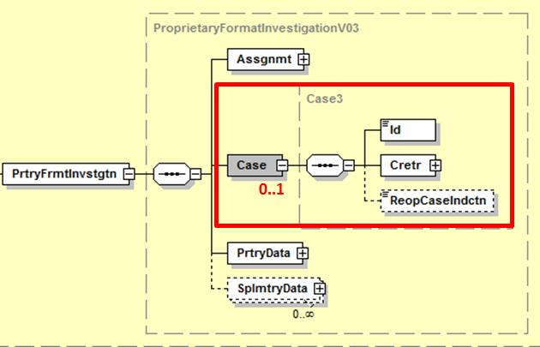

Furthermore, the scope of the message should be updated to reflect the actual usage of the message and not only the conditions under which the message is sent.

Purpose of the changes:
The use of the Exceptions & Investigation message portfolio has not yet reached critical mass. Although in the long term the mechanism of assigning a case to an investigation might make sense, at this time the concept might be an inhibitor to broader adoption, potentially even driving the industry towards the use of pure free format options. Changing the cardinality to optional might ease the initial adoption of the E&I message portfolio and will not impact current or future users that are familiar with the case concept.
Similar reasoning was applied when the Case component was made optional in the camt.056 (FIToFIPaymentCancellationRequest).

- Urgency of the request:
Request to include the change in the next maintenance cycle.

- Business example:

- SEG/TSG recommendation:

Consider |  | X | Timing
 |  |  | - Next yearly cycle: 2017/2018  (the change will be considered for implementation in the yearly maintenance cycle which starts in 2017 and completes with the publication of new message versions in the spring of 2018) |  | X
- At the occasion of the next maintenance of the messages
(the change will be considered for implementation, but does not justify maintenance of the messages in its own right – will be pending until more critical change requests are received for the messages)
- Urgent unscheduled
(the change justifies an urgent implementation outside of the normal yearly cycle)
 |  |  | - Other timing:
Comments:
Payments SEG meeting on 26 June 2017.

Reject
Reason for rejection:

The Format Advisory Group is jointly chaired by the Federal Reserve Bank of New York and The Clearing House and includes 14 global and regional banks. All institutions are Fedwire Funds Service participants and 10 are also CHIPS participants. The members are Bank of America, Bank of New York Mellon, Citibank, Deutsche Bank, HSBC, JPMC, Key Bank, MUFG Union Bank, PNC Bank, State Street, SunTrust, Wells Fargo, UBS, US Bank.

