Change Request
for the update of ISO 20022 financial repository items

- Origin of the request:
A.1 Submitter:
Federal Reserve Bank of New York (on behalf of the US Federal Reserve Banks)
33 Liberty Street
New York, NY 10045
U.S.A.
A.2 Contact person:
Federal Reserve Bank of New York Wholesale Product Office
Ms. Gina Russo (gina.russo@ny.frb.org)
Ms. Leslie Lee (leslie.lee@ny.frb.org)
A.3 Sponsors:
US Format Advisory Group

- Related messages:
camt.052.001.06 – BankToCustomerAccountReport
camt.060.001.03 – AccountReportingRequest

- Description of the change request:
The request is to update the ReportingPeriod component in the account reporting request and account report messages to enable to (request a) report a sequence range of messages.
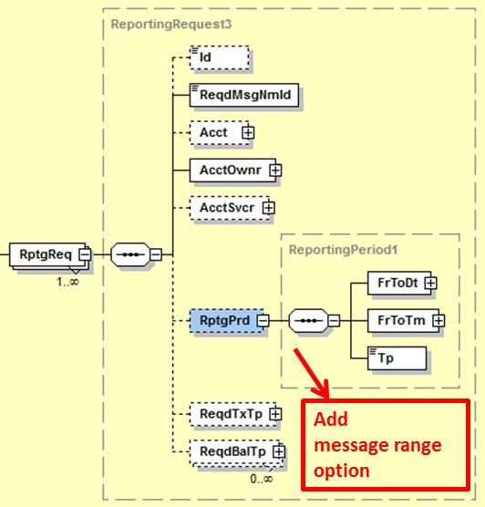

The detailed implementation proposal will need to cater for flexibility in selecting the actual message sequence ranges, i.e. From, To, FromTo, EqualTo, etc.
This can probably be achieved by using a FromToRange component that is aligned with the current FromToDate and FromToTime components, i.e., a “From” that is mandatory in combination with an optional “To” (to cater for open-end ranges) and make the overall component repetitive to enable singling out of a selection of specific messages by their sequence number.

Purpose of the change:
The change will increase the flexibility and value for users in (requesting) account reports by adding the capability to select a sequence range of messages -a widespread practice within market infrastructures-, complementing today’s mechanism where reporting is based on date and time ranges only.

- Urgency of the request:
Request to include the change in the next maintenance cycle.

- Business examples:
- SEG/TSG recommendation:

Consider |  | X | Timing
 |  |  | - Next yearly cycle: 2017/2018  (the change will be considered for implementation in the yearly maintenance cycle which starts in 2017 and completes with the publication of new message versions in the spring of 2018) |  | X
- At the occasion of the next maintenance of the messages
(the change will be considered for implementation, but does not justify maintenance of the messages in its own right – will be pending until more critical change requests are received for the messages)
- Urgent unscheduled
(the change justifies an urgent implementation outside of the normal yearly cycle)
 |  |  | - Other timing:
Comments:
Payments SEG meeting on 26 June 2017.

Reject
Reason for rejection:

The Format Advisory Group is jointly chaired by the Federal Reserve Bank of New York and The Clearing House and includes 14 global and regional banks. All institutions are Fedwire Funds Service participants and 10 are also CHIPS participants. The members are Bank of America, Bank of New York Mellon, Citibank, Deutsche Bank, HSBC, JPMC, Key Bank, MUFG Union Bank, PNC Bank, State Street, SunTrust, Wells Fargo, UBS, US Bank.

