Change Request
for the update of ISO 20022 financial repository items

- Origin of the request:
A.1 Submitter:
Federal Reserve Bank of New York (on behalf of the US Federal Reserve Banks)
33 Liberty Street
New York, NY 10045
U.S.A.
A.2 Contact person:
Federal Reserve Bank of New York Wholesale Product Office
Ms. Gina Russo (gina.russo@ny.frb.org)
Ms. Leslie Lee (leslie.lee@ny.frb.org)
A.3 Sponsors:
US Format Advisory Group

- Related messages:
camt.052.001.06 – BankToCustomerAccountReport (BalanceType and Status elements)
camt.053.001.06 – BankToCustomerAccountStatement (BalanceType and Status elements)
camt.054.001.06 – BankToCustomerDebitCreditNotification (Status element)

- Description of the change request:
The request is to change the data types of the balance Type (Report/Balance/Type) and Status (Report/Entry/Status) elements from a restricted code list explicitly embedded in the schema, to a choice component with Code vs Proprietary options (as implemented for a majority of code lists in the payment message portfolio). The Code element will be reserved for codes that have been published on an ISO 20022 externalized code lists, and the Proprietary element is available for use of any community or user specific codes.
More in general, we suggest that the principle of externalizing code lists should be consistently applied across all ISO 20022 messages.
In the below graphic the impacted elements of the Balance structure are highlighted in red: currently the balance Type still has the codes embedded in the schema, whereas the code list for the Subtype element has already been externalized. We suggest aligning the structure and externalizing both lists.
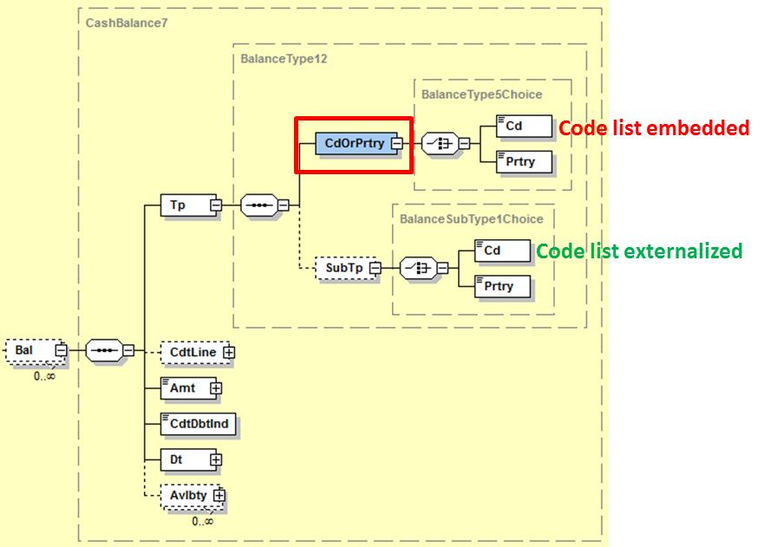

In the below graphic the impacted element is Status that currently has three codes embedded in the schema (BOOK, PDNG, INFO). The request is to change the data type to a choice element where the 3 current codes and potentially more will be added to an externalized code list, published on the ISO 20022 website. The Proprietary element is available for use of any community or user specific statuses.
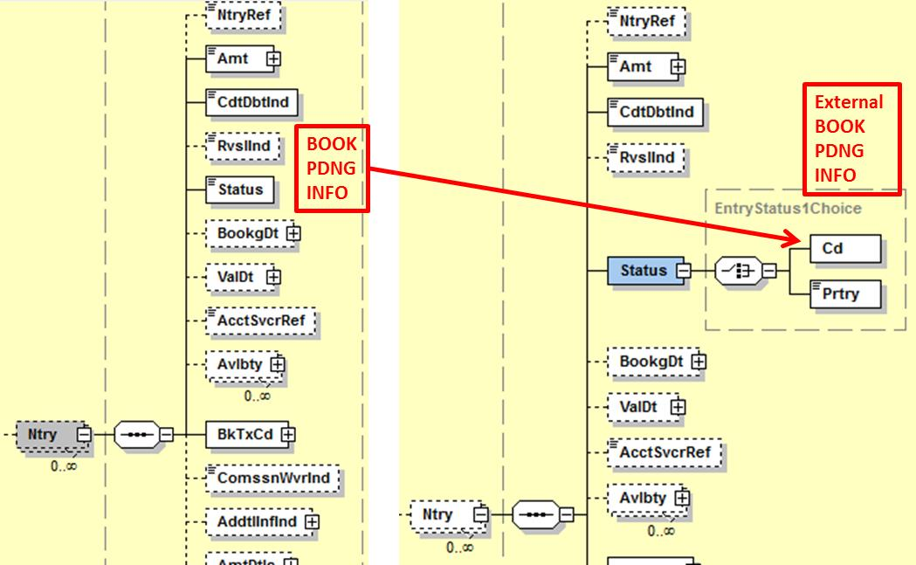

- Purpose of the change:
The change will increase the usability of the messages as an ever increasing number of communities is adopting them. Historically, the messages were developed for use in the corporate-to-bank space, but most of the adoption initiatives today focus on the interbank space where the reporting messages will be rolled out to report on accounts owned by financial institutions and serviced by other financial institutions or market infrastructures. As more players look at using the reporting messages, it is likely that the need for more specific codes, e.g. for the interbank space, will increase. Externalizing the lists will therefore bring flexibility to accommodate those needs in the shortest time-to-market way, while at the same moment it will bring stability to the standard as the addition of new codes to an externalized list does not cause for changes to the schemas.

- Urgency of the request:
Request to include the change in the next maintenance cycle.

- Business examples:

- SEG/TSG recommendation:

Consider |  | X | Timing
 |  |  | - Next yearly cycle: 2017/2018  (the change will be considered for implementation in the yearly maintenance cycle which starts in 2017 and completes with the publication of new message versions in the spring of 2018) |  | X
- At the occasion of the next maintenance of the messages
(the change will be considered for implementation, but does not justify maintenance of the messages in its own right – will be pending until more critical change requests are received for the messages)
- Urgent unscheduled
(the change justifies an urgent implementation outside of the normal yearly cycle)
 |  |  | - Other timing:
Comments:
Payments SEG meeting on 26 June 2017.

Reject
Reason for rejection:

The Format Advisory Group is jointly chaired by the Federal Reserve Bank of New York and The Clearing House and includes 14 global and regional banks. All institutions are Fedwire Funds Service participants and 10 are also CHIPS participants. The members are Bank of America, Bank of New York Mellon, Citibank, Deutsche Bank, HSBC, JPMC, Key Bank, MUFG Union Bank, PNC Bank, State Street, SunTrust, Wells Fargo, UBS, US Bank.
In case the change request would not be accepted by the SEG, then we will request the addition of additional new codes to the Balance Type code list.
In case the change request would not be accepted by the SEG, then we will request the addition of additional new codes to the Status code list.

