Change Request
for the update of ISO 20022 financial repository items

- Origin of the request:
A.1 Submitter:
Federal Reserve Bank of New York (on behalf of the US Federal Reserve Banks)
33 Liberty Street
New York, NY 10045
U.S.A.
A.2 Contact person:
Federal Reserve Bank of New York Wholesale Product Office
Ms. Gina Russo (gina.russo@ny.frb.org)
Ms. Leslie Lee (leslie.lee@ny.frb.org)
A.3 Sponsors:
US Format Advisory Group

- Related messages:
camt.052.001.06 – BankToCustomerAccountReport
camt.053.001.06 – BankToCustomerAccountStatement
camt.054.001.06 – BankToCustomerDebitCreditNotification

- Description of the change request:
The request is to make changes to the existing components RelatedParties (described under C1) and RelatedAgents (described under C2), both part of the TransactionDetails component as shown below.
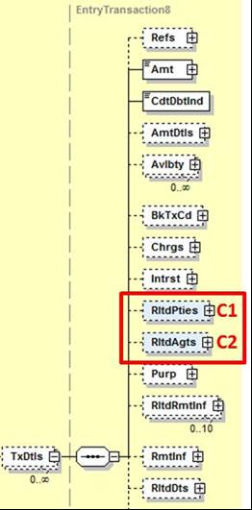

C1 – Related Parties
The request is to change the data type of the party elements in the existing RelatedParties component shown in the graphic below.
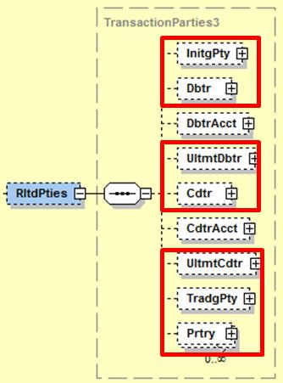

To enable reporting of account entries where a financial institution was acting as an InitiatingParty, (Ultimate) Debtor, (Ultimate) Creditor, TradingParty, or any other Proprietary party, the data type should offer the choice between identifying these parties as a financial institution next to the current non-financial institution option.
The suggestion is to reuse (the latest version of) the Party12Choice component shown below.

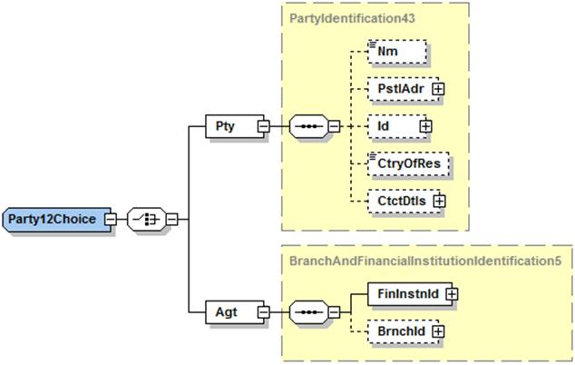
C2 – Related Agents
The request is to add two additional optional elements InstructingAgent and InstructedAgent to the existing RelatedAgents component as shown below. The data type should be aligned with the one used for the other elements already present in the component today (i.e. BranchAndFinancialInstituionIdentification5).

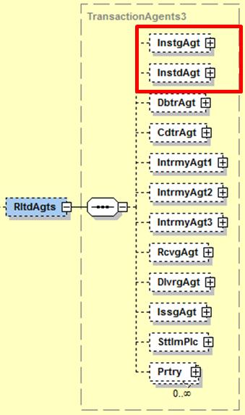

- Purpose of the changes:
Both C1 and C2 change requests will enable the inclusion of complete and structured information on all parties that were involved in a transaction that caused an account entry reported in any of the camt messages referenced above. Furthermore, change request C2 will provide a stable place for financial institutions as direct market infrastructure participants, i.e. sender or receiver of transactions.

- Urgency of the request:
Request to include the change in the next maintenance cycle.

- Business example:

If the account of a financial institution serviced by one of its correspondents or by a market infrastructure is credited as a result of a financial institution credit transfer (e.g. pacs.009 or MT 202), then in today’s camt.052 the financial institution Debtor of that transaction would need to be identified in a component that is traditionally used for non-financial institution debtors (for example, by using name and address). By offering the choice component, financial institutions will be identified with, for example, their BIC or domestic clearing code in a structured way.

- SEG/TSG recommendation:

Consider |  | X | Timing
 |  |  | - Next yearly cycle: 2017/2018  (the change will be considered for implementation in the yearly maintenance cycle which starts in 2017 and completes with the publication of new message versions in the spring of 2018) |  | X
- At the occasion of the next maintenance of the messages
(the change will be considered for implementation, but does not justify maintenance of the messages in its own right – will be pending until more critical change requests are received for the messages)
- Urgent unscheduled
(the change justifies an urgent implementation outside of the normal yearly cycle)
 |  |  | - Other timing:
Comments:
Payments SEG meeting on 26 June 2017.

Reject
Reason for rejection:

The Format Advisory Group is jointly chaired by the Federal Reserve Bank of New York and The Clearing House and includes 14 global and regional banks. All institutions are Fedwire Funds Service participants and 10 are also CHIPS participants. The members are Bank of America, Bank of New York Mellon, Citibank, Deutsche Bank, HSBC, JPMC, Key Bank, MUFG Union Bank, PNC Bank, State Street, SunTrust, Wells Fargo, UBS, US Bank.

