Change Request
for the update of ISO 20022 financial repository items
- Origin of the request:
A.1 Submitter: SMPG.
A.2 Contact person: Alexandre Hotat (alexandre.hotat@swift.com, + 32 2 655 3852).
A.3 Sponsors: N/A
- Related messages:
PortfolioTransferNotificationV04 : sese.037.001.04 and sese.037.002.04
- Description of the change request:
When the reverse engineering of the Settlement Reconciliation messages was done back in 2008, the MT586 (Allegement Report) was split into the semt.019 (Securities Settlement Transaction Allegement Report) and the sese.037 (Portfolio Transfer Notification) following the ISO 20022 concept "one business function per message". Back then the statuses in the MT586 were used only for the allegement process and therefore they were not mapped to the Portfolio Transfer Notification.
Back in 2015 and 2016 the CH and the BE National Market Practice groups worked on the Portfolio Transfer market practice and both groups reached the conclusion that statuses were also required in this message. Therefore the Status message element must be included in the sese.037 to allow the receiving party to provide an answer for each position to be delivered by the delivering party.
The Status message element must be added in the sese.037 at the Transfer Notification Details level just under the Payment message element. Possible values will be Accepted, Pending or Rejected. Proprietary status should also be possible.

Illustration
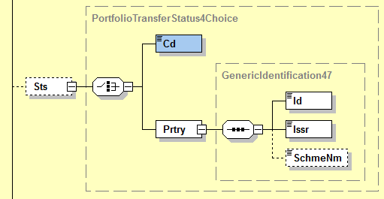

Code list
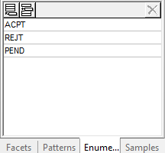

- Purpose of the change:
Include the status functionality present in the ISO 15022 message into the ISO 20022 equivalent message to comply with the evolution of the market practice.
- Urgency of the request:
Urgent. ISO 15022 and ISO 20022 must be aligned in terms of functionality.
Next maintenance cycle

- Business examples:
N/A.
- SEG/TSG recommendation:
This section is not to be taken care of by the submitter of the change request. It will be completed in due time by the SEG(s) in charge of the related ISO 20022 messages or the TSG for changes related to the BAH.

Consider |  |  | Timing
- Next yearly cycle: 2017/2018
(the change will be considered for implementation in the yearly maintenance cycle which starts in 2017 and completes with the publication of new message versions in the spring of 2018)
- At the occasion of the next maintenance of the messages
(the change will be considered for implementation, but does not justify maintenance of the messages in its own right – will be pending until more critical change requests are received for the messages)
- Urgent unscheduled
(the change justifies an urgent implementation outside of the normal yearly cycle)
 |  |  | - Other timing:
Comments:

Reject
Reason for rejection:

