Change Request
for the update of ISO 20022 financial repository items
.
- Origin of the request:
A.1 Submitter
The Clearing House
1114 Avenue of the Americas
New York, NY 10036
U.S.A.
A.2 Contact person:
Mr. Bob Pepitone
CHIPS Product Manager and Strategy
e-mail : robert.pepitone@theclearinghouse.org

- Related messages:
Pacs.004.001.07 – Payment Return

- Description of the change request:
Within some communities, a Payment Return message is considered as a new Payment Instruction message – as such, for regulatory and processing reasons, it has to transport additional information which would typically be found in the pacs.008 message (FIToFI CustomerCreditTransfer).
- Purpose of the change:
The pacs.004 will be implemented by The Clearing House and The Fed. In order to meet regulatory and processing requirements it is requested to add some additional elements under PaymentReturn/TransactionInformation and PaymentReturn/TransactionInformation/OriginalTransactionReference:

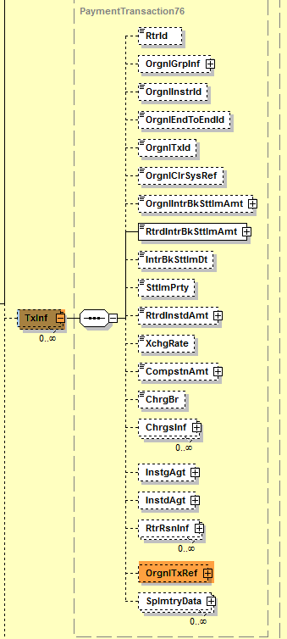

- Addition of a new element under PaymentReturn/TransactionInformation: ClearingSystemReference:
The ClearingSystemReference field is completed by some Market Infrastructures before the payment or return instruction is sent to the next agent in the payment chain (after settlement). It is then transported up to the Creditor Bank. Currently, only the OriginalClearingSystem Reference is available (ClearingSystemReference of the underlying payment instruction: pacs.008/pacs.009.

- Addition of a new element under PaymentReturn/TransactionInformation: OriginalInterbankSettlementDate:
The PaymentReturn/TransactionInformation currently transports the InterbankSettlementDate and ReturnedInstructedAmount (of the Payment Return) and the OriginalInterbankSettlementAmount (transported from the underlying payment instruction). The OriginalInterbankSettlementDate is currently located under PaymentReturn/TransactionInformation/OriginalTransactionReference. Because the Amount and SettlementDate are usually transported together, it is requested to move the OriginalInterbankSettlementDate under PaymentReturn/TransactionInformation, together with the OriginalInstructedAmount.

Illustrations:
- Payment Return/TransactionInformation/ ClearingSystemReference
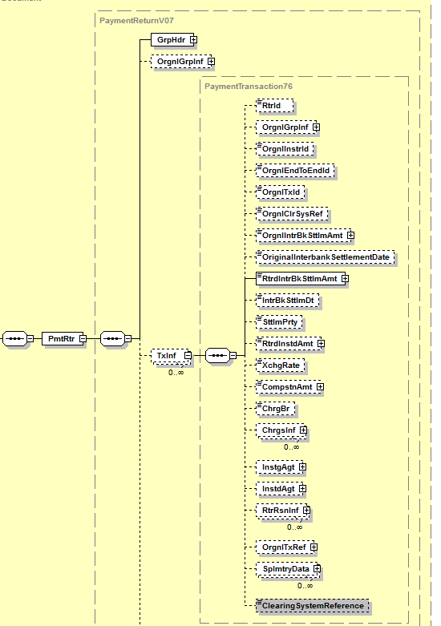

1

- PaymentReturn/TransactionInformation/OriginalTransactionReference

2

- Urgency of the request:
Several Market Infrastructures are currently working on their ISO 20022 implementation work – the pacs.004 is part of the Payments Portfolio of messages to be implemented. It is therefore requested to implement this change with the next release in 2018.
- Business examples:
Examples illustrating the change request:

- SEG/TSG recommendation:

Consider |  | X | Timing
 |  |  | - Next yearly cycle: 2017/2018  (the change will be considered for implementation in the yearly maintenance cycle which starts in 2017 and completes with the publication of new message versions in the spring of 2018) |  | X
- At the occasion of the next maintenance of the messages
(the change will be considered for implementation, but does not justify maintenance of the messages in its own right – will be pending until more critical change requests are received for the messages)
- Urgent unscheduled
(the change justifies an urgent implementation outside of the normal yearly cycle)
 |  |  | - Other timing:
Comments:
Decision made at the Payments SEG meeting on June 12th, 2017.

Reject
Reason for rejection:

