Change Request
for the update of ISO 20022 financial repository items
.
- Origin of the request:
A.1 Submitter
The High Value Payments Plus Group
A.2 Contact person:
Isabelle Bouille
Avenue Adèle 1
1310 La Hulpe/Belgium
Tel : +32.2.655.44.20
e-mail : isabelle.bouille@swift.com
A.3 Sponsors:
The European Payments Council
The Clearing House
GPI Community

- Related messages:
camt.029.001.07

- Description of the change request:
The camt.029.001.07 contains several lists of codes which are currently embedded in the message itself. This change request aims at transforming all of these lists into ISO 20022 external code sets.
- Purpose of the change:
The camt.029 is to be implemented by several additional Market Infrastructure communities. In order to facilitate addition of new codes, it is requested to transform the code lists into ISO 20022 external code sets.
Impacted elements in the camt.029:
- Under Status:
  - Confirmation
  - RejectedModification
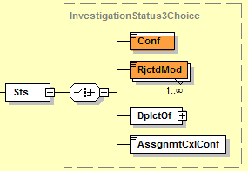
- Under CancellationDetails:
  - OriginalGroupInformationAndStatus:
    - CancellationStatusReasonInformation/Reason
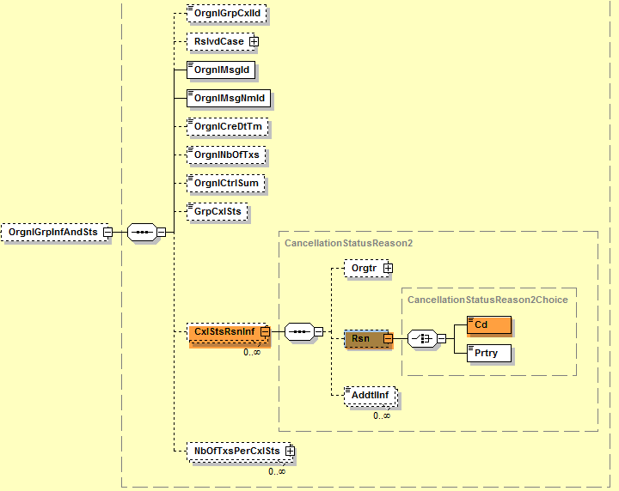
  - OriginalPaymentInformationAndStatus:

    - CancellationStatusReasonInformation/Reason
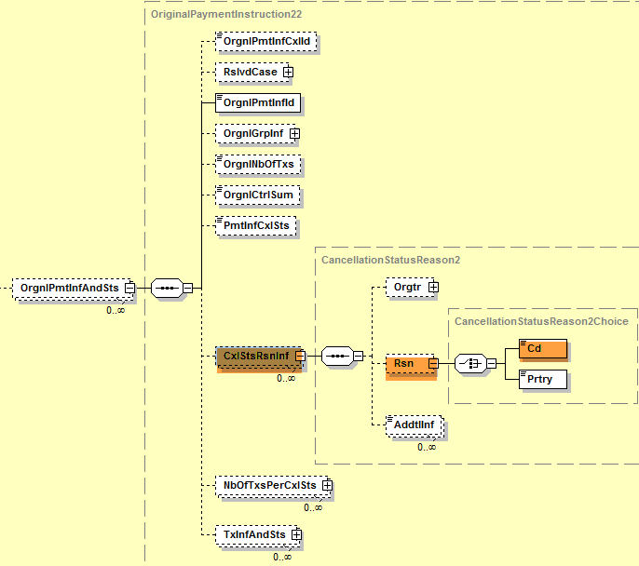
  - TransactionInformationAndStatus:
    - CancellationStatusReasonInformation/Reason
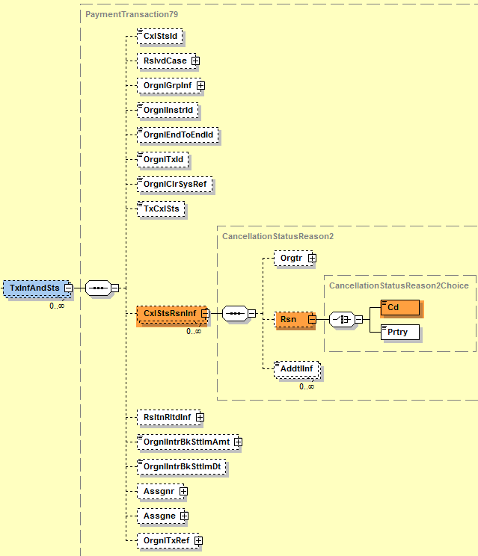

Requested additional codes to the already existing codes that will be moved into the external code set:
Under CancellationStatusReasonInformation, new codes are requested:

ADAC Awaiting Debit Authority From Customer
RQDA Requesting Debit Authority From Customer
ARPL Awaiting Reply
NARR Narrative
WSEQ Wrong Sequence
PTNA Passed To The Next Agent

- Urgency of the request:
Several Market Infrastructures are currently working on their ISO 20022 implementation work – the camt.029 is part of the payments portfolio of messages to be implemented. It is therefore requested to implement this change with the next release in 2018.

- Business examples:

- SEG/TSG recommendation:

Consider |  | X | Timing
 |  |  | - Next yearly cycle: 2017/2018  (the change will be considered for implementation in the yearly maintenance cycle which starts in 2017 and completes with the publication of new message versions in the spring of 2018) |  | X
- At the occasion of the next maintenance of the messages
(the change will be considered for implementation, but does not justify maintenance of the messages in its own right – will be pending until more critical change requests are received for the messages)
- Urgent unscheduled
(the change justifies an urgent implementation outside of the normal yearly cycle)
 |  |  | - Other timing:
Comments:
Decision made at the Payments SEG meeting on June 12th, 2017.

Reject
Reason for rejection:

