Change Request
for the update of ISO 20022 financial repository items
- Origin of the request:
A.1 Submitter:
European Payments Council
Cours Saint Michel 30a
B-1040 Brussels
Belgium

A.2 Contact person:
Mr. Christophe Godefroi
Senior Business Analyst
Tel: +32.2.739.16.93
e-mail: Christophe.godefroi@epc-cep.eu

A.3 Sponsors: The banking community of SEPA (Single Euro Payments Area)

- Related messages:
camt.087.001.04 - RequestToModifyPayment
camt.029.001.07 – ResolutionOfInvestigation
camt.027.001.05 - ClaimNonReceipt

- Description of the change request:
- Addition of elements in the camt.087.001.04, camt.027.001.05 and camt.029.001.07 to transport information from underlying payment instructions
- In the camt.029, include Claim Non Receipt Details, Compensation (value date compensation on customer account) and Charges.
- Create additional block “ModificationDetails” in the camt.029 to specify that the Resolution of Investigation may also relate to a Modification (not only to a cancellation)
- In the camt.029, rename Rejected Modification (under Status) into Rejection in order to be able to reject a Claim Non Receipt

- Purpose of the change:
The EPC 2017 SCT Rulebook v1.0 requires that the Request to Modify Payment message (camt.087) and the ResolutionOfInvestigation (camt.029) and the ClaimNonReceipt (camt.027) contain the complete set of information transported in the underlying payment instruction that is being modified.
Additionally, the camt.029 which must confirm or reject the Request to Modify Payment must also transport compensation and charges information which are currently missing.
Camt.087 /Camt.027:
- Under Underlying/Interbank/, add an optional element called OriginalTransactionReference to contain below elements:
  - Debtor: PartyIdentification43 (Optional)
  - Ultimate Debtor: PartyIdentification43 (Optional)
  - Debtor Account: CashAccount24 (Optional)
  - Debtor Agent: BranchAndFinancialInstitutionIdentification5 (Optional)
  - Creditor: PartyIdentification43 (Optional)
  - Creditor Account : CashAccount24 (Optional)
  - Ultimate Creditor: PartyIdentification43 (Optional)
  - Creditor Agent: BranchAndFinancialInstitutionIdentification5 (Optional )
  - PaymentTypeInformation: PaymentTypeInformation21 (Optional)
  - Purpose: Purpose2Choice (Optional)
  - Remittance Information: RemittanceInformation11 (Optional)
Camt.029
- Under CancellationDetails/TransactionInformationAndStatus /OriginalTransactionReference, add a new optional element:
  - Purpose
- Create a new message building block “ModificationDetails”
  - Same structure as “CancellationDetails”
  - In this structure rename all “Cancellation” related elements in “Modification” related elements.
  - Insert also Purpose in ModificationDetails/TransactionInformationAnd
Status/OriginalTransactionReference,
- At the same level as “CancellationDetails” and “ModificationDetails” and right below add a new element “ClaimNonReceiptDetails” to contain:
When positive:
  - Date Processed: date the instruction was processed
  - Original Next Agent: next party the original payment instruction was sent to
When Negative:
  - Reason: Code (New External Code List – see below)
Proprietary

Note: A new External ISO Code List is required: “ExternalClaimNonReceiptRejection1Code”. The new required codes are:

Code | Name | Definition
NOOR* | No Original Transaction Received | Original credit transfer never received
RNPR | Original Transaction Received but Not Processable | Original credit transfer was received but is not processable.
*Note: Code “NOOR” already exists in external code list ExternalReturnReason1Code.
- Under ResolutionRelatedInformation:
  - New optional element, called “Compensation” to contains below :
    - CompensationAmount (Currency & Amount)
    - DebtorAgent (Usage must specify that the Debtor Agent is the payer of the compensation)
    - CreditorAgent (Usage must specify that the Creditor Agent is the payee of the compensation)
    - Reason:
      - Code (New ISO External Code List)
      - Proprietary
Note: A new External ISO Code List is required: “CompensationReason1Code”. The new required code is:

Code | Name | Definition
VADA | Value Date Adjustment | Compensation requested for value date correction.

- Under ResolutionRelatedInformation:
  - New component, called Charges to contain:
    - ChargeInformation: Charges2
ISO 20022 Illustrations:

Camt.087

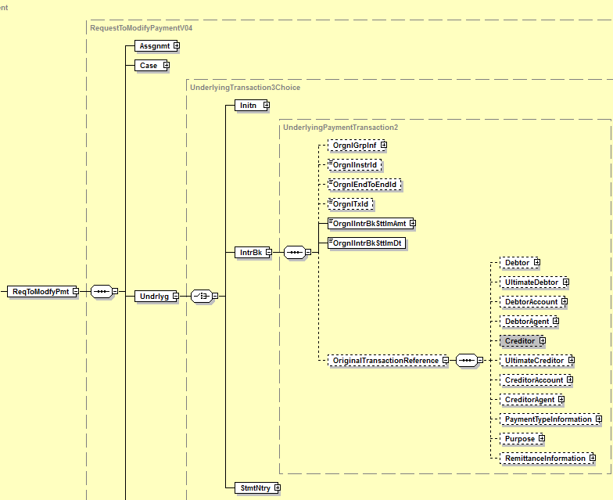

- Similar illustration also applies to the camt.027 since message structure is identical
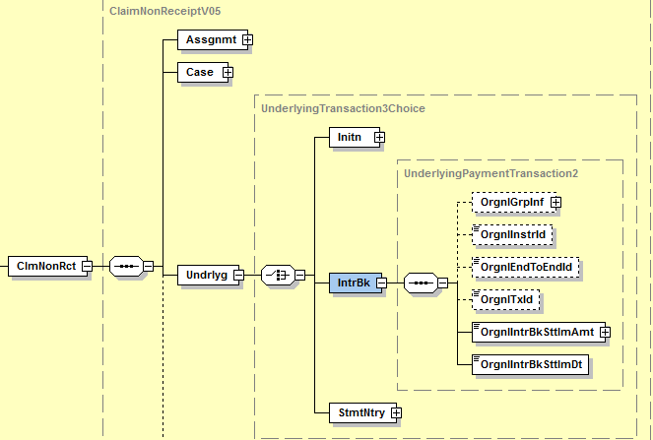

Camt.029
- Addition of new message building block “ModificationDetails” with same structure as “CancellationDetails”:

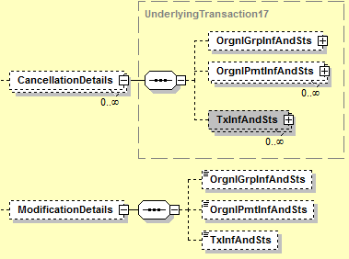

All “Cancellation” related elements of “OrgnlGrpInfAndSts”, “OrgnlPmtInfAndSts” and “TxInfAndSts” must be renamed to “Modification” (see illustration for “OrgnlGrpInfAndSts”)
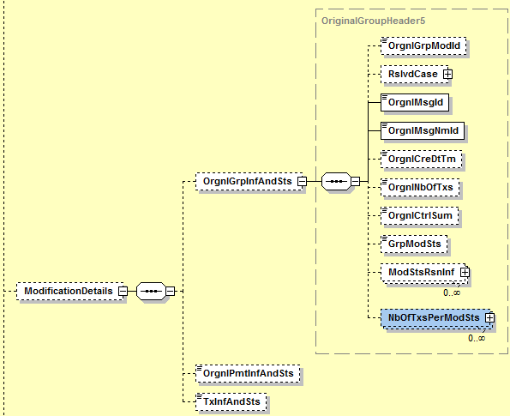

Same applies to “OrgnlPmtInfAndSts” and “TxInfAndSts”

- Addition of element “Purpose” in MC OriginalTransactionReference present in message building blocks “CancellationDetails” and “ModificationDetails”
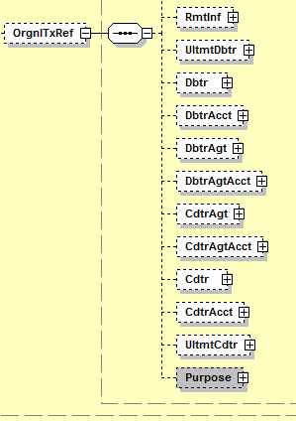
- Addition of a new element “ClaimNonReceiptDetails”:

Choice component: Positive or Negative
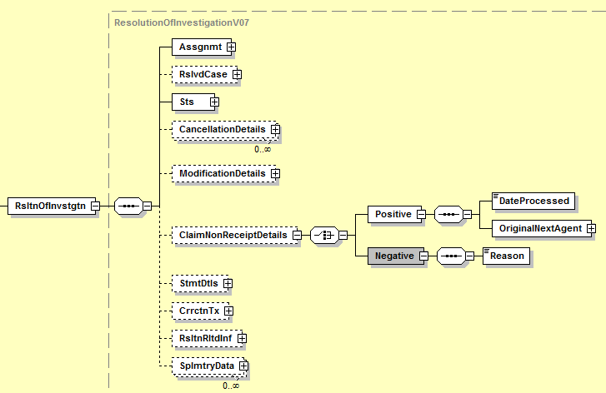

- Addition of two new optional elements “Compensation” and “Charges” Under ResolutionRelatedInformation:

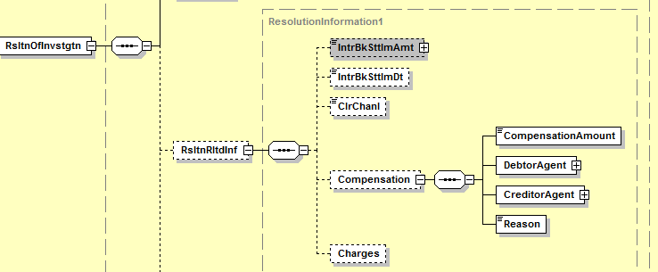

- Business example
A credit transfer is made from agent A (the payer’s agent) to agent B (the payee’s agent). Upon complaint from the payee, the payer requests its agent to ask the payee’s agent for a value date correction.
A request for value date correction (camt.087 RequestToModify) is then sent from agent A to agent B. If the cause for the value date correction does not fall within the responsibility of agent B, then agent B has the right to receive interest compensation from agent A.
This compensation is a variable amount, being the interest calculated for the number of calendar days between the original value date and the corrected value date of the original Credit Transfer. The calculation of such compensation is made according to the rules of the credit transfer scheme used.
When answering to the request (camt.029 ResolutionOfInvestigation), agent B indicates the amount of the compensation it asks for according to the above mentioned calculation in order to apply good value on the customer’s account.
Upon receipt of the answer, agent A transfers the compensation amount to agent B according to the scheme rules, through a pacs.008 in this case.

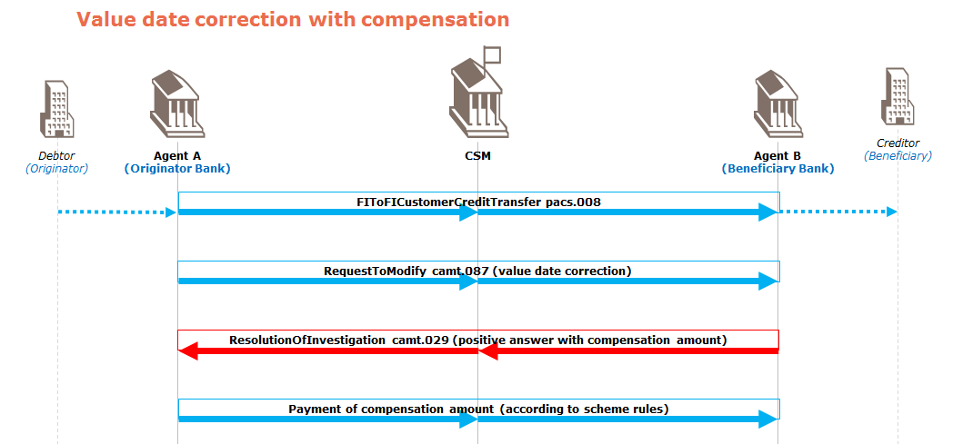

- Urgency of the request:
EPC must publish in November 2017 the Implementation Guidelines for these 3 “revised” messages. The implementation guidelines will become effective in November 2018.
- SEG recommendation:

Consider |  | X | Timing
 |  |  | - Next yearly cycle: 2017/2018  (the change will be considered for implementation in the yearly maintenance cycle which starts in 2017 and completes with the publication of new message versions in the spring of 2018) |  | X
- At the occasion of the next maintenance of the messages
(the change will be considered for implementation, but does not justify maintenance of the messages in its own right – will be pending until more critical change requests are received for the messages)
- Urgent unscheduled
(the change justifies an urgent implementation outside of the normal yearly cycle)
 |  |  | - Other timing:
Comments:
Decision made at the Payments SEG meeting on June 12th, 2017.

Reject
Reason for rejection:

