Change Request
for the update of ISO 20022 financial repository items
- Origin of the request:

A.1 Submitter:
- Deutsche Bundesbank, on behalf of the Eurosystem
- TARGET2-Securities

A.2 Contact person:
- Alexander Topel / Julia Lohle
- +49 69 – 9566 8184 / +49 69 – 9566 8843
- T2S-FAM@bundesbank.de

A.3 Sponsors:
- European Central Bank; Karen Birkel - karen.birkel@ecb.int
- TARGET2-Securities Community

- Related messages:
- Sese.023.001.07 - SecuritiesSettlementTransactionInstructionV07
- Description of the change request:
Currently, in an already matched instruction, a securities sub balance type (in the case of T2S this can be ‘earmarking’, ‘blocking’ or ‘reservation’) can only be provided for one side of the transaction. For the other side, T2S will always assume the default position type (AWAS, i.e. available position).

Therefore it was requested by the T2S community to enhance sese.023 functionality to be able to provide a dedicated securities sub-balance type for both sides of the transaction in an already matched instruction.

Currently, the securities sub-balance type is provided in the section:
Settlement Parameters/Securities Sub Balance Type
The field consists of Identification, Issuer and Scheme Name sub-fields. The section is non-repetitive.

The T2S community requests a change on the SecuritiesSettlementTransactionInstructionV07 to replace the existing ‘Securities Sub Balance Type’ block by two new blocks:
- Delivering Securities Sub Balance Type
- Receiving Securities Sub Balance Type

From T2S perspective, an update of sese.025 is not required as T2S settlement confirmations always relate to one side of the transaction only (always two separate sese.025 messages, also for already matched instructions).

The screenshot below shows a proposal for the implementation of the before mentioned change.

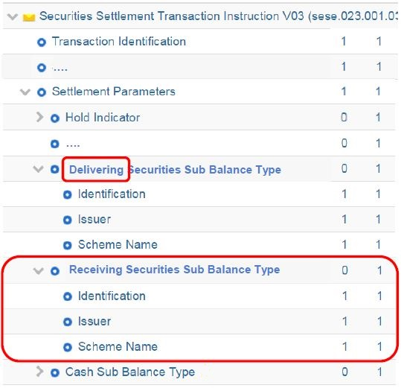

- Purpose of the change:
At present when a CSD or CSD participant is sending an already matched instruction to the T2S platform, it can only populate in the sese.023 instruction the securities sub-balance type of one party of the transaction and cannot populate this data for both counterparts. The sub balance type can be populated only for the party considered as the ‘account owner’ (the deliverer if the already matched is a DELI or the receiver if the instruction is a RECE). The sub-balance type of the counterparty is considered by default as AWAS (i.e. available position).
This is due in particular to existing limitation in ISO standards.

This creates an issue in the following business scenarios:
- when a CSD, CCP or trading platform has received permanent instructions from its members to use a sub balance type different from AWAS (e.g. earmarked for auto-collateralisation) in the instructions he sends on its behalf, it can use already matched instructions only if one party has made such a request. If both parties have made same request, the only way is to send ‘to be matched instructions’.
- when a participant is willing to move securities positions from one sub balance type to another one (none of them being the default sub-position), within the same securities account, the only way is to send ‘to be matched instructions’.
- also because of this constraint when any participant is willing to create already matched instruction to move securities from one sub balance type to another one (one of them being the default sub-position), within the same securities account, it must change the direction of the instruction (DELI or RECE) depending on whether the non-default sub balance type is on the debit or the credit side.
So the current set up creates unnecessary complexities and costs to the users.

- Urgency of the request:
The SEG is requested to consider this change request for the next maintenance cycle.

- Business examples:
A CCP receives instructions from its members to use a sub balance type in both the delivering and receiving instructions. The corresponding already matched instruction generated by the CCP will contain both a delivery and receiving securities sub balance type. This case is not possible using current message standards.
Message  Components | SI sent to CCP by member A | SI sent to CCP by member B | SI sent to T2S by CCP
Message | sese.023 | sese.023 | sese.023
Sender | Member A | Member B | CCP
Receiver | CCP | CCP | T2S
Securities Settlement Type | DELI | RECE | DELI (Already matched)
Usage with current approach:
Securities Sub Balance Type | EARA | EARB | Currently not possible to inform  both EARA and EARB in already  matched instruction.
Usage with proposed solution:
Delivering Securities Sub Balance Type | EARA |  | EARA
Receiving Securities Sub Balance Type |  | EARB | EARB
In the example above members A and B would instruct using the new delivering and receiving securities sub balance types to identify the appropriate sub balance type to the CCP. The CCP would then include both securities sub balance types when sending an already matched instruction to T2S, using in this case both the delivering and receiving securities sub balance types.

SEG/TSG recommendation:
This section is not to be taken care of by the submitter of the change request. It will be completed in due time by the SEG(s) in charge of the related ISO 20022 messages or the TSG for changes related to the BAH.

Consider |  |  | Timing
- Next yearly cycle: 2017/2018
(the change will be considered for implementation in the yearly maintenance cycle which starts in 2017 and completes with the publication of new message versions in the spring of 2018)
- At the occasion of the next maintenance of the messages
(the change will be considered for implementation, but does not justify maintenance of the messages in its own right – will be pending until more critical change requests are received for the messages)
- Urgent unscheduled
(the change justifies an urgent implementation outside of the normal yearly cycle)
 |  |  | - Other timing:
Comments:

Reject
Reason for rejection:

