Change Request
for the update of an External Code Set used in ISO 20022

- Origin of the request:
SWIFT SCRL
Avenue Adèle 1
1310 La Hulpe
Belgium
Contact:
Dominique Forceville/Standards Department
dominique.forceville@swift.com

- Related External Code Sets:
ExternalPaymentGroupStatus1Code
ExternalPaymentTransactionStatus1Code

- Description of the change request:
Addition of 1 new Transaction Status code ACCC (credit on creditor’s account completed) to the newly created ISO 20022 External Code Sets in the pacs.002.001.08 (FIToFIPaymentStatusReport) and in the pain.002.001.08 (CustomerStatusPaymentReport).
, under:
- OriginalGroupInformationAndStatus (ExternalPaymentGroupStatus1Code)
- TransactionInformationAndStatus (ExternalPaymentTransactionStatus1Code)

Code | Description | Definition
ACCC | AcceptedSettlementCompleted | Settlement on the creditor's account has been completed

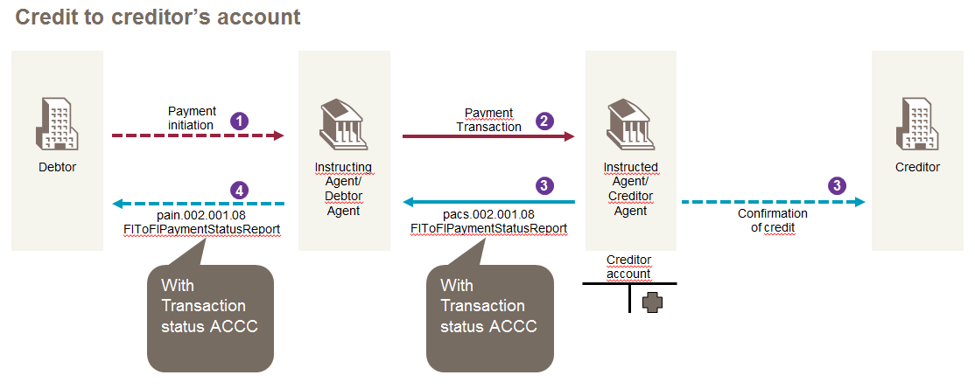

- Purpose of the change:
In correspondent banking, it could be required for the Creditor Agent to confirm credit done to the Creditor’s account towards preceding parties in the chain (e.g., SWIFT gpi). Today, in the pacs.002.001.08 and pain.002.001.08, a specific Transaction Status Code is missing for this specific purpose. A new Transaction Status code is to be added to the External Code Sets mentioned in section B in order to identify the credit done to the Creditor account.

- Urgency of the request:
It is requested that this code is added with the next quarterly publication of External Code Sets, i.e. by end May 2017.

- SEG recommendation:

Accept |  | X | Timing
 |  |  | - Next possible quarterly release |  | X
 |  |  | - Other timing:
Comments:

Reject
Reason for rejection:

