Change Request
for the update of an External Code Set used in ISO 20022
- Origin of the request:
A.1 Submitter: The Clearing House, LLC.
A.2 Contact person: Michael (Mike) Thomas; 212-612-9205; Michael.thomas@theclearinghouse.org
A.3 Sponsors: VocaLink

- Related External Code Set:
The code set is the new ExternalPaymentTransactionStatus1Code used in the recently approved new version pacs.002.001.08 message. It used to be the internal code set TransactionIndividualStatus3Code in previous versions of the message.

- Description of the change request:
Request to add the following new codes to the:
Code | Name | Definition
ACWP | AcceptedWithoutPosting | Payment instruction included in the Credit Transfer is Accepted without being Posted to the Creditor Customer’s account.
RCVD | Received | Payment initiation has been received by the receiving agent.
The example below describes how these responses will appear in TCH RTP message specifications:

Transaction Status
TxInfAndSts  +TxSts | ISO Definition: | Specifies the status of a transaction, in a coded form.
TxInfAndSts  +TxSts | Product Usage Credit Transfer: | The status of the item.
TxInfAndSts  +TxSts | Product Usage Payment Related Message: | Same as above
TxInfAndSts  +TxSts | Index: | 3.9
TxInfAndSts  +TxSts | XML Tag: | <TxSts>
TxInfAndSts  +TxSts | Occurrences: | [0..1]
TxInfAndSts  +TxSts | Rules: | Must be either 'RJCT', 'RCVD', 'ACWP' or 'ACTC'
TxInfAndSts  +TxSts | Reason Codes: | Reject with code 650 in administration message admi.002 if invalid code.
TxInfAndSts  +TxSts | Note: | Code 'RCVD' is used as Message Status Report to all Payment Related  Messages that can be processed without issue by the receiving agent.
TxInfAndSts  +TxSts | Example: | <TxSts>ACTC</TxSts>
TxInfAndSts  +TxSts | Codes | Name / Description
TxInfAndSts  +TxSts | ACTC | AcceptPayment initiation or individual transaction included in the payment initiation has been Accepted
TxInfAndSts  +TxSts | ACWP | AcceptWithoutPosting instruction included in the Credit Transfer is Accepted without being Posted to the Creditor Customers account.  This is done so further checks and status update can be performed (eg. OFAC checks).
TxInfAndSts  +TxSts | RCVD | Received  Payment initiation has been received by the receiving agent.
TxInfAndSts  +TxSts | RJCT | Reject  Payment initiation or individual transaction included in the payment initiation has been rejected.

- Purpose of the change:
The “AcceptedWithoutPosting” status code provides the Creditor Agent a means to accept a transaction pending further review for regulatory compliance or fraud mitigation. This status code allows the transaction to settle, but permits the Creditor Agent to conduct further investigation into the transaction should the need arise, whereas a “Pending” status implies that funds have not yet settled.
Business rules within the TCH RTP network scheme state that the Creditor Agent must notify the Debtor Agent via a camt.035 (Payment Acknowledgement) message when the transaction ultimately posts to the Creditor Customer’s account. If funds are not posted, the Creditor Agent must notify the Debtor Agent and take reasonable steps to return the funds to the Debtor Agent as permitted under applicable law.
The “Received” status code was historically provided in the pacs.002 Group Status but not in the Transaction Status. This code should be added to Transaction Status to allow a receiving agent to indicate that an individual transaction has been received.

- Urgency of the request:
The Clearing House’s implementation of a real-time payments system leveraging ISO 20022 standards is expected to go live in Q2 2017. As such, TCH requests that this change be incorporated in the new external code set as soon as it is published.
- Business examples:
In a Credit Transfer (pacs.008) from one individual to another within the U.S., the Creditor Agent’s OFAC screening system flags a transaction as high-risk due to a match of the Debtor Name to a Name on the OFAC Specially Designated Nationals sanctioned list. Upon the OFAC screening system flagging this transaction, the Creditor FI provides a pacs.002 response (Message Status Report) to the Credit Transfer with a ACWP (AcceptedWithoutPosting) status code.
Figure 1: Credit Transfer Flow (Creditor FI Accept without Posting)
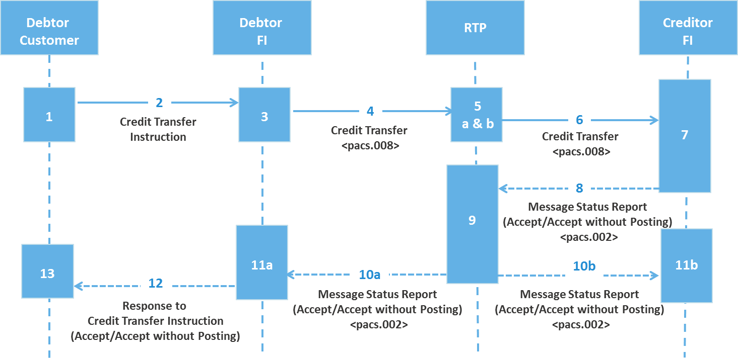
At this point, funds settle between the Debtor Agent and the Creditor Agent, but the Creditor Agent has not credited the Creditor Customer due to the possibility that funds were sent from a Specially Designated National. The Debtor Agent notifies the Debtor Customer that funds have been sent, but posting to the Creditor Customer’s account may be delayed (specific communication policies will be determined by the Debtor Agent).
Upon notification of the match, an OFAC analyst employed by the Creditor FI manually reviews the suspicious transaction. Upon review, the OFAC analyst will either (a) recognize that the alert was a false positive and clear the transaction, or (b) confirm the OFAC violation. If the OFAC analyst clears the transaction, funds are posted to the Creditor Customer’s account and the Debtor FI is notified via a camt.035 message (see Figure 2). If the OFAC analyst confirms that an OFAC violation has occurred, funds will be seized and frozen by the Creditor FI and the proper authorities will be notified.
Figure 2: Payment Acknowledgement following posting of funds by Creditor FI
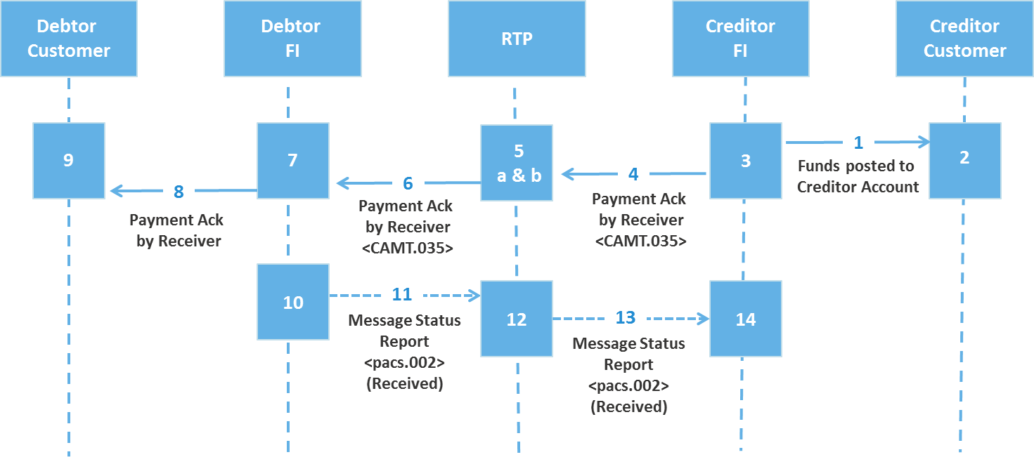

The RCVD status is used in the pacs.002 response to the camt.035 message to notify the Creditor FI that the Debtor FI RCVD the camt.035 message. Since the camt.035 is not a payment message, RCVD is more appropriate than ACTC given that no funds are exchanged in association with this message.

- SEG recommendation:

Accept |  | X | Timing
 |  |  | - Next possible quarterly release |  | X
 |  |  | - Other timing:
Comments: Approved at March 20th meeting.

Reject
Reason for rejection:

