Change Request
for the update of ISO 20022 financial repository items
- Origin of the request:
A.1 Submitter: TCH
A.2 Contact person: Michael Thomas; Michael.thomas@theclearinghouse.org; +1-212-612-9205
A.3 Sponsors: Banking community of TCH
- Related messages:
FIToFIPaymentCancellationRequest – camt.056
- Description of the change request:
In the existing FI to FI Payment Cancellation Request today the Reason specification is part of the message itself. The element defining the reason codes is “CancellationReason5Code”
In the view of the development for Real-Time Payments one of the additional reasons for payment cancellations is the ‘Time-Out’ Scenario. Today there is no specific code to reflect this. In the rest of the ISO 20022 messages using the ExternalStatusReason the code DS24 is already available.
Therefore, we would suggest the addition of the DS24 code for the FI to FI Payments Cancellation Reason code.

Existing Code List:
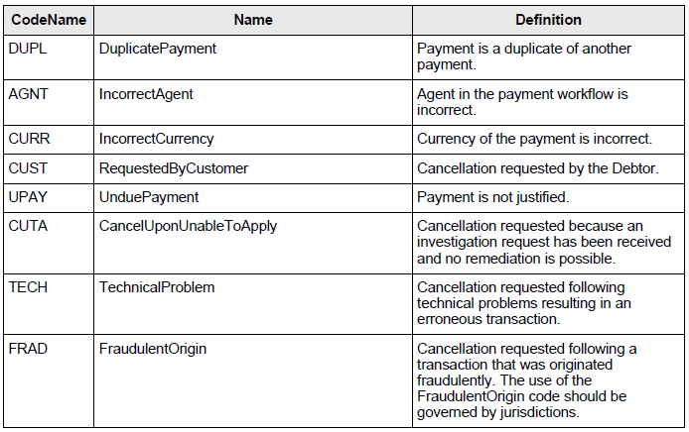

New additional code:
CodeName | Name | Definition
DS24 | TimeOut | Cancellation requested because the original payment order expired due to time-out.

In addition, we would recommend moving the CancellationReasonCode list to the External Code Set to expedite future changes in or additions of codes.
- Purpose of the change:
Within Real-Time payments, if the Central Clearing System does not receive an acceptance of the payment message during a predefined period, a camt.056 message can be used to communicate to the Beneficiary FI that the Clearing System has timed-out the request. Such usage will avoid scenarios in which the Beneficiary FI posts the transaction to the Beneficiary account, but the transaction does not complete.
Besides the usage for the US bank community through the TCH initiative, we are aware that also in the European area the introduction of SEPA Inst may also require information based on payment turn-around during a specific timeframe.
- Urgency of the request:
We would like to request this as an urgent change request as we are planning to introduce the Real-time payments for the US in April 2017.
In addition for the European area the SEPA Inst live date is November 2017 and we can see also an urgency there to provide the time-out reason code or even move the cancellation reason code to the External Code Set list.
- Business examples:
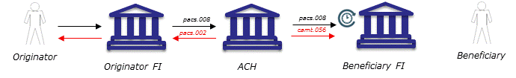
The Originator FI sends via his Automated Clearing House (ACH) the real-time payment. The ACH forwards the payment request and keeps the record of time to ensure this real-time payment is processed according to the scheme rules.
In the case that the Beneficiary FI is not responding within the scheme’s predefined time-out period, the ACH sends two messages a) the reject back to the Originator FI with the error code DS24 and b) the cancellation request to the Beneficiary FI with the cancellation reason “Time-Out”.
The ACH unwinds / reverses the payment amount for both FIs.
- SEG/TSG recommendation:
This section is not to be taken care of by the submitter of the change request. It will be completed in due time by the SEG(s) in charge of the related ISO 20022 messages or the TSG for changes related to the BAH.

Consider |  | X | Timing
- Next yearly cycle: 2017/2018
(the change will be considered for implementation in the yearly maintenance cycle which starts in 2017 and completes with the publication of new message versions in the spring of 2018)
- At the occasion of the next maintenance of the messages
(the change will be considered for implementation, but does not justify maintenance of the messages in its own right – will be pending until more critical change requests are received for the messages)
- Urgent unscheduled
(the change justifies an urgent implementation outside of the normal yearly cycle)
 |  |  | - Other timing: with 2016/2017 maintenance cycle
Comments:
The code set has been externalised with the 2016/2017 maintenance of the Exceptions and Investigations messages. The code DS24 will be added in the next publication of the External Code sets (Q4 2016)

Reject
Reason for rejection:

Unwind in case of deferred settlement / revers in case of pre-funding.

