Change Request
for the update of an External Code Set used in ISO 20022

- Origin of the request:
SWIFT SCRL
Avenue Adèle 1
1310 La Hulpe
Belgium
Contact:
Isabelle Bouille/Standards Department
isabelle.bouille@swift.com

And

SABS (South African Bureau of Standards)
Johannesburg
South Africa
Contact:
Sean Mouton
Seancm@absa.co.za

- Related External Code Set:
ExternalPurpose1Code

- Description of the change request:
5 new codes are requested in the ExternalPurpose1Code list as listed and described below:

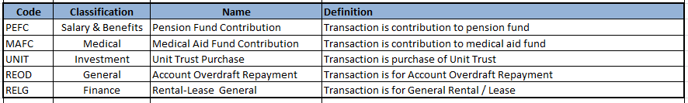

- Purpose of the change:

The South African community is currently preparing its migration onto ISO 20022 for the Authenticated Direct Debits business and will be heavily using the Payments Mandates and Direct Debits set of messages as a basis for this business.
Implementation work has shown that the current set of codes available in the ExternalPurpose1 Code list would need to be complemented with 5 additional codes to meet the regulation and automated processing requirements. These new codes will also be of interest to SADC and any other community implementing the mandate messages.

- Urgency of the request:
It is requested that these codes are added with the next quarterly publication of External Code Sets, i.e. September 2016.

- SEG recommendation:

Accept |  | X | Timing
 |  |  | - Next possible quarterly release |  | 3Q2016
 |  |  | - Other timing:
Comments:

Reject
Reason for rejection:

