Change Request
for the update of ISO 20022 financial repository items
- Origin of the request:
A.1 Submitter: SWIFT scrl
A.2 Contact person: Alexandre Hotat, alexandre.hotat@swift.com, +32 2 655 3852
A.3 Sponsors: SMPG

- Related messages:
The list of messages impacted is: sese.033, sese.034, sese.035, sese.036

- Description of the change request:
Addition of codes SBBK and BSBK codes as Securities Financing Transaction Type in the ISO 20022 Securities Financing messages to enable using those messages to cover the Buy Sell/Sell Buy Back business process.

- Purpose of the change:
Currently the ISO 20022 Securities Financing messages do not support the Buy Sell/Sell Buy Back business process. Theses codes are present in ISO 15022 messages but the ISO 20022 Securities Financing messages only support the codes for Repo, Reverse Repo, Securities Lending and Securities Borrowing.

- Urgency of the request:
Maintenance 2016/2017
- Business examples:
Examples illustrating the change request.

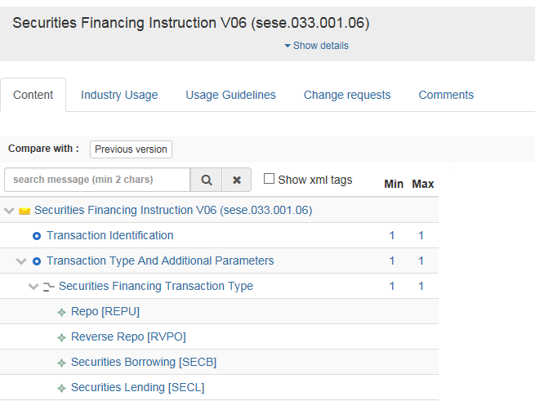
Buy Sell Back (BSBK)
Sell Buy Back (SBBK)
- SEG/TSG recommendation:

Consider |  | X | Timing
 |  |  | - Next yearly cycle: 2016/2017  (the change will be considered for implementation in the yearly maintenance cycle which starts in 2016 and completes with the publication of new message versions in the spring of 2017) |  | X
- At the occasion of the next maintenance of the messages
(the change will be considered for implementation, but does not justify maintenance of the messages in its own right – will be pending until more critical change requests are received for the messages)
- Urgent unscheduled
(the change justifies an urgent implementation outside of the normal yearly cycle)
 |  |  | - Other timing:
Comments:

Reject
Reason for rejection:

