Change Request
for the update of ISO 20022 financial repository items

- Origin of the request:
A.1 Submitter: The Clearing House, LLC
A.2 Contact person:
Michael Thomas
212-612-9205
Michael.thomas@theclearinghouse.org
A.3 Sponsors:
VocaLink

- Related messages:
camt.026.001.04 UnableToApplyV04

- Description of the change request:
To create an updated version of the message with an additional tag that allows for additional justification information in a 140 character free text.
As is
Structure | XML Tag | Field format
+Justification | <Id>
++AnyInformation | <AnyInf> | YesNoIndicator
++MissingOrIncorrectInformation | <MssngOrIncrrctInf>
+++AntiMoneyLaunderingRequest | <AMLReq> | AMLIndicator
+++MissingInformation | <MssngInf> | UnableToApplyMissingInformation2Code
+++IncorrectInformation | <IncrrctInf> | UnableToApplyIncorrectInformation3Code
++PossibleDuplicateInstruction | <PssblDplctInstr> | TrueFalseIndicator
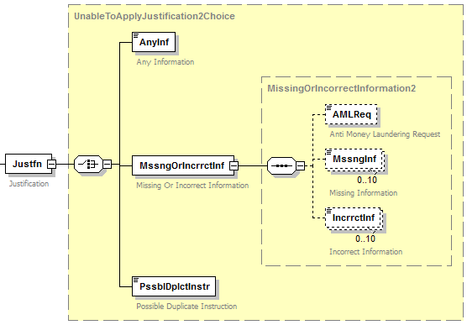

To be
Structure | XML Tag | Field format
+Justification | <Id>
++AnyInformation | <AnyInf> | YesNoIndicator
++MissingOrIncorrectInformation | <MssngOrIncrrctInf>
+++AntiMoneyLaunderingRequest | <AMLReq> | AMLIndicator
+++MissingInformation | <MssngInf> | UnableToApplyMissingInformation2Code
+++IncorrectInformation | <IncrrctInf> | UnableToApplyIncorrectInformation3Code
+++AdditionalJustificationInformation | <AddtlJustInf> | Max140Text
++PossibleDuplicateInstruction | <PssblDplctInstr> | TrueFalseIndicator

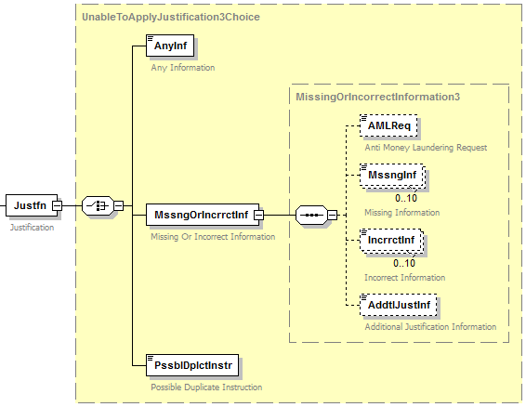

- Purpose of the change:
The TCH Real Time Payment system provides the capability for the receiver of a payment to request additional information from the sender in order to apply a payment if the original payment is sent with either missing or incorrect information. This field will provide additional information regarding the code used in the Missing Information or Incorrect Information field. The data within this field may be provided to the end-user recipient to assist the end-user in determining why additional information is necessary to apply a particular transaction, and may avoid a situation in which the recipient resends information that cannot be processed by the sender of the camt.026. Please see example of the proposed field below.

Additional Justification Information
Justfn  +MssngOrIncrrctInf  ++AddtlJustInf | ISO Definition: | Specifies a character string with a maximum length of 140 characters.
Justfn  +MssngOrIncrrctInf  ++AddtlJustInf | Product Usage: | This field is being used to provide additional information to the code used in the element MissingInformation or IncorrectInformaiton field.
Justfn  +MssngOrIncrrctInf  ++AddtlJustInf | Index: | 4.6
Justfn  +MssngOrIncrrctInf  ++AddtlJustInf | XML Tag: | <AddtlJustInf>
Justfn  +MssngOrIncrrctInf  ++AddtlJustInf | Occurrences: | [0..1]
Justfn  +MssngOrIncrrctInf  ++AddtlJustInf | Example: | <AddtlJustInf>Unstructured Information</AddtlJustInf>

- Urgency of the request:
The Clearing House’s implementation of a real-time payments system leveraging ISO 20022 standards is expected to go live in Q1 2017. As such, TCH requests that this change be incorporated into the specification by the 2017 maintenance cycle or earlier if possible.

- Business examples:
See section D above
- SEG recommendation:
This section is not to be taken care of by the submitter of the change request. It will be completed in due time by the SEG(s) in charge of the related ISO 20022 messages.

Consider |  | X | Timing
 |  |  | - Next yearly cycle: 2016/2017  (the change will be considered for implementation in the yearly maintenance cycle which starts in 2016 and completes with the publication of new message versions in the spring of 2017) |  | X
- At the occasion of the next maintenance of the messages
(the change will be considered for implementation, but does not justify maintenance of the messages in its own right – will be pending until more critical change requests are received for the messages)
- Urgent unscheduled
(the change justifies an urgent implementation outside of the normal yearly cycle)
 |  |  | - Other timing:
Comments:

Reject
Reason for rejection:

