Change Request
for the update of an External Code Set used in ISO 20022

- Origin of the request:
A.1 Submitter:
SIX Interbank Clearing Ltd, Zurich (Switzerland)

A.2 Contact person:
Istvan Teglas
Senior Product Manager
SIX Interbank Clearing AG
Hardturmstrasse 201
CH-8021 Zürich
T +41 58 399 4238
istvan.teglas@six-group.com
www.six-interbank-clearing.com

A.3 Sponsors:
UBS AG, CH-8098 Zurich
Credit Suisse, CH-8070 Zurich
PostFinance, CH-3000 Bern
Zürcher Kantonalbank, CH-8001 Zurich
Raiffeisen Schweiz, CH-9001 St. Gallen
SIX Interbank Clearing Ltd, CH-8021 Zurich

- Related External Code Set:
16-Status Reason

- Description of the change request:
The Name and Definition of the following codes should be updated:

CH14 | OriginalDebtorAgentIsOnlyToBeUsedWithSequenceTypeFRST | Original Debtor Agent is only to be used with Sequence Type=FRST

The new Name and Definition should be:

CH14 | OriginalDebtorAgentIsNotToBeUsed | Original Debtor Agent is not to be used

- Purpose of the change:
As of the changes in the SEPA Direct Debit (see “PRE-NOTICE”), the Sequence Type “FRST” will no longer be mandatory.
SEPA Rulebook Version 8.0:
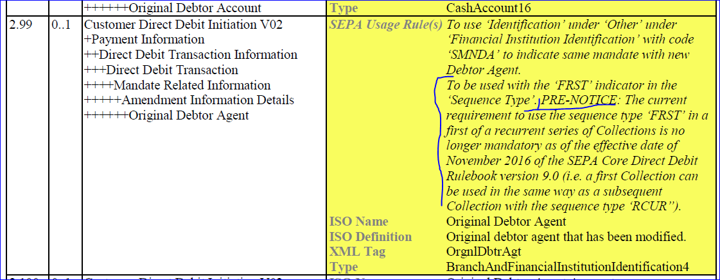.
Therefore, the Name and the Text of the Status “CH14” has to be changed.
- Urgency of the request:
By default, valid change requests, subsequently approved by the SEG will be included in the following quarterly publication of External Code Sets, unless decided otherwise by the SEG.

- Business examples:
See Screenshots of adoptions made in the Swiss Implementation Guidelines SEPA Direct Debit (pain.008):
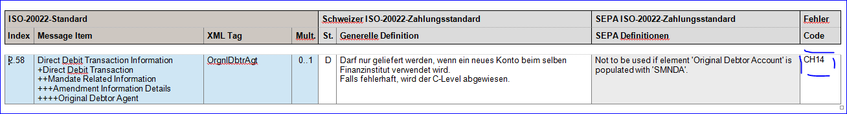(According to the new SEPA Rulebook Version 9.0)
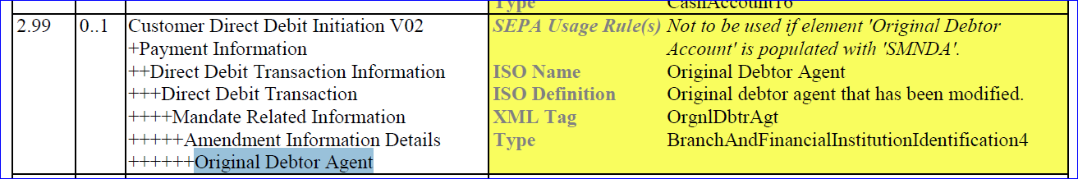

- SEG recommendation:
This section will be completed in due time by the SEG in charge of the related External Code Set.

Accept |  | X | Timing
 |  |  | - Next possible quarterly release |  | X
 |  |  | - Other timing:
Comments: The European Payments Council (EPC) sent feedback after last meeting and they have no objections against the approval of the requested name and definition update.

Reject
Reason for rejection:

