Change Request
For the Update of ISO 20022 Financial Repository Items
A Origin of the request:
A.1 Submitter: SWIFT Standards
A.2 Contact person: Janice Chapman janice.chapman@swift.com +32 2 655 3390
A.3 Sponsors:
- Related messages:
 | Message | Identifier |  |  | Message | Identifier
 | Redemption Bulk Order | setr.001.001.03 |  |  | Subscription Order Cancellation Request | setr.011.001.03
 | Redemption Bulk Order Cancellation Request | setr.002.001.03 |  |  | Subscription Order Confirmation | setr.012.001.03
 | Redemption Bulk Order Confirmation | setr.003.001.03 |  |  | Subscription Order Confirmation Cancellation Instruction | setr.047.001.01
 | Redemption Order | setr.004.001.03 |  |  | Subscription Order Confirmation Amendment | setr.048.001.01
 | Redemption Order Cancellation Request | setr.005.001.03 |  |  | Subscription Bulk Order Confirmation Cancellation Instruction | setr.049.001.01
 | Redemption Order Confirmation | setr.006.001.03 |  |  | Subscription Bulk Order Confirmation Amendment | setr.050.001.01
 | Subscription Bulk Order | setr.007.001.03 |  |  | Redemption Order Confirmation Cancellation Instruction | setr.051.001.01
 | Subscription Bulk Order Cancellation Request | setr.008.001.03 |  |  | Redemption Order Confirmation Amendment | setr.052.001.01
 | Subscription Bulk Order Confirmation | setr.009.001.03 |  |  | Redemption Bulk Order Confirmation Cancellation Instruction | setr.053.001.01
 | Subscription Order | setr.010.001.03 |  |  | Redemption Bulk Order Confirmation Amendment | setr.054.001.01
- Description of the change request:
This change request is for the OrderOriginatorEligibility1Rule, which exists only as a textual rule. This particular rule can be expressed as a formal rule. This means the formal rule can be validated in an automated way.
Before changing the rule, it should first be validated that the rule is still desirable.
This rule resides inside a message component and the rule only concerns elements in the component – there are two components that contain this rule, Intermediary 8 and Intermediary 9. The messages that contain these components are identified in section B.
Requested Settlement Currency Rule:
Rule as Text | Rule when expressed in a formal way
OrderOriginatorEligibility1Rule  OrderOriginatorEligibility may only be present if Role is either UnderlyingClient1 (UCL1) or UnderlyingClient2 (UCL2). | On Condition  /OrderOriginatorEligibility is present  Following Must be True  /Role Must be equal to value 'UnderlyingClient1'  Or /Role Must be equal to value 'UnderlyingClient2'

An illustrated example of where the rule is located (1)
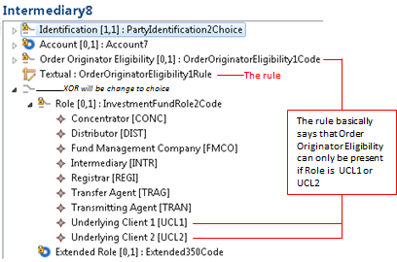
The messages that use Intermediary 8 are:
 | Message | Identifier |  |  | Message | Identifier
 | Redemption Bulk Order | setr.001.001.03 |  |  | Subscription Bulk Order | setr.007.001.03
 | Redemption Bulk Order Cancellation Request | setr.002.001.03 |  |  | Subscription Bulk Order Cancellation Request | setr.008.001.03
 | Redemption Order | setr.004.001.03 |  |  | Subscription Order | setr.010.001.03
 | Redemption Order Cancellation Request | setr.005.001.03 |  |  | Subscription Order Cancellation Request | setr.011.001.03

An illustrated example of where the rule is located (2)
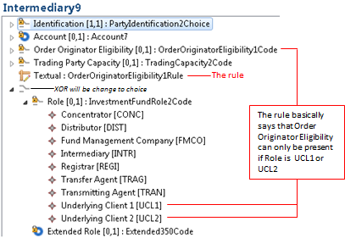

The messages that use Intermediary 9 are:
 | Message | Identifier |  |  | Message | Identifier
 | Redemption Bulk Order Confirmation | setr.003.001.03 |  |  | Subscription Bulk Order Confirmation Cancellation Instruction | setr.049.001.01
 | Redemption Order Confirmation | setr.006.001.03 |  |  | Subscription Bulk Order Confirmation Amendment | setr.050.001.01
 | Subscription Bulk Order Confirmation | setr.009.001.03 |  |  | Redemption Order Confirmation Cancellation Instruction | setr.051.001.01
 | Subscription Order Confirmation | setr.012.001.03 |  |  | Redemption Order Confirmation Amendment | setr.052.001.01
 | Subscription Order Confirmation Cancellation Instruction | setr.047.001.01 |  |  | Redemption Bulk Order Confirmation Cancellation Instruction | setr.053.001.01
 | Subscription Order Confirmation Amendment | setr.048.001.01 |  |  | Redemption Bulk Order Confirmation Amendment | setr.054.001.01

If the change request for the deletion of ‘cancel by details’ is agreed then this eliminates the need for changes to the cancellation messages (setr.005, setr.011, setr.047, setr.051).
- Purpose of the change:
[1] To make an existing cross-element rule ‘formal’ so that it can be validated automaticallly.
[2] To conform to the ISO 20022 linguistic style for a rule.
- Urgency of the request:
The next maintenance cycle in which the maintenance of orders is permitted.
- Business examples:
None.
- SEG recommendation:
Consider |  | X | Timing
 |  |  | - Next yearly cycle: 2016/2017  (the change will be considered for implementation in the yearly maintenance cycle which starts in 2016 and completes with the publication of new message versions in the spring of 2017) |  | X
- At the occasion of the next maintenance of the messages
(the change will be considered for implementation, but does not justify maintenance of the messages in its own right – will be pending until more critical change requests are received for the messages)
- Urgent unscheduled
(the change justifies an urgent implementation outside of the normal yearly cycle)
 |  |  | - Other timing:
Comments:

Reject
Reason for rejection:

