Change Request
For the Update of ISO 20022 Financial Repository Items
A Origin of the request:
A.1 Submitter: SWIFT Standards
A.2 Contact person: Janice Chapman janice.chapman@swift.com +32 2 655 3390
A.3 Sponsors:
- Related messages:
 | Message | Identifier |  |  | Message | Identifier
 | Redemption Bulk Order | setr.001.001.03 |  |  | Subscription Order Cancellation Request | setr.011.001.03
 | Redemption Bulk Order Cancellation Request | setr.002.001.03 |  |  | Subscription Order Confirmation | setr.012.001.03
 | Redemption Bulk Order Confirmation | setr.003.001.03 |  |  | Subscription Order Confirmation Cancellation Instruction | setr.047.001.01
 | Redemption Order | setr.004.001.03 |  |  | Subscription Order Confirmation Amendment | setr.048.001.01
 | Redemption Order Cancellation Request | setr.005.001.03 |  |  | Subscription Bulk Order Confirmation Cancellation Instruction | setr.049.001.01
 | Redemption Order Confirmation | setr.006.001.03 |  |  | Subscription Bulk Order Confirmation Amendment | setr.050.001.01
 | Subscription Bulk Order | setr.007.001.03 |  |  | Redemption Order Confirmation Cancellation Instruction | setr.051.001.01
 | Subscription Bulk Order Cancellation Request | setr.008.001.03 |  |  | Redemption Order Confirmation Amendment | setr.052.001.01
 | Subscription Bulk Order Confirmation | setr.009.001.03 |  |  | Redemption Bulk Order Confirmation Cancellation Instruction | setr.053.001.01
 | Subscription Order | setr.010.001.03 |  |  | Redemption Bulk Order Confirmation Amendment | setr.054.001.01
- Description of the change request:
This change request is to correct a rule, Bulk Cash Settlement Details Rule, because the language used to express the rule does not conform to the ISO 20022 linguistic style for a rule.

An illustrated example of where the rule is located
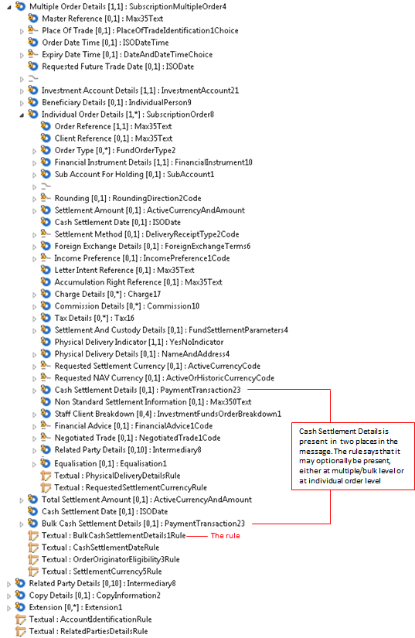

If the change request for the deletion of ‘cancel by details’ is agreed then this eliminates the need for changes to the cancellation messages (setr.002, setr.005, setr.008, setr.011, setr.047, setr.049, setr.051 and setr.053).
With respect to the change from rules that are described as text only into formally expressed rules that can be validated in an automated way, the Bulk Cash Settlement Details Rule is not a rule that currently can be expressed formally because of the repetitive nature of the sequences in which the concerned elements are located.

 | Message | Path | MC name | Current Rule Name and Textual Description | Proposed Rule Name & Textual Description
 | setr.004 | Multiple Order Details | Redemption Multiple Order 4 | BulkCashSettlementDetails1Rule  Either IndividualOrderDetails/CashSettlementDetails or BulkCashSettlementDetails may be present, but not both. | BulkCashSettlementDetails1Rule  Either one or more occurrences of IndividualOrderDetails/CashSettlementDetails or BulkCashSettlementDetails may be present, but not both.
 | setr.005 | Cancellation By Order Details \ Multiple Order Details | Redemption Multiple Order 3 | BulkCashSettlementDetails1Rule  Either IndividualOrderDetails/CashSettlementDetails or BulkCashSettlementDetails may be present, but not both. | BulkCashSettlementDetails1Rule  Either one or more occurrences of IndividualOrderDetails/CashSettlementDetails or BulkCashSettlementDetails may be present, but not both.
 | setr.010 | Multiple Order Details | Subscription Multiple Order 4 | BulkCashSettlementDetails1Rule  Either IndividualOrderDetails/CashSettlementDetails or BulkCashSettlementDetails may be present, but not both. | BulkCashSettlementDetails1Rule  Either one or more occurrences of IndividualOrderDetails/CashSettlementDetails or BulkCashSettlementDetails may be present, but not both.
 | setr.011 | Cancellation By Order Details \ Multiple Order Details | Subscription Multiple Order 3 | BulkCashSettlementDetails1Rule  Either IndividualOrderDetails/CashSettlementDetails or BulkCashSettlementDetails may be present, but not both. | BulkCashSettlementDetails1Rule  Either one or more occurrence of IndividualOrderDetails/CashSettlementDetails or BulkCashSettlementDetails may be present, but not both.
 | Setr.003 | Bulk Execution Details | Redemption Bulk Execution 3 | BulkCashSettlementDetails2Rule  Either IndividualExecutionDetails/CashSettlementDetails or BulkCashSettlementDetails may be present, but not both. | BulkCashSettlementDetails2Rule  Either one or more occurrences of IndividualExecutionDetails/CashSettlementDetails or BulkCashSettlementDetails may be present, but not both.
 | Setr.006 | Multiple Execution Details | Redemption Multiple Execution 3 | BulkCashSettlementDetails2Rule  Either IndividualExecutionDetails/CashSettlementDetails or BulkCashSettlementDetails may be present, but not both. | BulkCashSettlementDetails2Rule  Either one or more occurrences of IndividualExecutionDetails/CashSettlementDetails or BulkCashSettlementDetails may be present, but not both.
 | setr.012 | Multiple Execution Details | Subscription Multiple Execution 3 | BulkCashSettlementDetails2Rule  Either IndividualExecutionDetails/CashSettlementDetails or BulkCashSettlementDetails may be present, but not both. | BulkCashSettlementDetails2Rule  Either one or more occurrences of IndividualExecutionDetails/CashSettlementDetails or BulkCashSettlementDetails may be present, but not both.
 | Setr.048 | Multiple Execution Details | Subscription Multiple Execution 3 | BulkCashSettlementDetails2Rule  Either IndividualExecutionDetails/CashSettlementDetails or BulkCashSettlementDetails may be present, but not both. | BulkCashSettlementDetails2Rule  Either one or more occurrences of IndividualExecutionDetails/CashSettlementDetails or BulkCashSettlementDetails may be present, but not both.
 | Setr.051 | Multiple Execution Details | Redemption Multiple Execution 3 | BulkCashSettlementDetails2Rule  Either IndividualExecutionDetails/CashSettlementDetails or BulkCashSettlementDetails may be present, but not both. | BulkCashSettlementDetails2Rule  Either one or more occurrences of IndividualExecutionDetails/CashSettlementDetails or BulkCashSettlementDetails may be present, but not both.
 | Setr.052 | Multiple Execution Details | Redemption Multiple Execution 3 | BulkCashSettlementDetails2Rule  Either IndividualExecutionDetails/CashSettlementDetails or BulkCashSettlementDetails may be present, but not both. | BulkCashSettlementDetails2Rule  Either one or more occurrences of IndividualExecutionDetails/CashSettlementDetails or BulkCashSettlementDetails may be present, but not both.
 | Setr.001 | Bulk Order Details | Redemption Bulk Order 4 | BulkCashSettlementDetails5Rule  Either IndividualOrderDetails/CashSettlementDetails or BulkCashSettlementDetails may be present, but not both. | BulkCashSettlementDetails5Rule  Either one or more occurrences of IndividualOrderDetails/CashSettlementDetails or BulkCashSettlementDetails may be present, but not both.
 | Setr.002 | Bulk Order Details | Redemption Bulk Order 3 | BulkCashSettlementDetails5Rule  Either IndividualOrderDetails/CashSettlementDetails or BulkCashSettlementDetails may be present, but not both. | BulkCashSettlementDetails5Rule  Either one or more occurrences of IndividualOrderDetails/CashSettlementDetails or BulkCashSettlementDetails may be present, but not both.
 | Setr.008 | Bulk Order Details | Subscription Bulk Order 3 | BulkCashSettlementDetails5Rule  Either IndividualOrderDetails/CashSettlementDetails or BulkCashSettlementDetails may be present, but not both. | BulkCashSettlementDetails5Rule  Either one or more occurrences of IndividualOrderDetails/CashSettlementDetails or BulkCashSettlementDetails may be present, but not both.
 | Setr.007 | Bulk Order Details | Subscription Bulk Order 4 | BulkCashSettlementDetails3Rule  Either IndividualOrderDetails/CashSettlementDetails or BulkCashSettlementDetails may be present, but not both. | BulkCashSettlementDetails3Rule  Either one or more occurrences of IndividualOrderDetails/CashSettlementDetails or BulkCashSettlementDetails may be present, but not both.
 | Setr.009 | Bulk Execution Details | Subscription Bulk Execution 3 | BulkCashSettlementDetails4Rule  Either IndividualExecutionDetails/CashSettlementDetails or BulkCashSettlementDetails may be present, but not both. | BulkCashSettlementDetails4Rule  Either one or more occurrences of IndividualExecutionDetails/CashSettlementDetails or BulkCashSettlementDetails may be present, but not both.
 | Setr.047 | Multiple Execution Details | Subscription Multiple Execution 3 | BulkCashSettlementDetails4Rule  Either IndividualExecutionDetails/CashSettlementDetails or BulkCashSettlementDetails may be present, but not both. | BulkCashSettlementDetails4Rule  Either one or more occurrences of IndividualExecutionDetails/CashSettlementDetails or BulkCashSettlementDetails may be present, but not both.
 | Setr.049 | Bulk Execution Details | Subscription Bulk Execution 3 | BulkCashSettlementDetails4Rule  Either IndividualExecutionDetails/CashSettlementDetails or BulkCashSettlementDetails may be present, but not both. | BulkCashSettlementDetails4Rule  Either one or more occurrences of IndividualExecutionDetails/CashSettlementDetails or BulkCashSettlementDetails may be present, but not both.
 | Setr.050 | Bulk Execution Details | Subscription Bulk Execution 3 | BulkCashSettlementDetails4Rule  Either IndividualExecutionDetails/CashSettlementDetails or BulkCashSettlementDetails may be present, but not both. | BulkCashSettlementDetails4Rule  Either one or more occurrences of IndividualExecutionDetails/CashSettlementDetails or BulkCashSettlementDetails may be present, but not both.
 | Setr.053 | Bulk Execution Details | Redemption Bulk Execution 3 | BulkCashSettlementDetails4Rule  Either IndividualExecutionDetails/CashSettlementDetails or BulkCashSettlementDetails may be present, but not both. | BulkCashSettlementDetails4Rule  Either one or more occurrences of IndividualExecutionDetails/CashSettlementDetails or BulkCashSettlementDetails may be present, but not both.
 | Setr.054 | Bulk Execution Details | Redemption Bulk Execution 3 | BulkCashSettlementDetails4Rule  Either IndividualExecutionDetails/CashSettlementDetails or BulkCashSettlementDetails may be present, but not both. | BulkCashSettlementDetails4Rule  Either one or more occurrences of IndividualExecutionDetails/CashSettlementDetails or BulkCashSettlementDetails may be present, but not both.

- Purpose of the change:
To correct an error in the documentation.
- Urgency of the request:
The next maintenance cycle in which the maintenance of orders is permitted.
- Business examples:
None.
- SEG recommendation:
Consider |  | X | Timing
 |  |  | - Next yearly cycle: 2016/2017  (the change will be considered for implementation in the yearly maintenance cycle which starts in 2016 and completes with the publication of new message versions in the spring of 2017) |  | X
- At the occasion of the next maintenance of the messages
(the change will be considered for implementation, but does not justify maintenance of the messages in its own right – will be pending until more critical change requests are received for the messages)
- Urgent unscheduled
(the change justifies an urgent implementation outside of the normal yearly cycle)
 |  |  | - Other timing:
Comments:

Reject
Reason for rejection:

