**Change Request**

**For the Update of ISO 20022 Financial Repository Items**

**A Origin of the request:**

*A.1 Submitter*: SWIFT Standards

*A.2 Contact person:* Janice Chapman [janice.chapman@swift.com](mailto:janice.chapman@swift.com)+32 2 655 3390

*A.3 Sponsors*:

1. **Related messages:**

|  | **Message** | **Identifier** |  |  | **Message** | **Identifier** |
| --- | --- | --- | --- | --- | --- | --- |
|  | Redemption Bulk Order Cancellation Request | setr.002.001.03 |  |  | Subscription Bulk Order Cancellation Request | setr.008.001.03 |

1. **Description of the change request:**

This change request is to correct a rule, Account Identification Rule, because a path in the rule is wrong.

**An illustrated example of where the rule is located**

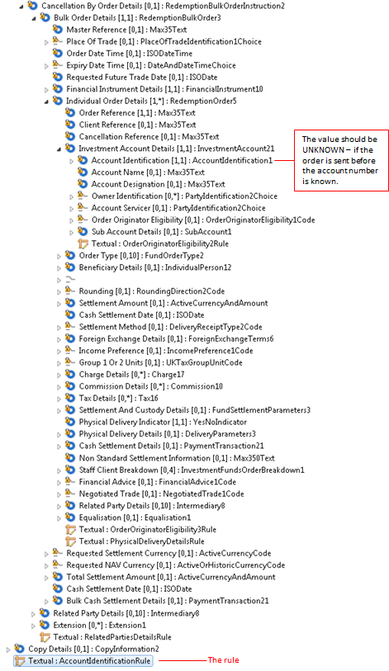

If the change request for the deletion of the ‘cancel by details’ concept is agreed then this eliminates the need for this change request.

With respect to the change from rules that are described as text only into formally expressed rules that can be validated in an automated way, the Account Identification Rule is not a rule that currently can be expressed formally because of the repetitive nature of the sequences in which the concerned elements are located.

The message has an XOR at the root

|  |  |
| --- | --- |
| When the XOR is fixed, this will impact the path for the Account Identification Rule. |  |

|  | Message | Path | MC name | Current Rule Name and Textual Description | Proposed Rule Name & Textual Description |
| --- | --- | --- | --- | --- | --- |
|  | Setr.002 | Root |  | AccountIdentificationRule  If this message is linked to an account opening request and the account identification is not yet known then the value of the AccountIdentification element in OrderToBeCancelled/BulkOrderDetails/IndividualOrderDetails/InvestmentAccountDetails must be UNKNOWN. | AccountIdentificationRule  If this message is linked to an account opening request and the account identification is not yet known then the value of the AccountIdentification element in CancellationByOrderDetails/BulkOrderDetails/IndividualOrderDetails/InvestmentAccountDetails must be UNKNOWN.  ***THIS IS IMPACTED BY THE CHANGE OF XOR TO CHOICE*** |
|  | Setr.008 | Root |  | AccountIdentificationRule  If this message is linked to an account opening request and the account identification is not yet known then the value of the AccountIdentification element in OrderToBeCancelled/BulkOrderDetails/IndividualOrderDetails/InvestmentAccountDetails must be UNKNOWN. | AccountIdentificationRule  If this message is linked to an account opening request and the account identification is not yet known then the value of the AccountIdentification element in CancellationByOrderDetails/BulkOrderDetails/IndividualOrderDetails/InvestmentAccountDetails must be UNKNOWN.  ***THIS IS IMPACTED BY THE CHANGE OF XOR TO CHOICE*** |

1. **Purpose of the change:**

To correct an error in the documentation.

1. **Urgency of the request:**

The next maintenance cycle in which the maintenance of orders is permitted.

1. **Business examples:**

None.

1. **SEG recommendation:**

|  |  |  |  |
| --- | --- | --- | --- |
| **Consider** | |  | **Timing** |
|  | | - **Next yearly cycle: 2016/2017**  (the change will be considered for implementation in the yearly maintenance cycle which starts in 2016 and completes with the publication of new message versions in the spring of 2017) | |  |
|  | | - **At the occasion of the next maintenance of the messages**  (the change will be considered for implementation, but does not justify maintenance of the messages in its own right – will be pending until more critical change requests are received for the messages) | |  |
|  | | - **Urgent unscheduled**  (the change justifies an urgent implementation outside of the normal yearly cycle) | |  |  |
|  | | - **Other timing:** | | |  |

Comments:

|  |  |
| --- | --- |
| **Reject** | X |

Reason for rejection: