Change Request
For the Update of ISO 20022 Financial Repository Items
A Origin of the request:
A.1 Submitter: SWIFT Standards
A.2 Contact person: Janice Chapman janice.chapman@swift.com +32 2 655 3390
A.3 Sponsors:
- Related messages:
 | Message | Identifier |  |  | Message | Identifier
 | Switch Order | setr.013.001.03 |  |  | Switch Order Cancellation Request | setr.014.001.03
- Description of the change request:
This change request is to request the re-validation of a textual (usage) rule, TotalSubscriptionAmountRule. If the rule is to remain, then the rule text needs fine-tuning and the rule can be formally expressed to enable automated validation.
The rule is at the level of the switch order. Basically, it is saying: if the redemption leg quantity is expressed as a percentage of total subscription amount, then the Total Subscription Amount (at the order level) of the order must also be present.

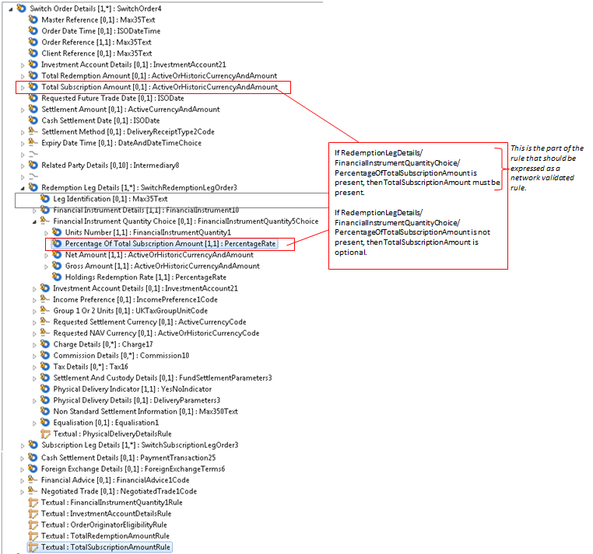

TotalSubscriptionAmountRule
If RedemptionLegDetails/
FinancialInstrumentQuantityChoice/
PercentageOfTotalSubscriptionAmount is present in any occurrence of RedemptionLegDetails/FinancialInstrumentQuantityChoice ,
then TotalSubscriptionAmount must be present.
If RedemptionLegDetails/
FinancialInstrumentQuantityChoice/
PercentageOfTotalSubscriptionAmount is not present,
then TotalSubscriptionAmount is optional.

Should this rule be retained? If yes, then:
[1] the text of the rule is to be fine-tuned as shown above.
[2] the rule is to be expressed formally so that it can be validated automatically:
If RedemptionLegDetails/  FinancialInstrumentQuantityChoice/  PercentageOfTotalSubscriptionAmount is present in any occurrence of RedemptionLegDetails/FinancialInstrumentQuantityChoice ,  then TotalSubscriptionAmount must be present.  If RedemptionLegDetails/  FinancialInstrumentQuantityChoice/  PercentageOfTotalSubscriptionAmount is not present,  then TotalSubscriptionAmount is optional. | Only the first part of the rule can be expressed formally:  On Condition  /RedemptionLegDetails[*]/FinancialInstrumentQuantityChoice/PercentageOfTotalSubscriptionAmount is present  Following Must be True  /TotalSubscriptionAmount Must be present
When the rule is expressed formally so that it can be validated automatically, messages that don’t comply with this rule may get a negative response.
If the change request for the deletion of ‘cancel by details’ is agreed then this eliminates the need for changes to the cancellation messages (setr.014, setr.055).
There is a similar rule ‘TotalSubscriptionAmountRule’ which is also to be re-validated. This is covered by a separate change request.
- Purpose of the change:
To re-validate the business meaning of a rule and if the rule is found to be correct, express it in a formal way so that it can be validated automatically.
- Urgency of the request:
The next maintenance cycle in which the maintenance of orders is permitted.
- Business examples:
None.
- SEG recommendation:
Consider |  |  | Timing
- Next yearly cycle: 2016/2017
(the change will be considered for implementation in the yearly maintenance cycle which starts in 2016 and completes with the publication of new message versions in the spring of 2017)
- At the occasion of the next maintenance of the messages
(the change will be considered for implementation, but does not justify maintenance of the messages in its own right – will be pending until more critical change requests are received for the messages)
- Urgent unscheduled
(the change justifies an urgent implementation outside of the normal yearly cycle)
 |  |  | - Other timing:
Comments:
Reject | X
Reason for rejection:
Superseded by CR0612

