Change Request
For the Update of ISO 20022 Financial Repository Items
A Origin of the request:
A.1 Submitter: SWIFT Standards
A.2 Contact person: Janice Chapman janice.chapman@swift.com +32 2 655 3390
A.3 Sponsors:
- Related messages:
 | Message | Identifier |  |  | Message | Identifier
 | Redemption Order Confirmation | setr.006.001.03 |  |  | Subscription Order Confirmation Amendment | setr.048.001.01
 | Subscription Order Confirmation | setr.012.001.03 |  |  | Redemption Order Confirmation Cancellation Instruction | setr.051.001.01
 | Subscription Order Confirmation Cancellation Instruction | setr.047.001.01 |  |  | Redemption Order Confirmation Amendment | setr.052.001.01
- Description of the change request:
This change request is to add a missing rule.
Soon after the release of the 2007 version of the order, status and confirmation messages, it was noticed that there is a missing rule; a rule to say that if, in the multiple execution details, settlement amount is specified in more than one iteration of individual execution details, and the currency code is not the same, then the Cash Settlement Date at the level of the multiple execution is not allowed.
As there was a maintenance freeze on the order, status and confirmation messages, these missing rules have been published by SWIFT in an addendum to the SWIFT funds user handbook.
This additional rule is relevant to single/multiple confirmation messages, not the bulk messages.
[1] For setr.006, 012 (confirmations)
The rule is to be added in the multiple execution details sequence.
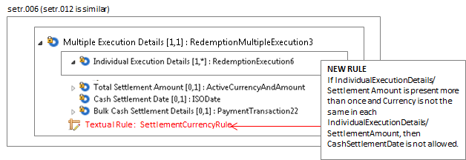

Rule Name | Rule Text
SettlementCurrencyRule | If IndividualExecutionDetails/Settlement Amount is present more than once and Currency is not the same in each IndividualExecutionDetails/SettlementAmount, then CashSettlementDate is not allowed.
[3] For setr.047, 051 (confirmation cancellations)
The rule is to be added in the multiple execution details sequence.
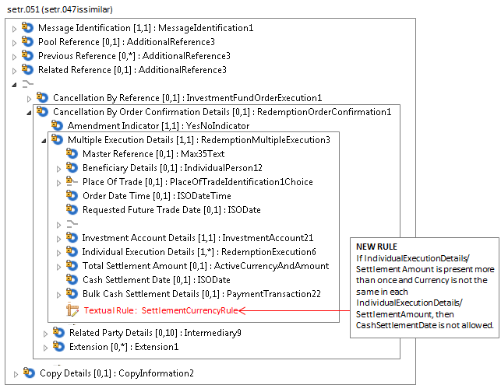
Rule Name | Rule Text
SettlementCurrency Rule | If IndividualExecutionDetails/Settlement Amount is present more than once and Currency is not the same in each IndividualExecutionDetails/SettlementAmount, then CashSettlementDate is not allowed.
[4] For setr.048, 052 (confirmation amendments)
The rule is to be added in the multiple execution details sequence.
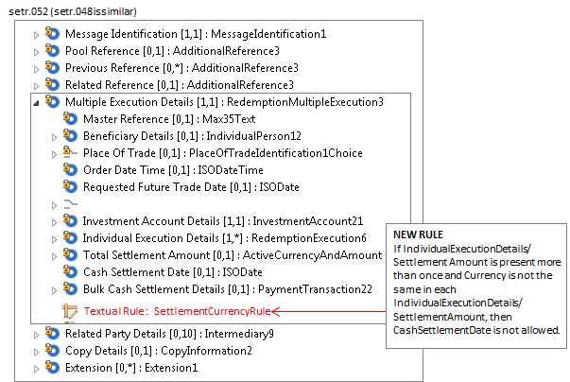
Rule Name | Rule Text
SettlementCurrency Rule | If IndividualExecutionDetails/Settlement Amount is present more than once and Currency is not the same in each IndividualExecutionDetails/SettlementAmount, then CashSettlementDate is not allowed.
With respect to changing rules that are described as text only into formally expressed rules that can be validated in an automated way, the new Settlement Currency Rule is not a rule that currently can be expressed formally because of the repetitive nature of the sequences in which the concerned elements are located.
If the change request for the deletion of ‘cancel by details’ is agreed then this eliminates the need for changes to setr.005, setr.011, setr.047, setr.048, setr.051, setr.052.
- Purpose of the change:
To add a missing cross element rule.
- Urgency of the request:
The next maintenance cycle in which the maintenance of orders is permitted.
- Business examples:
None.

- SEG recommendation:
Consider |  |  | Timing
- Next yearly cycle: 2016/2017
(the change will be considered for implementation in the yearly maintenance cycle which starts in 2016 and completes with the publication of new message versions in the spring of 2017)
- At the occasion of the next maintenance of the messages
(the change will be considered for implementation, but does not justify maintenance of the messages in its own right – will be pending until more critical change requests are received for the messages)
- Urgent unscheduled
(the change justifies an urgent implementation outside of the normal yearly cycle)
 |  |  | - Other timing:
Comments:

Reject | X
Reason for rejection:

