Change Request
For the Update of ISO 20022 Financial Repository Items
A Origin of the request:
A.1 Submitter: SWIFT Standards
A.2 Contact person: Janice Chapman janice.chapman@swift.com +32 2 655 3390
A.3 Sponsors:
- Related messages:
 | Message | Identifier |  |  | Message | Identifier
 | Redemption Order | setr.004.001.03 |  |  | Subscription Order Confirmation | setr.012.001.03
 | Redemption Order Cancellation Request | setr.005.001.03 |  |  | Subscription Order Confirmation Cancellation Instruction | setr.047.001.01
 | Subscription Order | setr.010.001.03 |  |  | Subscription Order Confirmation Amendment | setr.048.001.01
 | Subscription Order Cancellation Request | setr.011.001.03 |  |  | Redemption Order Confirmation Cancellation Instruction | setr.051.001.01
 | Redemption Order Confirmation | setr.006.001.03 |  |  | Redemption Order Confirmation Amendment | setr.052.001.01
- Description of the change request:
This change request is to add a rule, TotalSettlementCurrency Rule.
Soon after the release of the 2007 version of the order, status and confirmation messages, it was noticed that there is a missing rule; a rule to say that if, at multiple order level, the total settlement amount is specified, then at individual order level, the currency in the settlement amount, if present, must be the same in each individual order sequence.
Similarly, that if, at multiple execution level, the total settlement amount is specified, then, at individual execution level, the currency in the settlement amount must be the same in each individual execution sequence.
As there was a maintenance freeze on the order, status and confirmation messages, these missing rules have been published by SWIFT in an addendum to the SWIFT funds user handbook.
This additional rule is relevant to the single/multiple order and confirmation messages, not the bulk messages.

[1] For setr.004, 010 (orders)
The rule is to be added in the multiple order details sequence.
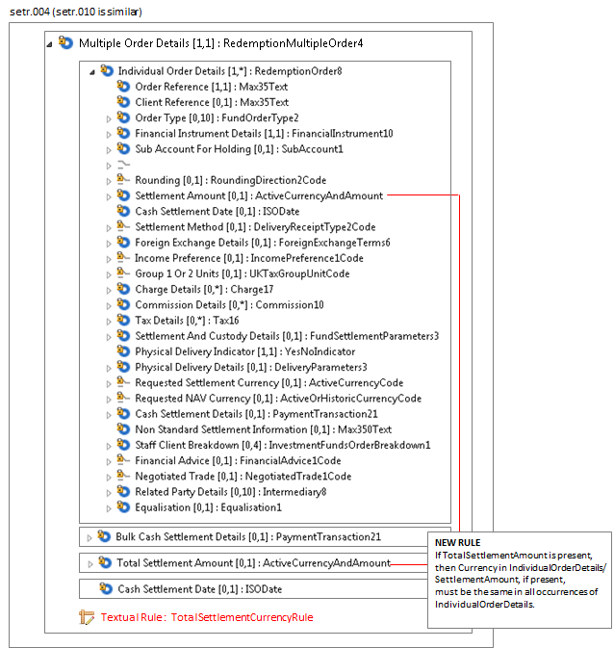

Rule Name | Rule Text
TotalSettlementCurrency Rule | If TotalSettlementAmount is present, then Currency in IndividualOrderDetails/SettlementAmount, if present, must be the same in all occurrences of IndividualOrderDetails.

[2] For setr.006, 012 (confirmations)
The rule is to be added the multiple execution details sequence.
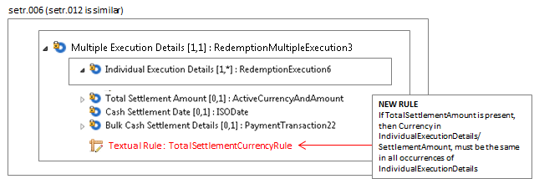
Rule Name | Rule Text
TotalSettlementCurrency Rule | If TotalSettlementAmount is present, then Currency in IndividualExecutionDetails/SettlementAmount, must be the same in all occurrences of IndividualExecutionDetails.
[3] For setr.047, 051 (confirmation cancellations)
The rule is to be added to the multiple execution details sequence.
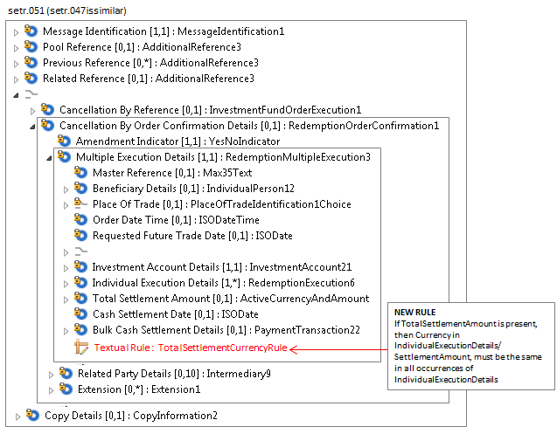
Rule Name | Rule Text
TotalSettlementCurrency Rule | If TotalSettlementAmount is present, then Currency in IndividualExecutionDetails/SettlementAmount, must be the same in all occurrences of IndividualExecutionDetails.
[4] For setr.048, 052 (confirmation amendments)
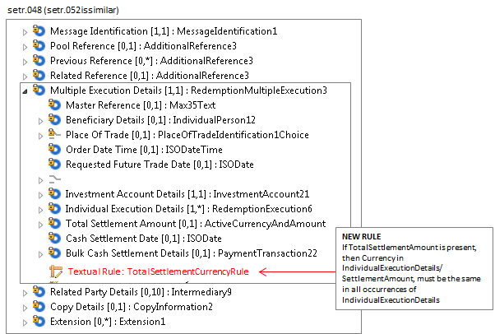
Rule Name | Rule Text
TotalSettlementCurrency Rule | If TotalSettlementAmount is present, then Currency in IndividualExecutionDetails/SettlementAmount, must be the same in all occurrences of IndividualExecutionDetails.
With respect to changing rules that are described as text only into formally expressed rules that can be validated in an automated way, the new rule, Total Settlement Currency Rule, is not a rule that currently can be expressed formally because of the repetitive nature of the sequences in which the concerned elements are located.
If the change request for the deletion of the ‘cancel by details’ concept is agreed then this eliminates the need for changes to setr.005, setr.011, setr.047, setr.051.
- Purpose of the change:
To add a missing cross element rule.
- Urgency of the request:
The next maintenance cycle in which the maintenance of orders is permitted.
- Business examples:
None.
- SEG recommendation:
Consider |  | X | Timing
 |  |  | - Next yearly cycle: 2016/2017  (the change will be considered for implementation in the yearly maintenance cycle which starts in 2016 and completes with the publication of new message versions in the spring of 2017) |  | X
- At the occasion of the next maintenance of the messages
(the change will be considered for implementation, but does not justify maintenance of the messages in its own right – will be pending until more critical change requests are received for the messages)
- Urgent unscheduled
(the change justifies an urgent implementation outside of the normal yearly cycle)
 |  |  | - Other timing:
Comments:

Reject
Reason for rejection:

