Change Request
For the Update of ISO 20022 Financial Repository Items
A Origin of the request:
A.1 Submitter: SWIFT Standards
A.2 Contact person: Janice Chapman janice.chapman@swift.com +32 2 655 3390
A.3 Sponsors:
- Related messages:
 | Message | Identifier |  |  | Message | Identifier
 | Redemption Bulk Order | setr.001.001.03 |  |  | Subscription Order Cancellation Request | setr.011.001.03
 | Redemption Bulk Order Cancellation Request | setr.002.001.03 |  |  | Subscription Order Confirmation | setr.012.001.03
 | Redemption Bulk Order Confirmation | setr.003.001.03 |  |  | Subscription Order Confirmation Cancellation Instruction | setr.047.001.01
 | Redemption Order | setr.004.001.03 |  |  | Subscription Order Confirmation Amendment | setr.048.001.01
 | Redemption Order Cancellation Request | setr.005.001.03 |  |  | Subscription Bulk Order Confirmation Cancellation Instruction | setr.049.001.01
 | Redemption Order Confirmation | setr.006.001.03 |  |  | Subscription Bulk Order Confirmation Amendment | setr.050.001.01
 | Subscription Bulk Order | setr.007.001.03 |  |  | Redemption Order Confirmation Cancellation Instruction | setr.051.001.01
 | Subscription Bulk Order Cancellation Request | setr.008.001.03 |  |  | Redemption Order Confirmation Amendment | setr.052.001.01
 | Subscription Bulk Order Confirmation | setr.009.001.03 |  |  | Redemption Bulk Order Confirmation Cancellation Instruction | setr.053.001.01
 | Subscription Order | setr.010.001.03 |  |  | Redemption Bulk Order Confirmation Amendment | setr.054.001.01
- Description of the change request:
This change request is to correct a rule, RelatedPartiesDetailsRule, because
[1] the name of the rule does not refer to a correct element name
[2] the paths in the rule are wrong
[3] the language used to express the rule does not conform to the ISO 20022 linguistic style for a rule.
Since the messages were delivered in 2007, for this particular rule, the corrections to the rule has been published by SWIFT with the SWIFT Funds User Handbook in an ‘updates addendum’.
Illustrations of location of the rule
[1] For setr.004, 010
The rule to be corrected is at the root of the message.
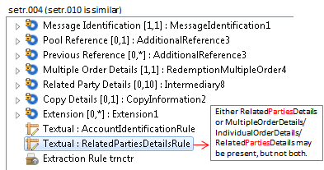

[2] For setr.005, 011
The rule to be corrected is in Cancellation By Order Details.
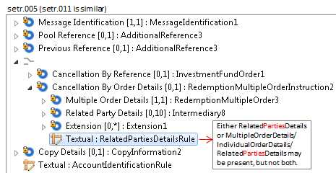
[2] For setr.006, 012
The rule to be corrected is at the root of the message.
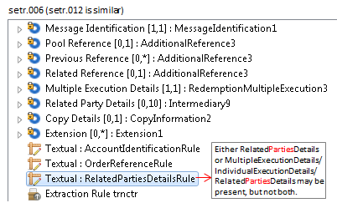

[3] 051, 047
The rule to be corrected is in the Cancel By Order Confirmation Details sequence.
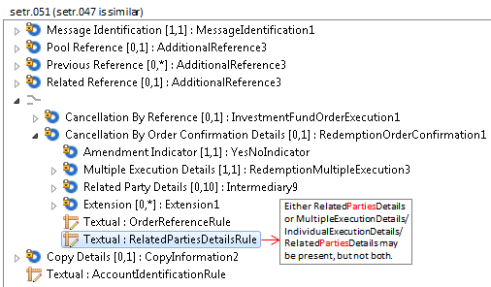
[4] 052, 048
The rule to be corrected is at the root of the message.
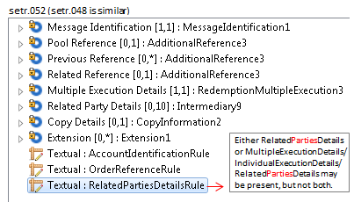
If the change request for the deletion of the ‘cancel by details’ concept is agreed then this eliminates the need for changes to the cancellation messages (setr.002, setr.005, setr.008, setr.011, setr.047, setr.049, setr.051 and setr.053).
With respect to changing rules that are described as text only into formally expressed rules that can be validated in an automated way, the RelatedPartiesPartyDetailsRule is not a rule that currently can be expressed formally because of the repetitive nature of the sequences in which the concerned elements are located.
 | Message | Path | MC name | Current Rule Name and Textual Description | Proposed Rule Name & Textual Description
 | Setr.001 | Root |  | RelatedPartiesDetailsRule  Either RelatedPartiesDetails or BulkOrderDetails/IndividualOrderDetails/RelatedPartiesDetails may be present, but not both. | RelatedPartyDetailsRule  Either RelatedPartyDetails or one or more occurrences of BulkOrderDetails/IndividualOrderDetails/RelatedPartyDetails may be present, but not both.
 | Setr.002 | Cancellation By Order Details | Redemption Bulk Order Instruction 2 | RelatedPartiesDetailsRule  Either RelatedPartiesDetails or BulkOrderDetails/IndividualOrderDetails/RelatedPartiesDetails may be present, but not both. | RelatedPartyDetailsRule  Either RelatedPartyDetails or one or more occurrence of BulkOrderDetails/IndividualOrderDetails/RelatedPartyDetails may be present, but not both.
 | Setr.003 | Root |  | RelatedPartiesDetailsRule  Either RelatedPartiesDetails or BulkExecutionDetails/IndividualExecutionDetails/RelatedPartiesDetails may be present, but not both. | RelatedPartyDetailsRule  Either RelatedPartyDetails or one or more occurrences of BulkExecutionDetails/IndividualExecutionDetails/RelatedPartyDetails may be present, but not both.
 | setr.004 | Root |  | RelatedPartiesDetailsRule  Either RelatedPartiesDetails or MultipleOrderDetails/IndividualOrderDetails/RelatedPartiesDetails may be present, but not both. | RelatedPartyDetailsRule  Either RelatedPartyDetails or one or more occurrences of MultipleOrderDetails/IndividualOrderDetails/RelatedPartyDetails may be present, but not both.
 | setr.005 | Cancellation By Order Details | Redemption Multiple Order Instruction 2 | RelatedPartiesDetailsRule  Either RelatedPartiesDetails or MultipleOrderDetails/IndividualOrderDetails/RelatedPartiesDetails may be present, but not both. | RelatedPartyDetailsRule  Either RelatedPartyDetails or one or more occurrences of MultipleOrderDetails/IndividualOrderDetails/RelatedPartyDetails may be present, but not both.
 | Setr.006 | Root |  | RelatedPartiesDetailsRule  Either RelatedPartiesDetails or MultipleExecutionDetails/IndividualExecutionDetails/RelatedPartiesDetails may be present, but not both. | RelatedPartyDetailsRule  Either RelatedPartyDetails or one or more occurrences of MultipleExecutionDetails/IndividualExecutionDetails/RelatedPartyDetails may be present, but not both.
 | Setr.007 | Root |  | RelatedPartiesDetailsRule  Either RelatedPartiesDetails or BulkOrderDetails/IndividualOrderDetails/RelatedPartiesDetails may be present, but not both. | RelatedPartyDetailsRule  Either RelatedPartyDetails or one or more occurrence of BulkOrderDetails/IndividualOrderDetails/RelatedPartyDetails may be present, but not both.
 | Setr.008 | Cancellation By OrderDetails | Subscription Bulk Order Instruction 2 | RelatedPartiesDetailsRule  Either RelatedPartiesDetails or BulkOrderDetails/IndividualOrderDetails/RelatedPartiesDetails may be present, but not both. | RelatedPartyDetailsRule  Either RelatedPartyDetails or one or more occurrence of BulkOrderDetails/IndividualOrderDetails/RelatedPartyDetails may be present, but not both.
 | Setr.009 | Root |  | RelatedPartiesDetailsRule  Either RelatedPartiesDetails or BulkExecutionDetails/IndividualExecutionDetails/RelatedPartiesDetails may be present, but not both. | RelatedPartyDetailsRule  Either RelatedPartyDetails or one or more occurrences of BulkExecutionDetails/IndividualExecutionDetails/RelatedPartyDetails may be present, but not both.
 | setr.010 | Root |  | RelatedPartiesDetailsRule  Either RelatedPartiesDetails or MultipleOrderDetails/IndividualOrderDetails/RelatedPartiesDetails may be present, but not both. | RelatedPartyDetailsRule  Either RelatedPartyDetails or one or more occurrences of MultipleOrderDetails/IndividualOrderDetails/RelatedPartyDetails may be present, but not both.
 | setr.011 | Cancellation By Order Details | Subscription Multiple Order Instruction 2 | RelatedPartiesDetailsRule  Either RelatedPartiesDetails or occurrencesMultipleOrderDetails/IndividualOrderDetails/RelatedPartiesDetails may be present, but not both. | RelatedPartyDetailsRule  Either RelatedPartyDetails or one or more occurrences of MultipleOrderDetails/IndividualOrderDetails/RelatedPartyDetails may be present, but not both.
 | setr.012 | Root |  | RelatedPartiesDetailsRule  Either RelatedPartiesDetails or MultipleExecutionDetails/IndividualExecutionDetails/RelatedPartiesDetails may be present, but not both. | RelatedPartyDetailsRule  Either RelatedPartyDetails or one or more occurrences of MultipleExecutionDetails/IndividualExecutionDetails/RelatedPartyDetails may be present, but not both.
 | Setr.048 | Root |  | RelatedPartiesDetailsRule  Either RelatedPartiesDetails or MultipleExecutionDetails/IndividualExecutionDetails/RelatedPartiesDetails may be present, but not both. | RelatedPartyDetailsRule  Either RelatedPartyDetails or one or more occurrences of MultipleExecutionDetails/IndividualExecutionDetails/RelatedPartyDetails may be present, but not both.
 | Setr.047 | Cancellation By Order Confirmation Details | Subscription Order Confirmation 1 | RelatedPartiesDetailsRule  Either RelatedPartiesDetails or MultipleExecutionDetails/IndividualExecutionDetails/RelatedPartiesDetails may be present, but not both. | RelatedPartyDetailsRule  Either RelatedPartyDetails or one or more occurrences of MultipleExecutionDetails/IndividualExecutionDetails/RelatedPartyDetails may be present, but not both.
 | Setr.049 | Cancellation By Order Confirmation Details | Subscription Bulk Order Confirmation 1 | RelatedPartiesDetailsRule  Either RelatedPartiesDetails or BulkExecutionDetails/IndividualExecutionDetails/RelatedPartiesDetails may be present, but not both. | RelatedPartyDetailsRule  Either RelatedPartyDetails or one or more occurrences of BulkExecutionDetails/IndividualExecutionDetails/RelatedPartyDetails may be present, but not both.
 | Setr.050 | Root |  | RelatedPartiesDetailsRule  Either RelatedPartiesDetails or BulkExecutionDetails/IndividualExecutionDetails/RelatedPartiesDetails may be present, but not both. | RelatedPartyDetailsRule  Either RelatedPartyDetails or one or more occurrences of BulkExecutionDetails/IndividualExecutionDetails/RelatedPartyDetails may be present, but not both.
 | Setr.051 | CancellationByOrderConfirmationDetails | Redemption Order Confirmation 1 | RelatedPartiesDetailsRule  Either RelatedPartiesDetails or MultipleExecutionDetails/IndividualExecutionDetails/RelatedPartiesDetails may be present, but not both. | RelatedPartyDetailsRule  Either RelatedPartyDetails s or one or more occurrences of MultipleExecutionDetails/IndividualExecutionDetails/RelatedPartyDetails may be present, but not both.
 | Setr.052 | Root |  | RelatedPartiesDetailsRule  Either RelatedPartiesDetails or MultipleExecutionDetails/IndividualExecutionDetails/RelatedPartiesDetails may be present, but not both. | RelatedPartyDetailsRule  Either RelatedPartyDetails or one or more occurrences of MultipleExecutionDetails/IndividualExecutionDetails/RelatedPartyDetails may be present, but not both.
 | Setr.053 | Cancellation By Order Confirmation Details | Order Confirmation Details 1 | RelatedPartiesDetailsRule  Either RelatedPartiesDetails or BulkExecutionDetails/IndividualExecutionDetails/RelatedPartiesDetails may be present, but not both. | RelatedPartyDetailsRule  Either RelatedPartyDetails or one or more occurrences of BulkExecutionDetails/IndividualExecutionDetails/RelatedPartyDetails may be present, but not both.
 | Setr.054 | Root |  | RelatedPartiesDetailsRule  Either RelatedPartiesDetails or BulkExecutionDetails/IndividualExecutionDetails/RelatedPartiesDetails may be present, but not both. | RelatedPartyDetailsRule  Either RelatedPartyDetails or one or more occurrences of BulkExecutionDetails/IndividualExecutionDetails/RelatedPartyDetails may be present, but not both.

- Purpose of the change:
To correct an error in the documentation.
- Urgency of the request:
The next maintenance cycle in which the maintenance of orders is permitted.
- Business examples:
None.
- SEG recommendation:
Consider |  |  | Timing
- Next yearly cycle: 2016/2017
(the change will be considered for implementation in the yearly maintenance cycle which starts in 2016 and completes with the publication of new message versions in the spring of 2017)
- At the occasion of the next maintenance of the messages
(the change will be considered for implementation, but does not justify maintenance of the messages in its own right – will be pending until more critical change requests are received for the messages)
- Urgent unscheduled
(the change justifies an urgent implementation outside of the normal yearly cycle)
 |  |  | - Other timing:
Comments:

Reject | X
Reason for rejection:
Superseded by CR0614

