Change Request
for the update of ISO 20022 financial repository items
- Origin of the request:
A.1 Submitter: SWIFT Standards.
A.2 Contact person:
Janice Chapman, SWIFT Janice.Chapman@swift.com + 32 2 655 3390
A.3 Sponsors: None
- Related messages:
 | Message | Identifier |  |  | Message | Identifier
 | Redemption Bulk Order Cancellation Request | setr.002.001.03 |  |  | Subscription Order Confirmation Cancellation Instruction | setr.047.001.01
 | Redemption Order Cancellation Request | setr.005.001.03 |  |  | Subscription Bulk Order Confirmation Cancellation Instruction | setr.049.001.01
 | Subscription Bulk Order Cancellation Request | setr.008.001.03 |  |  | Redemption Order Confirmation Cancellation Instruction | setr.051.001.01
 | Subscription Order Cancellation Request | setr.011.001.03 |  |  | Redemption Bulk Order Confirmation Cancellation Instruction | setr.053.001.01
 | Switch Order Cancellation | setr.014.001.03 |  |  | Switch Order Confirmation Cancellation Instruction | setr.055.001.01

- Description of the change request:
[1] Remove the ‘cancel by order’ details sequence from the order cancellation messages.
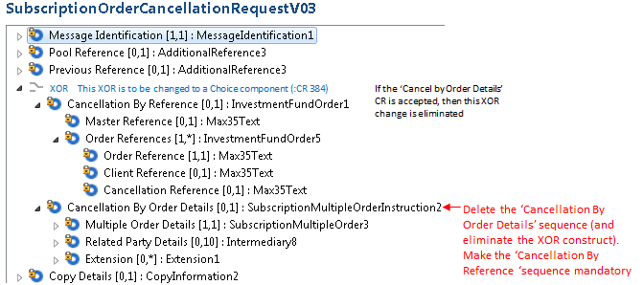
[2] Remove the ‘cancel by order confirmation details’ sequence from the order confirmation messages.
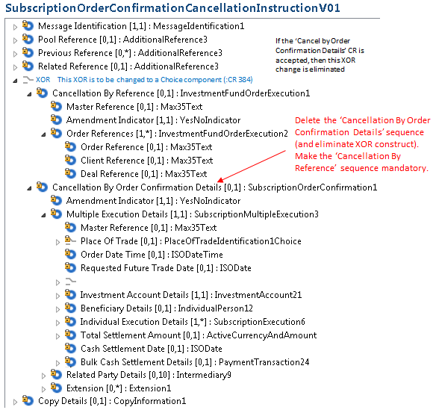
[3] The scopes/usage documentation of the messages will be modified to reflect this change in functionality.
- Purpose of the change:
To align the message structure to the use of the message. The inclusion of all the details in the cancellation message is probably something that was included to be consistent with ISO 15022. Market practice says that the ‘cancel by order cancellation details’ and ‘cancel by order confirmation details’ sequences should not be used.
The S & R cancellation of settlement instructions follow a similar approach.
- Urgency of the request:
The next maintenance cycle in which the maintenance of orders is permitted.
- Business examples:
N/A

- SEG recommendation:

Consider |  | X | Timing
 |  |  | - Next yearly cycle: 2016/2017  (the change will be considered for implementation in the yearly maintenance cycle which starts in 2016 and completes with the publication of new message versions in the spring of 2017) |  | X
- At the occasion of the next maintenance of the messages
(the change will be considered for implementation, but does not justify maintenance of the messages in its own right – will be pending until more critical change requests are received for the messages)
- Urgent unscheduled
(the change justifies an urgent implementation outside of the normal yearly cycle)
 |  |  | - Other timing:
Comments:

Reject
Reason for rejection:

