Change Request
for the update of an External Code Set used in ISO 20022
- Origin of the request:
A.1 Submitter:

SWIFT
8 Marina View, Asia Square Tower 1, #28-04, Singapore 018960

A.2 Contact person:

Mr. David Dobbing SWIFT Standards Department
Tel: +65 8500 8056

A.3 Sponsors:

ETDA (Electronic Transactions Development Agency)
The 9th Tower Grand Rama9 Building (Tower B) Floor 21
33/4 Rama 9 Road, Huai Khwang,
Bangkok 10310
Thailand

www.etda.or.th
Tel. +66 2123 1234

Mr. Supachok Jantarapatin
e-mail: supachok@etda.or.th
Tel: +66 2123 1234

- Related External Code Set:
3 – Cash Clearing System

- Description of the change request:

Code | Name | Definition
THN | Thailand-NITMX | TH (Thailand) - National ITMX Payment System

The format of ClearingSystem and ExternalCashClearingSystem1Code under Payments Clearing and Settlement - Maintenance 2014 – 2015.
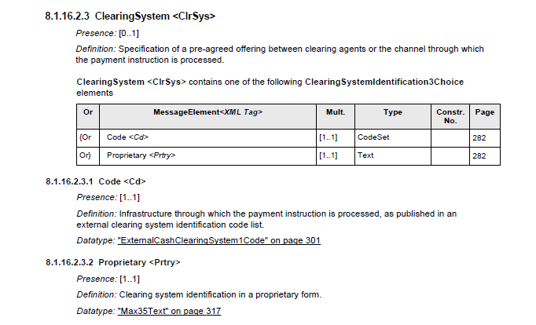
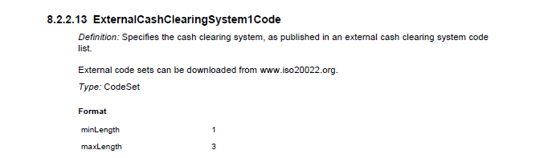

- Purpose of the change:
Additional code is required to support the Thailand payment implementations.

- Urgency of the request:
Default

- Business examples:
Examples illustrating the change request.

- SEG recommendation:

Accept |  | X | Timing
 |  |  | - Next possible quarterly release |  | 1Q2016
 |  |  | - Other timing:
Comments:

Reject
Reason for rejection:

