Change Request
for the update of an External Code Set used in ISO 20022

- Origin of the request:
A.1 Submitter:
SIX Interbank Clearing Ltd, Zurich (Switzerland)
A.2 Contact person:
Istvan Teglas
Senior Product Manager
SIX Interbank Clearing AG
Hardturmstrasse 201
CH-8021 Zürich
T +41 58 399 4238
istvan.teglas@six-group.com
www.six-interbank-clearing.com
A.3 Sponsors:
UBS AG, CH-8098 Zurich
Credit Suisse, CH-8070 Zurich
PostFinance, CH-3000 Bern
Zürcher Kantonalbank, CH-8001 Zurich
SIX Interbank Clearing Ltd, CH-8021 Zurich

- Related External Code Set:
5-ClearingSystemIdentification

- Description of the change request:
The Name and Definition of the following two codes should be updated:

CHBCC | Swiss Clearing Code (BC Code) | Bank Clearing number used in Switzerland | Switzerland | [0-9]{3,5}
CHSIC | Swiss Clearing Code (SIC Code) | Bank Branch code used in clearing with Swiss Francs | Switzerland | [0-9]{6,6}

The new Name and Definition should be:

CHBCC | Swiss Financial Institution Identification (short) | Financial Institution Identification (IID) used in Switzerland, including without check digit. | Switzerland | [0-9]{3,5}
CHSIC | Swiss Financial Institution Identification (long) | Financial Institution Identification (IID) used in Switzerland, including check digit. | Switzerland | [0-9]{6,6}

- Purpose of the change:
The BC number has functioned for the identification of system participants since introduction of the SIC RTGS system in 1987. Starting April 2016, this identification number will be called the Institution Identification (IID).
The term known as the bank clearing number (BC no.) has been obsolete since at least 2010 when system participants without bank status (e.g. insurance companies) were permitted as participants of the RTGS by the Swiss National Bank. Furthermore, this number is not used exclusively for the clearing of payments, but also for information beyond the various payment infrastructures. For example, as a component of the IBAN, this can be used as a bank account number for many purposes.

- Urgency of the request:
By default, valid change requests, subsequently approved by the SEG will be included in the following quarterly publication of External Code Sets, unless decided otherwise by the SEG.

- Business examples:
“IID” used at http://www.six-interbank-clearing.com/en/home/bank-master-data/inquiry-bc-number.html :
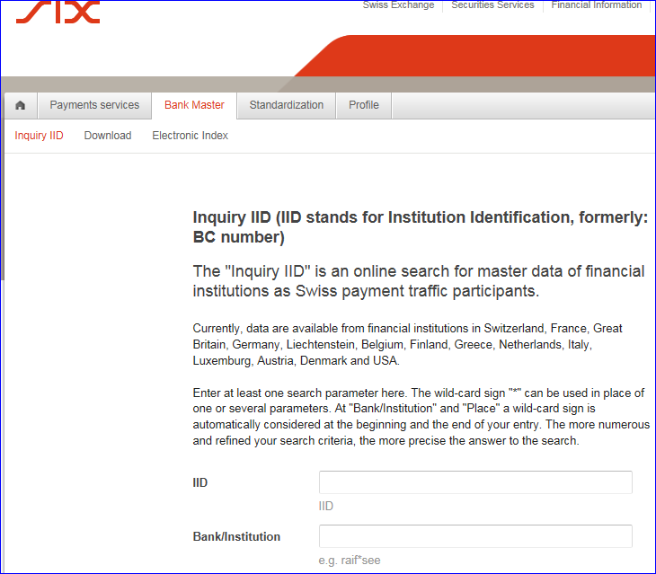

- SEG recommendation:

Accept |  | X | Timing
 |  |  | - Next possible quarterly release |  | X
 |  |  | - Other timing:
Comments:
Reject
Reason for rejection:

