Change Request
for the update of an External Code Set used in ISO 20022

- Origin of the request:
A.1 Submitter:
Bloomberg Open Symbology and International Securities Association for Institutional Trade Communication (ISITC)

A.2 Contact person:
Jason Brasile, ISITC (Email: jbrasile@statestreet.com, Tel: 1-917-790-4199 )
Richard Robinson, Bloomberg LP (Email: rrobinson57@bloomberg.net, Tel: +1.609.279.3467 )

A.3 Sponsors:
International Securities Association for Institutional Trade Communication (ISITC)
Bloomberg LLP; Open Symbology division

- Related External Code Set:
Tab 24-Financial Instrument ID Type
External Code Sets spreadsheet

- Description of the change request:
Request is to create additional External Financial Instrument Identification Type Codes specifically for instruments identified using the Object Management Group's Financial Instrument Global Identifier (FIGI) standard.
The FIGI identifier is currently used in information services provided by Bloomberg, Interactive Data, SIX Financial Information and other data vendors as well as by many exchanges. Additionally, it is in use by various financial services firms (brokers, investment managers, custodians, others) for instrument identification internally and in transaction messaging between parties.

Full list of Bloomberg Identifiers with definitions noted on the attached URL: http://bsym.bloomberg.com/sym/
The three Identification Type codes being requested with definitions are:
- FIGI Financial Instrument Global Identifier A Financial Instrument Global Identifier (FIGI) is a unique, persistent twelve character string that serves to identify financial instruments across asset classes at the venue level. It is associated with one Composite ID.
- FIGC Financial Instrument Global Identifier Composite A Financial Instrument Global Identifier Composite (FIGC) is a unique, persistent twelve character string that serves to identify financial instruments across asset classes at the composite level, is associated with one or more FIGI venue level ID’s and a single Share Class level ID
- FIGG Financial Instrument Global Identifier Share Class A Financial Instrument Global Identifier Share Class (FIGG) is a unique, persistent twelve character string that serves to identify financial instruments across asset classes at the global share class level, and is associated with one or more Composite level ID’s.
The attached OMG document provides additional detail on the Financial Instrument Global Identifier currently in Beta which was adopted by the OMG board of directors in September, 2014 and will become official in September, 2015.

- Purpose of the change:
Current Bloomberg Security ID type codeword represents a list of ticker like codes assigned by Bloomberg.
BLOM Bloomberg Ticker-like code assigned by Bloomberg to identify financial instruments. The current BLOM type code is distinctly different from the FIGI code in how it is assigned, structure, granularity, maintained hierarchy, utilized and governed.
The FIGI standard allows for the identification of all financial instruments across all asset classes with which financial institutions may be involved, as well as the associated hierarchies where appropriate. FIGIs have been allocated to over 240 million financial instruments and are non-proprietary, open and free to use and re-distribute, with no terms or conditions on usage. FIGIs are used by banks, brokers, investment managers, exchanges, regulators and data vendors internationally within their information and processing systems and in their communication with other organizations. Including a Code Type for FIGIs will allow financial institutions to use within the ISO 20022 framework these identifiers that are already part of their everyday business operations.
While the current BLOM codeword refers to the dataset of identifiers specific to the Bloomberg services, FIGI is an Open Source dataset offered under Open Symbology and is a distinctly independent and unique identifier.

- Urgency of the request:

New regulatory requirements in different regimes involve the unique identification of a much wider range of financial instruments for regulatory reporting purposes, eg EU MiFID/MiFIR. Some regulators consider that ISO 6166 ISIN codes are not used to identify a significant proportion of the instruments that regulators must monitor, and have recommended that other identifiers be used in such cases. Adapting ISO 20022 to allow financial institutions to use FIGIs within ISO 20022-generated messages will increase the value of ISO 20022 to regulators and to financial institutions, thereby encouraging a greater adoption of the ISO 20022 standard internationally across a broader range of business processes.

- Business examples:
Separate /FIGI/, /FIGC/, and /FIGG/ security identifiers are needed to specifically refer to instrument identifiers allocated in accordance with the OMG's Financial Instrument Global Identifier standard as unique and distinct from the list of other Bloomberg identifiers that exist:

DS001 – TICKER
DX657 – TICKER AND EXCHANGE
DS156 – SECURITY_DES
ID059 – ID_BB_UNIQUE
ID122 – ID_BB_SEC_NUM_SRC
DY003 – ID_BB_SEC_NUM_DES
ID 121 – ID_BB_SEC_NUM
ID008 – FEED_ID_BB_SECURITY
ID036 – ID_BB_SECURITY
DS587 – PARSEKYABLE_DES
ID135 - ID_BB_GLOBAL
ID145 –COMPOSITE_ID_BB_GLOBAL
ID239 – PRIM_SECURITY_COMP_ID
ID236 – ID_BB_GLOBAL_SHARE_CLASS_LEVEL
The following example of an IBM Call option highlights the multiple ways it can be identified across various identifier types used by Bloomberg under the existing /BLOM/ ID type. The ID_BB_Global ID135, COMPOSITE_ID_BB_GLOBAL ID145, and ID_BB_GLOBAL SHARE_CLASS_LEVEL ID236 refer to the Financial Instrument Global Identifier as defined by the OMG assignment specification document (referencing the assignment of a unique identifier at different hierarchical levels as required by the assignment rules) that needs to be specifically stated in the new /FIGI/ ID type.
IBM January 2011 $20 Call Option
Bloomberg Ticker = VIB 1 C20
Bloomberg Security Description = VIB US 01/22/11 C20
Bloomberg Unique ID = EO1008012011010182800001
Bloomberg Security Number = 399440301188
ID_BB_GLOBAL (ID135) - BBG0005V55Y1

In regards to Equity Common Stock, multiple levels may need to be indicated (/FIGI/, /FIGC/, /FIGG/) as per the following, requiring explicit distinct codewords to differentiate the assignment level of the identifier.;
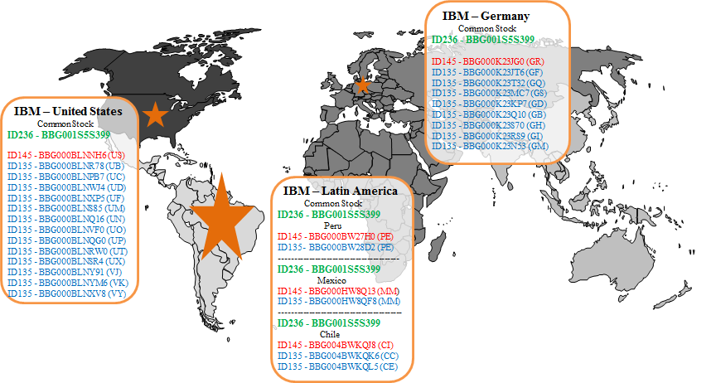

- SEG recommendation:

Accept |  | X | Timing
 |  |  | - Next possible quarterly release |  | X
 |  |  | - Other timing:
Comments:

Reject
Reason for rejection:

