Change Request
for the update of ISO 20022 financial repository items
- Origin of the request:
A.1 Submitter: SWIFT Standards, on behalf of the Findel SLT Market Practice Group
A.2 Contact person:
Janice Chapman, SWIFT Janice.Chapman@swift.com + 32 2 655 3390
Charles Boniver, RBC Charlesraymond.Boniver@rbc.com
A.3 Sponsors: None
- Related messages:
 | TransferInInstructionV06 | sese.005.001.06
 | TransferInInstructionCancellationRequestV06 | sese.006.001.06
 | TransferInConfirmationV06 | sese.007.001.06
 | ReversalOfTransferInConfirmationV06 | sese.008.001.06

- Description of the change request:
The transfer in messages need to be able to support the Findel single leg transfer model. In the more complex scenario, involving custodians between the transferee and the transfer agent, there is a need to send a transfer in instruction message, not as an instruction, but as an advice and a request for information to the next party in the chain. In a similar way, there is a need for the transfer in confirmation message to be used, not as a confirmation of a transfer, but as an advice.
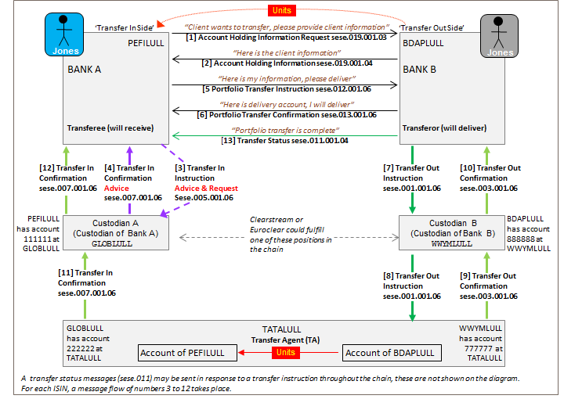
There is a gap in the message standard and an additional element is required. In addition, the scope/usage part of the documentation needs to state that the message can be used as an advice and a request for information.
The following addition is required in the Transfer Details sequence just below the Business Flow Type.
Sese.005 & sese.006
Element | M/O | Data Type | Definition
Function | 0.1 | Choice Code / Proprietary | Function of the transfer in.

Code set
Code | Code Name | Definition
ADV2 | AdviceAndRequest | Advice and request for information.
INST | Instruction | Instruction.

Sese.007 + 008
Element | M/O | Data Type | Definition
Function | 0.1 | Choice Code / Proprietary | Function of the transfer in confirmation.
Code set
Code | Code Name | Definition
ADV1 | Advice | Advice
CONF | Confirmation | Confirmation

- Purpose of the change:
To enable the transfers message set to meet the requirements of complex portfolio transfers for the Findel Single Leg Transfer process.

- Urgency of the request:
Urgent. For the next maintenance cycle (2015-2016)

- Business examples:
N/A.
- SEG recommendation:

Consider |  | X | Timing
 |  |  | - Next yearly cycle: 2015/2016  (the change will be considered for implementation in the yearly maintenance cycle which starts in 2015 and completes with the publication of new message versions in the spring of 2016) |  | X
- At the occasion of the next maintenance of the messages
(the change will be considered for implementation, but does not justify maintenance of the messages in its own right – will be pending until more critical change requests are received for the messages)
- Urgent unscheduled
(the change justifies an urgent implementation outside of the normal yearly cycle)
 |  |  | - Other timing:
Comments:

Reject
Reason for rejection:

