Change Request
for the update of ISO 20022 financial repository items
- Origin of the request:
A.1 Submitter: SWIFT Standards, on behalf of the Findel SLT Market Practice Group
A.2 Contact person:
Janice Chapman, SWIFT Janice.Chapman@swift.com + 32 2 655 3390
Charles Boniver, RBC Charlesraymond.Boniver@rbc.com
A.3 Sponsors: None
- Related messages:
 | TransferInstructionStatusReportV04 | sese.011.001.04

- Description of the change request:
The transfer instruction status message needs to be able to support a process in which, following the transfer of several ISINs individually as part of a portfolio transfer, the transferor can send a status message to indicate that the portfolio transfer is complete (UK and Findel).
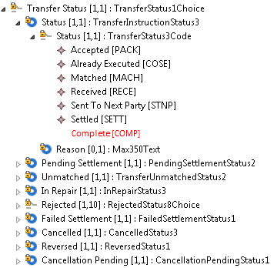

Code | Code Name | Code Definition
COMP | Complete | Portfolio transfer is complete

- Purpose of the change:
To enable the transfers message set to meet the requirements of complex portfolio transfers for the Findel Single Leg Transfer process.

- Urgency of the request:
Urgent. For the next maintenance cycle (2015-2016)

- Business examples:
N/A.

- SEG recommendation:

Consider |  | X | Timing
 |  |  | - Next yearly cycle: 2015/2016  (the change will be considered for implementation in the yearly maintenance cycle which starts in 2015 and completes with the publication of new message versions in the spring of 2016) |  | X
- At the occasion of the next maintenance of the messages
(the change will be considered for implementation, but does not justify maintenance of the messages in its own right – will be pending until more critical change requests are received for the messages)
- Urgent unscheduled
(the change justifies an urgent implementation outside of the normal yearly cycle)
 |  |  | - Other timing:
Comments:

Reject
Reason for rejection:

