Change Request
for the update of an External Code Set used in ISO 20022

- Origin of the request:
A.1 Submitter: German Savings Banks Association (DSGV)
A.2 Contact persons:
Dr. Ralf Schopohl (Ralf.Schopohl@dsgv.de, +49 228 4495 7379)
Richard Hauke (Richard.Hauke@dsgv.de, +49 30 202225 5542)

A.3 Sponsors:
- Die Deutsche Kreditwirtschaft (DK)
- Association of German Private Banks (BdB)
- Association of German Public Banks (VÖB)
- German Savings Banks Association (DSGV) representing all German Savings Banks and regional banks (Landesbanken)
- National Association of German Cooperative Banks (BVR) representing all German Cooperative Banks
- Deutsche Bundesbank

- Related External Code Set:
ExternalPurpose1Code

- Description of the change request:
New value for the code set “ExternalPurpose1Code”:
Code | Classification | Name | Definition
IVRF | General | InvoiceWith CreditorReferenceRF | Transaction is the payment of an invoice using a structured creditor reference (ISO 11649) provided by the creditor in a specific manner

- Purpose of the change:
ISO 11649 specifies the elements of a structured creditor reference (RF Creditor Reference) used to facilitate the processing of data in data interchange and in the financial services, as well as between other business domains. The structured creditor reference is designed for use in an automated processing environment, but can also be implemented in other media interchanges (e.g. paper document exchange, QR codes).
The European Payments Council (EPC) supports ISO 11649 for usage in the ISO 20022 messages (CreditorReferenceInformation) for SEPA Credit Transfers and SEPA Direct Debits.
Usually (German) customers receive invoices together with prepared paper based orders containing a structured creditor reference. Since EPC also supports QR-Codes for SEPA Credit Transfers an invoice and/or a paper based order may also contain a QR-Code.
For reconciliation purposes creditors are looking for an indicator to recognize whether the provided paper based order or QR code is used to create the transaction.
Therefore in addition to the existing Purpose Code IVPT (InvoicePayment) a separate Purpose Code IVRF (InvoiceWithCreditorReferenceRF) is needed.

- Urgency of the request:
Next maintenance cycle of the External Code Sets

- Business examples:

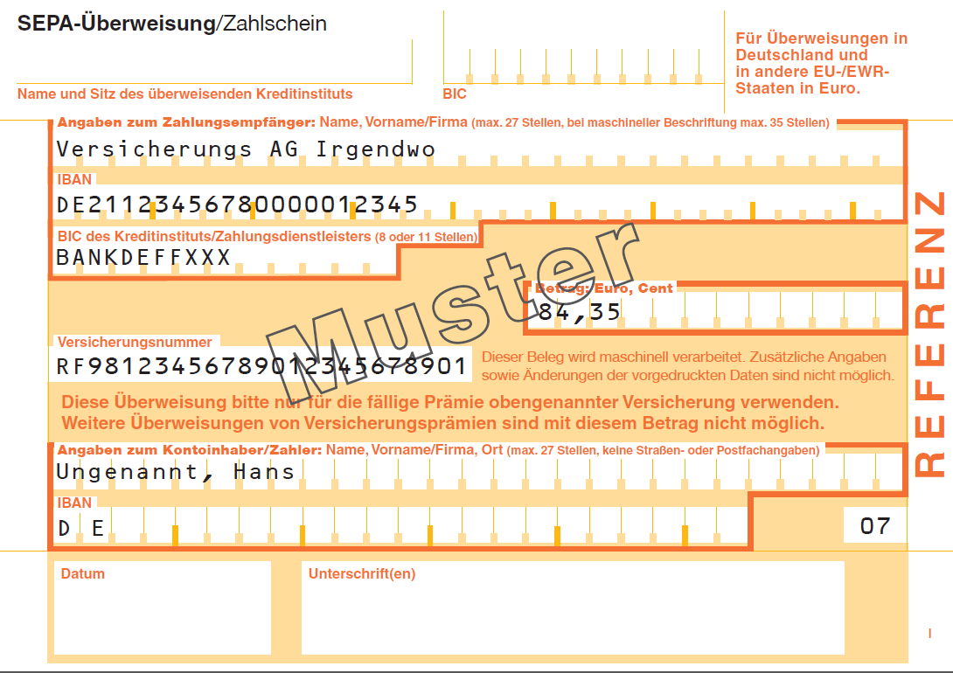

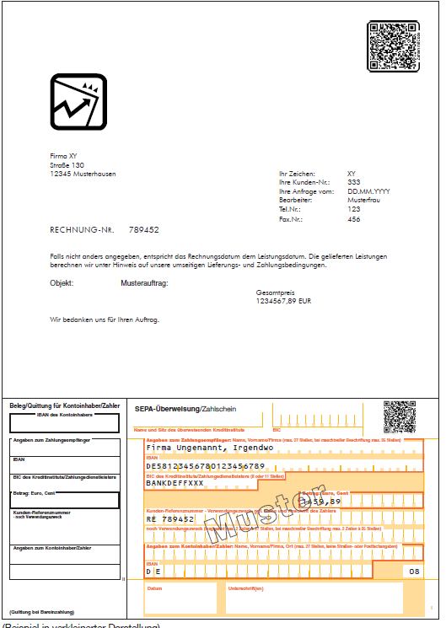

- SEG recommendation:.

Accept |  |  | Timing
 |  |  | - Next possible quarterly release
 |  |  | - Other timing:
Comments:

Reject
Reason for rejection:
2nd March 2015: CR withdrawn by the submitter.

EPC document 069-12 “Quick Response Code: Guidelines to Enable Data Capture for the Initiation of a SEPA Credit Transfer”

