Change Request
for the update of ISO 20022 financial repository items

- Origin of the request:
A.1 Submitter: SWIFT Standards on behalf Findel Group
A.2 Contact person:
Janice Chapman, SWIFT Janice.Chapman@swift.com + 32 2 655 3390
A.3 Sponsors: None
- Related messages:
 | TransferOutInstructionV05 | sese.001.001.05
 | TransferOutCancellationRequestV05 | sese.002.001.05
 | TransferOutConfirmationV05 | sese.003.001.05
 | ReversalOfTransferOutConfirmationV05 | sese.004.001.05
 | TransferInInstructionV05 | sese.005.001.05
 | TransferInCancellationRequestV05 | sese.006.001.05
 | TransferInConfirmationV05 | sese.007.001.05
 | ReversalOfTransferInConfirmationV05 | sese.008.001.05
- Description of the change request:
In the 2013/2014 maintenance cycle, in the Settlement Details / Commission Details sequence the XOR for Basis [0..1] and Extended Basis [0..1] was changed into the element Basis, typed a choice component. The multiplicity of Basis was set to [1..1], when it should have been set to [0..1].
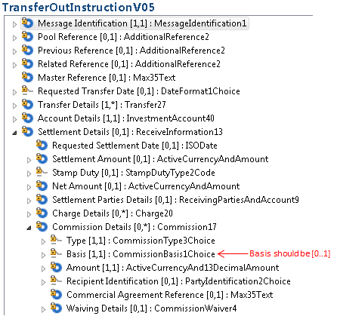
- Purpose of the change:
Correction of an error.
- Urgency of the request:
This is a late change request and, as it is the correction of an error, should be included in the next yearly maintenance cycle (2014/2015).
- Business examples:
None
- SEG recommendation:
This section is not to be taken care of by the submitter of the change request. It will be completed in due time by the SEG(s) in charge of the related ISO 20022 messages.

Consider |  | X | Timing
 |  |  | - Next yearly cycle: 2014/2015  (the change will be considered for implementation in the yearly maintenance cycle which starts in 2014 and completes with the publication of new message versions in the spring of 2015) |  | X
- At the occasion of the next maintenance of the messages
(the change will be considered for implementation, but does not justify maintenance of the messages in its own right – will be pending until more critical change requests are received for the messages)
- Urgent unscheduled
(the change justifies an urgent implementation outside of the normal yearly cycle)
 |  |  | - Other timing:
Comments:

Reject
Reason for rejection:

