Change Request
for the update of ISO 20022 financial repository items
- Origin of the request:
A.1 Submitter:
SWIFT SCRL, Avenue Adèle 1, B-1310 La Hulpe, Belgium
A.2 Contact person:
Isabelle Bouille, e-mail: Isabelle.bouille@swift.com, Tel: +32 2 655 44 20
A.3 Sponsors:

- Related messages:
- pacs.003.001.04: FIToFICustomerDirectDebitV04
- pacs.004.001.04: PaymentReturnV04
- pacs.007.001.04: FIToFIPaymentReversalV04

- Description of the change request:
Proposed changes to the pacs.003, pacs.004 and pacs.007 messages:
Add a “SettlementPriority” block (0..1) in:
- The TransactionInformation block of pacs.003.001.04 (FIToFICustomerDirectDebitV04)
- The TransactionInformation block of pacs.004.001.04 (PaymentReturnV04), with a Usage Rule: SettlementPriority applies to the PaymentReturn message
- The TransactionInformation block of pacs.007.001.04 (FIToFIPaymentReversal), with a Usage Rule: SettlementPriority applies to the FIToFIPaymentReversal.
Following codes should be included in the SettlementPriority code set, as defined in the pacs.008.001.04 today, using the Priority3Code code set:
- Urgent: URGT
- High: HIGH
- Normal: NORM
Specification of the SettlementPriority element in the pacs.008.001.04 message:
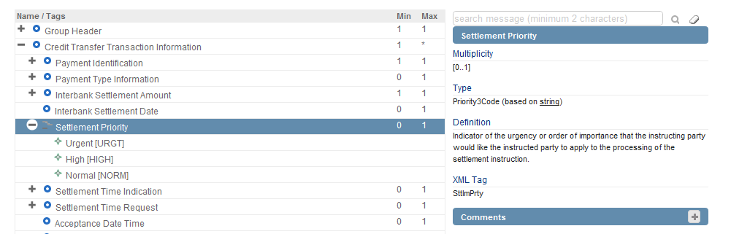

- Purpose of the change:
During implementation work conducted by Payments Market Infrastructures, it was noted that whilst pacs.008.001.04 (FIToFICustomerCreditTransferV04) and pacs.009.001.04 (FinancialInstitutionCreditTransferV04) include a SettlementPriority component (catering for 3 codes: URGT, HIGH and NORM), this is not the case for:
pacs.004.001.04: PaymentReturnV04
pacs.003.001.04: FIToFICustomerDirectDebitV04
pacs.007.001.04: FIToFIPaymentReversalV04
Considering that within a Clearing and Settlement System, Returns and Reversals are not necessarily settled the same way as the original instructions, it is required to add a SettlementPriority component in those messages, thus indicating the priority to be applied to their settlement. By adding this component, banks will decide to follow the same settlement priority as the original instruction, or choose a different one.

In the case of the FIToFICustomerDirectDebit (pacs.003.001.04), the inclusion of the SettlementPriority component will guarantee a harmonisation with the candidate FIToFIDirectDebitV01 recently submitted by SWIFT in a new business justification and with the whole Payments Clearing and Settlement portfolio.

- Urgency of the request:
Next yearly ISO 20022 maintenance cycle 2014/2015
Several Payments Market Infrastructures, including T2, are currently working on their migration plans from proprietary/FIN formats to ISO 20022, and intend to start their testing in the course of 2015.

- Business examples:
On 6 May 2014, company VIAY instructs its Bank ABN Amro in France, to pay EURO 154,500 to UBS Zürich, for the IBAN account of company ULYLAN. VIAY has requested ABN Amro to process this payment as urgent, with same value day.
On 7 May 2014, UBS Zürich sends a PaymentReturn message (pacs.004.001.05) to ABN Amro, for the IBAN account of company VIAY, with Return Reason Code BE06, Unknown End Customer. UBS Zürich wants to use a different Settlement Priority and instructs the Payment as a normal payment.

- SEG recommendation:

Consider |  | X | Timing
 |  |  | - Next yearly cycle: 2014/2015  (the change will be considered for implementation in the yearly maintenance cycle which starts in 2014 and completes with the publication of new message versions in the spring of 2015) |  | X
- At the occasion of the next maintenance of the messages
(the change will be considered for implementation, but does not justify maintenance of the messages in its own right – will be pending until more critical change requests are received for the messages)
- Urgent unscheduled
(the change justifies an urgent implementation outside of the normal yearly cycle)
 |  |  | - Other timing:
Comments:

Reject
Reason for rejection:

