Change Request
for the update of ISO 20022 financial repository items

- Origin of the request:
A.1 Submitter: SWIFT Standards on behalf of IMA + UK Fund Cash Forecast Market Practice Working Group
A.2 Contact person: Janice.chapman@swift.com +32 2 655 3390
A.3 Sponsors:

- Related messages:

 | FundEstimatedCashForecastReportV03 | camt.040.001.03
 | FundConfirmedCashForecastReportV03 | camt.041.001.03
 | FundDetailedEstimatedCashForecastReportV03 | camt.042.001.03
 | FundDetailedConfirmedCashForecastReportV03 | camt.043.001.03
 | FundConfirmedCashForecastReportCancellationV02 | camt.044.001.03
 | FundDetailedConfirmedCashForecastReportCancellationV02 | camt.045.001.03

- Description of the change request:
Addition of optional sequence - estimated report
# | Sequence Name | Definition | Data Type
 | Additional Balances | Additional balances for cash amounts and number of units. The total cash derived from orders placed as a number of units is an estimated cash amount and the total number of units derived from orders placed as a cash amount is an estimated number of units. | New message component (see below)
Addition of optional sequence - confirmed report
# | Sequence Name | Definition | Data Type
 | Additional Balances | Additional balances for cash amounts and number of units. | New message component (see below)
Elements of the new message component:
# | Element Name | Definition
1 | Total Units From Unit Orders | Total number of units from orders placed in units. | Financial Instrument Quantity 1
2 | Total Cash From Unit Orders | Total amount of cash derived from orders placed as units. | Active Or Historic Currency And Amount
3 | Total Cash From Cash Orders | Total amount of cash from orders placed in cash. | Active Or Historic Currency And Amount
4 | Total Units From Cash Orders | Number of units derived from orders placed in cash. | Financial Instrument Quantity 1

The elements will be positioned in the following locations:
[1] Fund Estimated Cash Forecast Report (camt.040)
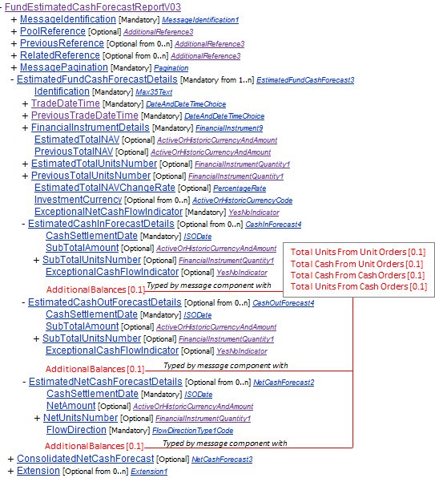

[2] Fund Confirmed Cash Forecast Report (camt.041)
The new sequence will be made added to FundCashForecastDetails/ CashInForecastDetails, CashOutForecastDetails and NetCashForecastDetails.
[3] Fund Confirmed Cash Forecast Report Cancellation (camt.044)
The new sequence will be made added to CashForecastReportToBeCancelled/ FundCashForecastDetailsCashInForecastDetails, CashOutForecastDetails and NetCashForecastDetails.

[4] Fund Detailed Estimated Cash Forecast Report (camt.042)
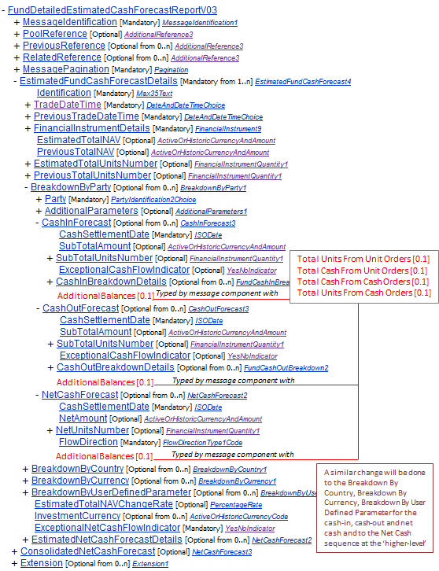

[5] Fund Detailed Confirmed Cash Forecast Report (camt.043)
The new sequence will be made added to FundCashForecastDetails/ BreakdownByParty / CashInForecastDetails, CashOutForecastDetails and NetCashForecastDetails (as well as to Breakdown By Country, Breakdown By Currency, Breakdown By User Defined Parameter for the cash-in, cash-out and net cash and to the Net Cash sequence at the ‘higher-level).
[6] Fund Detailed Confirmed Cash Forecast Report Cancellation (camt.045)
The new sequence will be made added to CashForecastReportToBeCancelled/ FundCashForecastDetails / BreakdownByParty/ CashInForecastDetails, CashOutForecastDetails and NetCashForecastDetails (as well as to Breakdown By Country, Breakdown By Currency, Breakdown By User Defined Parameter for the cash-in, cash-out and net cash and to the Net Cash sequence at the ‘higher-level).

Additonal Notes for Change Request CR0387
[1] The addition of optional settlement currency is proposed only for the BreakdownByParty. This should perhaps be extended to Breakdown By Country, Breakdown By Currency and Breakdown By User Defined Parameter.
[2] Perhaps there should be something added to the message scope/usage that reports using Breakdown By Party, Breakdown By Country, Breakdown By Currency and Breakdown By User Defined Parameter should not be mixed in the same message instance?

- Purpose of the change:
Market practice work with asset managers for cash forecasts on funds with a ‘hedge share class’ led to the identification of gaps in the message and additional data elements are needed. This is additional data that may benefit the wider community of funds cash forecast messages.

- Urgency of the request:
Next yearly maintenance cycle (2014/2015).

- Business examples:
None.

- SEG recommendation:

Consider |  | X | Timing
 |  |  | - Next yearly cycle: 2014/2015  (the change will be considered for implementation in the yearly maintenance cycle which starts in 2014 and completes with the publication of new message versions in the spring of 2015) |  | X
- At the occasion of the next maintenance of the messages
(the change will be considered for implementation, but does not justify maintenance of the messages in its own right – will be pending until more critical change requests are received for the messages)
- Urgent unscheduled
(the change justifies an urgent implementation outside of the normal yearly cycle)
 |  |  | - Other timing:
Comments:

Reject
Reason for rejection:

