Change Request
for the update of ISO 20022 financial repository items
- Origin of the request:
A.1 Submitter: SMPG CA Working Group.
A.2 Contact person: Jacques Littré, jacques.littre@swift.com, +3226554335
A.3 Sponsors: SMPG CA WG NMPGs members

- Related messages:
The list of ISO 20022 messages which would be impacted by the change, including the Message IDs as shown in the Catalogue of ISO 20022 messages.
seev.008.001.04 MeetingResultDisseminationV04

- Description of the change request:
Change the data type ActiveCurrencyAndAmount of the element TotalNumberOfSecuritiesOutstanding by UnitOtFaceAmount1Choice data type.
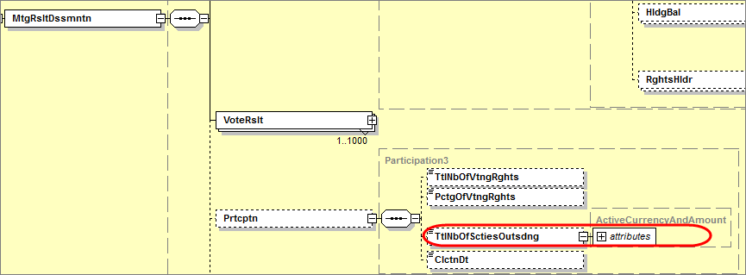
- Purpose of the change:
In the Participation component, the element TotalNumberOfSecuritiesOutstanding can only be expressed as Active Currency and Amount. Given that a large proportion of results will apply to shareholder meetings, the group agreed that it should be possible to also have the option to express this simply in Units or in FaceAmount.
- Urgency of the request:
Maintenance cycle 2014/2015
- Business examples:
N/A
- SEG recommendation:

Consider |  | X | Timing
 |  |  | - Next yearly cycle: 2014/2015  (the change will be considered for implementation in the yearly maintenance cycle which starts in 2014 and completes with the publication of new message versions in the spring of 2015) |  | X
- At the occasion of the next maintenance of the messages
(the change will be considered for implementation, but does not justify maintenance of the messages in its own right – will be pending until more critical change requests are received for the messages)
- Urgent unscheduled
(the change justifies an urgent implementation outside of the normal yearly cycle)
 |  |  | - Other timing:
Comments:

Reject
Reason for rejection:

