Change Request
for the update of ISO 20022 financial repository items
- Origin of the request:
A.1 Submitter: SMPG CA Working Group.
A.2 Contact person: Jacques Littré, jacques.littre@swift.com, +3226554335
A.3 Sponsors: SMPG CA WG NMPGs members

- Related messages:
The list of ISO 20022 messages which would be impacted by the change, including the Message IDs as shown in the Catalogue of ISO 20022 messages.
seev.006.001.04 MeetingInstructionStatusV04
seev.007.001.04 MeetingVoteExecutionConfirmationV04
seev.008.001.04 MeetingResultDisseminationV04

- Description of the change request:
Make the ReportingParty element in the above 3 messages optional.
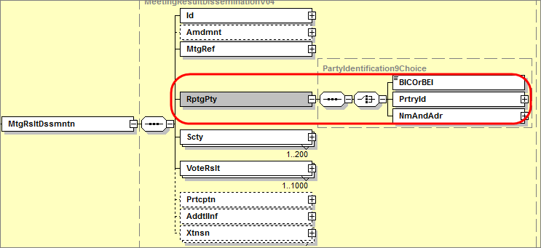
- Purpose of the change:
Similarly to the NotifyingParty in the MeetingNotification message, this ReportingParty element is redundant with the Business Application Header (BAH) element identifying the Sender of the message (“From” element) since at the time those messages were completed, the BAH was not yet mandated for the securities messages.
Therefore this component should now be made optional and could be used eventually in case the sender would not be the actual entity reporting on the meeting.
- Urgency of the request:
Maintenance cycle 2014/2015
- Business examples:
N/A
- SEG recommendation:

Consider |  | X | Timing
 |  |  | - Next yearly cycle: 2014/2015  (the change will be considered for implementation in the yearly maintenance cycle which starts in 2014 and completes with the publication of new message versions in the spring of 2015) |  | X
- At the occasion of the next maintenance of the messages
(the change will be considered for implementation, but does not justify maintenance of the messages in its own right – will be pending until more critical change requests are received for the messages)
- Urgent unscheduled
(the change justifies an urgent implementation outside of the normal yearly cycle)
 |  |  | - Other timing:
Comments:

Reject
Reason for rejection:

