Change Request
for the update of ISO 20022 financial repository items
- Origin of the request:
A.1 Submitter: SMPG CA Working Group.
A.2 Contact person: Jacques Littré, jacques.littre@swift.com, +3226554335
A.3 Sponsors: SMPG CA WG NMPGs members

- Related messages:
The list of ISO 20022 messages which would be impacted by the change, including the Message IDs as shown in the Catalogue of ISO 20022 messages.
seev.002.001.04 MeetingCancellationV04

- Description of the change request:
Remove the MessageCancellation component from the message.
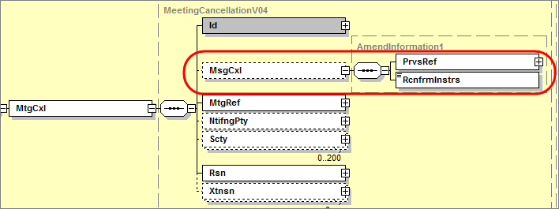
- Purpose of the change:
This is to align with the SMPG market practice implemented after the Corporate Actions XML messages were created. The SMPG Market Practice is such that if the meeting is valid, a MeetingCancellation message should not be sent. The cancellation message in only used to withdraw/cancel events and not messages. The meeting notification messages are always replaced and not cancelled. Therefore any reference to a message to be cancelled in that message is useless.
Cancelling an event because the event was erroneously sent to a account owner can be done by using the “Processing error” (PROC) code. On the other hand, if the issuer cancels the meeting a Withdrawn (WITH) code is used.

- Urgency of the request:
Maintenance cycle 2014/2015
- Business examples:
N/A
- SEG recommendation:

Consider |  | X | Timing
 |  |  | - Next yearly cycle: 2014/2015  (the change will be considered for implementation in the yearly maintenance cycle which starts in 2014 and completes with the publication of new message versions in the spring of 2015) |  | X
- At the occasion of the next maintenance of the messages
(the change will be considered for implementation, but does not justify maintenance of the messages in its own right – will be pending until more critical change requests are received for the messages)
- Urgent unscheduled
(the change justifies an urgent implementation outside of the normal yearly cycle)
 |  |  | - Other timing:
Comments:

Reject
Reason for rejection:

