Change Request
for the update of ISO 20022 financial repository items
- Origin of the request:
A.1 Submitter: SMPG CA Working Group.
A.2 Contact person: Jacques Littré, jacques.littre@swift.com, +3226554335
A.3 Sponsors: SMPG CA WG NMPGs members
- Related messages:
seev.001.001.04 MeetingNotificationV04
seev.002.001.04 MeetingCancellationV04
seev.003.001.04 MeetingEntitlementNotificationV04
seev.004.001.04 MeetingInstructionV04
seev.005.001.04 MeetingInstructionCancellationRequestV04
seev.006.001.04 MeetingInstructionStatusV04
seev.007.001.04 MeetingVoteExecutionConfirmationV04
seev.008.001.04 MeetingResultDisseminationV04
- Description of the change request:
For the element “Vote/VoteMarketDeadline”, make a choice between a Date alone or a DateTime or a DateCode (“Unknown”).
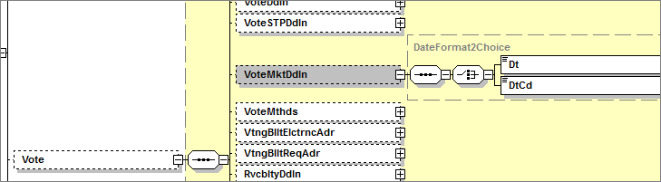
- Purpose of the change:
In some markets, deadline time is not explicit, for example ‘close of business’ or not specified. This field requires ISODateTime so we need to allow the presence of just a Date.

- Urgency of the request:
Maintenance cycle 2014/2015
- Business examples:
N/A
- SEG recommendation:

Consider |  | X | Timing
 |  |  | - Next yearly cycle: 2014/2015  (the change will be considered for implementation in the yearly maintenance cycle which starts in 2014 and completes with the publication of new message versions in the spring of 2015) |  | X
- At the occasion of the next maintenance of the messages
(the change will be considered for implementation, but does not justify maintenance of the messages in its own right – will be pending until more critical change requests are received for the messages)
- Urgent unscheduled
(the change justifies an urgent implementation outside of the normal yearly cycle)
 |  |  | - Other timing:
Comments:

Reject
Reason for rejection:

